

**DATA**

**ANALYTICS**

**USING PYTHON**

**Program #1.1**

**Date :**

**17**

**/06/**

**24**

**Create a simple calculator in Python.**

**SOURCE CODE :**

num1 = int(input("Enter Number 1: "))

operator = input("Enter the Operator: ")

num2 = int(input("Enter Number 2: "))

if operator == '+':

print(num1 + num2)

elif operator == '

-

':

print(num1

-

num2)

elif operator == '*':

print(num1 * num2)

elif operator == '/' and num2 != 0:

print(num1/num2)

else: print("Error")

**OUTPUT:**

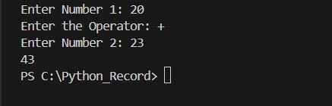

**DATA**

**ANALYTICS**

**USING PYTHON**

**Program #1.**

**2**

**Date :**

**24**

**/06/**

**17**

**An electric power distribution company charges domestic customers**

**as follows:**

**Consumption unit Rate of charge:**

**0**

**-**

**Rs. 0.50 per unit**

**200**

**201**

**-**

**200**

**Rs. 0.65 per unit in excess of**

**400**

**401**

**-**

**600**

**Rs 0.80 per unit excess of**

**400**

**600**

**601**

**and above Rs 1.00per unit excess of**

**If the bill exceeds Rs. 400, then a surcharge of 15% will be charged**

**a**

**and the minimum bill should be Rs. 100/**

**-**

**Create a Python program based on the scenario mentioned above.**

**SOURCE CODE:**

charge=0

unit=int(input("enter the unit"))

if unit <=200 :

charge=unit*0.50

elif unit>200 and unit<=400:

charge=(200*0.50)+((unit

-

200)*0.65)

elif unit>400 and unit<=600:

sur_charge=((400*0.60)+((unit

-

400)*0.8))*1.5

charge+=sur_charge

else:

sur_charge=((600*0.80)+((unit

-

600)*1))*1.5

charge+=sur_charge

if charge<100:

print("bill is:100")

else:

print("bill is:"+str(charge))

**OUTPUT:**

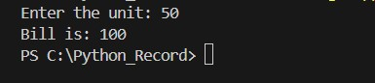

**DATA**

**ANALYTICS**

**USING PYTHON**

**Program #1.**

**3**

**Date :**

**24**

**/06/**

**17**

**Print the pyramid of numbers using for loops.**

**SOURCE_CODE:**

startRange = int(33/2)

endRange = int(33/2

-

1)

for i in range(1,18):

for j in range(1,33):

if j in range(startRange,endRange):

print("*",end="")

else:

print(" ", end="")

startRange

-

=

1

endRange += 1

print()

**OUTPUT:**

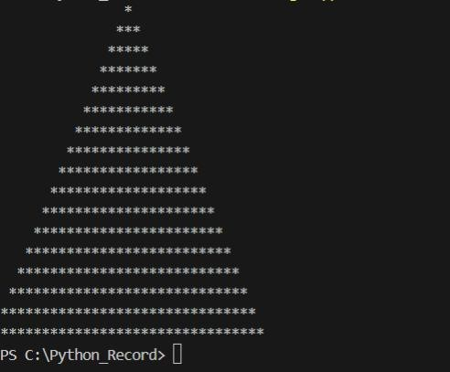

**DATA**

**ANALYTICS**

**USING PYTHON**

**Program #1.**

**4**

**Date :**

**17**

**24**

**/06/**

**Write**

**a**

**program**

**to**

**find the**

**number**

**and sum**

**of**

**all**

**integers**

**greater**

**than**

**100**

**and**

**less**

**than**

**200**

**that**

**are**

**divisible**

**by**

**7.**

**SOURCE CODE :**

sum=0

count=0

for num in range(100,200):

if num%7==0:

count+=1

sum+=count

print("sum="+str(sum))

**OUTPUT:**

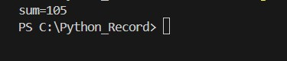

**DATA**

**ANALYTICS**

**USING PYTHON**

**Program #1.**

**5**

**Date :**

**24**

**/06/**

**17**

**Write**

**a**

**recursive**

**function**

**to**

**calculate**

**the**

**sum**

**of**

**numbers**

**from**

**0**

**to**

**10**

**SOURCE CODE :**

def sum(number):

if number > 0:

return number + sum(number

-

1)

return 0

n = int(input("Number: "))

print("Sum:", sum(n))

**OUTPUT:**

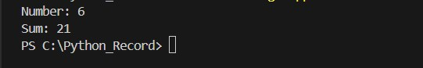

**DATA**

**ANALYTICS**

**USING PYTHON**

**Program #1.**

**6**

**Date :**

**17**

**/06/**

**24**

**Write a Python program to reverse the digits of a given number and**

**add them to the original. If the**

**sum is not a palindrome, repeat this**

**procedure**

**.**

**SOURCE CODE :**

def reverseNum(num):

rev = 0

while num > 0:

rev *= 10

rev += (num % 10)

num = num // 10

return rev

def isPalindrome(number):

isPal = True

if number != reverseNum(number):

isPal = False

return isPal

n = int(input("Enter Number: "))

n += reverseNum(n)

while(not isPalindrome(n)):

n += reverseNum(n)

print(n)

**OUTPUT:**

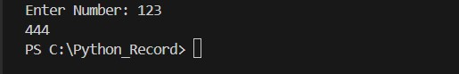

**DATA**

**ANALYTICS**

**USING PYTHON**

**Program #1.**

**7**

**Date :**

**/06/**

**24**

**19**

**Write a menu**

**-**

**driven program that performs the following operations on**

**strings**

**1.7.1.**

**Check if the String is a Substring of Another String**

**1.7.2.**

**Count Occurrences of Character**

**1.7.3.**

**Replace a substring with another substring**

**1.7.4.**

**Convert to Capital Letters**

**SOURCE CODE :**

import os

def checkSubstring():

str1 = input("Enter String 1: ")

str2 = input("Enter String 2: ")

if str2 in str1:

print(str2, "is a substring of", str1)

else:

print(str2, "is not a substring of", str1)

input("Press Enter to continue...")

def countOccurrence():

str_input = input("Enter a String: ")

ch = input("Enter Character to check: ")

count = str_input.count(ch)

print(ch, "found", count, "times in", str_input)

input("Press Enter to continue...")

def replaceSubstring():

str1 = input("Enter String 1: ")

str2 = input("Enter Substring: ")

str3 = input("Enter Substring replacement: ")

if str2 in str1:

str1 = str1.replace(str2, str3)

print("Updated String:", str1)

else:

print(str2, "not found in", str1)

input("Press Enter to continue...")

def toCapital():

str_input = input("Enter a String: ")

print(str_input.upper())

input("Press Enter to continue...")

def initMenu():

choice = 0

while choice != 5:

os.system('cls' if os.name == 'nt' else 'clear')

print("1. Check if the String is a Substring of Another String")

print("2. Count Occurrences of Character")

print("3. Replace a Substring with Another Substring")

print("4. Convert to Capital Letters")

print("5. Exit")

choice = int(input("Enter Your Choice: "))

if choice in range(1, 6):



**DATA**

**ANALYTICS**

**USING PYTHON**

if choice == 1:

checkSubstring()

elif choice == 2:

countOccurrence()

elif choice == 3:

replaceSubstring()

elif choice == 4:

toCapital()

else:

print("Enter a Valid Choice")

input("Press Enter to continue...")

initMenu()

**OUTPUT:**

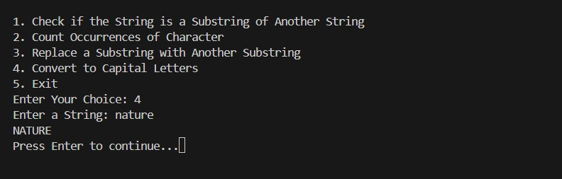

**DATA**

**ANALYTICS**

**USING PYTHON**

**Program #1.**

**8**

**Date :**

**19**

**24**

**/06/**

**Write a function to find the factorial of a number but also store the factorials calculated in a**

**dictionary.**

**SOURCE CODE :**

def factorial(n, memo={}):

if n < 0:

raise ValueError("Factorial is not defined for negative numbers.")

if n == 0 or n == 1:

return 1

if n in memo:

return memo[n]

else:

result = n * factorial(n

-

1

)

, memo

memo[n] = result

return result

num = 5

print(f"The factorial of {num} is {factorial(num)}")

print(f"Memoized factorials: {factorial.__defaults__[0]}")

**OUTPUT:**

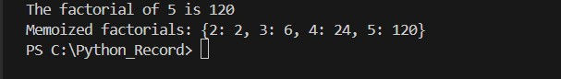

**DATA**

**ANALYTICS**

**USING PYTHON**

**Program #1.**

**9**

**Date :**

**24**

**/06/**

**19**

**Perform various set operations**

**1.**

**9**

**Set Union**

**.1**

**1.**

**9**

**.2**

**Set Intersection**

**1.**

**9**

**.3**

**Set Difference**

**SOURCE CODE :**

set1 = {1, 2, 3, 4}

set2= {3, 4, 5, 6}

union_set = set1.union(set2)

print("Union using union() method:", union_set)

union_set_operator = set1 | set2

print("Union using | operator:", union_set_operator)

intersection_set = set1.intersection(set2)

print("Intersection using intersection() method:",intersection_set)

intersection_set_operator = set1 & set2

print("Intersection using &

operator:", intersection_set_operator)

difference_set = set1.difference(set2)

print("Difference using difference() method (set1

-

set2):", difference_set)

difference_set_operator = set1

-

set2

print("Difference using

-

operator (set1

-

set2):", difference_set_operator)

**OUTPUT:**

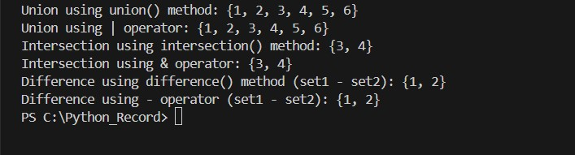

**DATA**

**ANALYTICS**

**USING PYTHON**

**Program #1.**

**10**

**Date :**

**24**

**/06/**

**19**

**Create a dictionary to store the name, roll_no, and total_mark of N students. Now print the details of**

**the student with the highest total_mark.**

**SOURCE CODE :**

students = [

{

"name": "Alice", "roll_no": 101, "total_mark": 85},

{

"name": "Bob",

"roll_no": 102, "total_mark": 92},

"name": "Charlie", "roll_no": 103, "total_mark": 78},

{

"name": "David", "roll_no": 104, "total_mark": 95},

{

: 88}

"name": "Eve", "roll_no": 105, "total_mark"

{

]

highest_mark_student = max(students, key=lambda student: student["total_mark"])

print("Details of the student with the highest total_mark:")

print(f"Name: {highest_mark_student['name']}")

print(f"Roll No: {highest_mark_student['roll_no']}")

print(f"Total Marks: {highest_mark_student['total_mark']}")

**OUTPUT :**

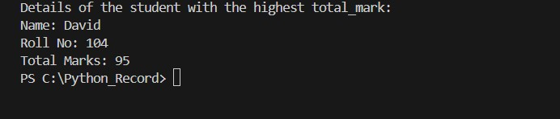

**DATA**

**ANALYTICS**

**USING PYTHON**

**Program #1.**

**1**

**1**

**Date :**

**24**

**/06/**

**19**

**Write a Python program to copy the contents of a file into another file, line by line.**

**SOURCE CODE :**

def copy_file(source_file, destination_file):

try:

with open(source_file, 'r') as src:

with open(destination_file, 'w') as dest:

for line in src:

dest.write(line)

print(f"Contents of '{source_file}' copied to '{destination_file}' successfully.")

except IOError as e:

print(f"Error copying file: {e}")

source_file = 'source.txt'

destination_file = 'destination.txt'

copy_file(source_file, destination_file)

**OUTPUT :**



**DATA**

**ANALYTICS**

**USING PYTHON**

**Program #1.**

**1**

**2**

**Date :**

**24**

**19**

**/06/**

**Use the OS module to perform**

**1.12.1.**

**Create a directory**

**1.1**

**2**

**.**

**.2**

**Directory Listing**

**1.12.3.**

**Search for “.py” files**

**1.12.4.**

**Remove a particular file**

**SOURCE CODE :**

import os

def create_directory(directory):

try:

if not os.path.exists(directory):

os.makedirs(directory)

print(f"Directory '{directory}' created successfully.")

else:

print(f"Directory '{directory}' already exists.")

except OSError as e:

print(f"Error creating directory '{directory}': {e}")

def list_directory(directory):

try:

files = os.listdir(directory)

print(f"Listing of directory '{directory}':")

for file in files:

print(file)

except OSError as e:

print(f"Error listing directory '{directory}': {e}")

def search_files(directory, extension):

try:

print(f"Searching for files with extension '{extension}' in directory '{directory}':")

for root, _, files in os.walk(directory):

for file in files:

if file.endswith(extension):

print(os.path.join(root, file))

except OSError as e:

print(f"Error searching files in directory '{directory}': {e}")

def remove_file(file_path):

try:

os.remove(file_path)

print(f"File '{file_path}' removed successfully.")

except OSError as e:

print(f"Error removing file '{file_path}': {e}")

def create_test_file(file_path):

try:

with open(file_path, 'w') as f:

f.write("This is a test file to be removed.

\

n")

print(f"File '{file_path}' created successfully.")

except OSError as e:

print(f"Error creating file '{file_path}': {e}")

# Main script execution

directory_name = "test_directory"



**DATA**

**ANALYTICS**

**USING PYTHON**

file_extension = ".py"

file_to_remove = "test_directory/file_to_remove.txt"

create_directory(directory_name)

list_directory(directory_name)

search_files(directory_name, file_extension)

# Create the test file

create_test_file(file_to_remove)

# Check if the file exists before attempting to remove it

if os.path.exists(file_to_remove):

remove_file(file_to_remove)

else:

print(f"File '{file_to_remove}' does not exist, so it cannot be removed.")

**OUTPUT :**

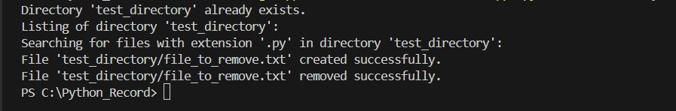

**DATA**

**ANALYTICS**

**USING PYTHON**

**Program #1.**

**1**

**3**

**Date :**

**19**

**24**

**/06/**

**Create a simple banking application by using inheritance.**

**SOURCE CODE :**

class Account:

def

init

(

self, account_number, balance=0):

self.account_number = account_number

self.balance = balance

def deposit(self, amount):

self.balance += amount

print(f"Deposited ${amount}. New balance is ${self.balance}.")

def withdraw(self, amount):

if self.balance >= amount:

self.balance

-

=

amount

print(f"Withdrew ${amount}. New balance is ${self.balance}.")

else:

print("Insufficient funds.")

def display_balance(self):

print(f"Account Number: {self.account_number}")

print(f"Current Balance: ${self.balance}")

class SavingsAccount(Account):

def

init

=0.01):

(

self, account_number, balance=0, interest_rate

super().

init

(

account_number, balance

)

self.interest_rate = interest_rate

def add_interest(self):

interest = self.balance * self.interest_rate

self.balance += interest

print(f"Interest added. New balance is ${self.balance}.")

class CheckingAccount(Account):

def

init

(

self, account_number, balance=0, transaction_fee=1):

super().

init

)

account_number, balance

(

self.transaction_fee = transaction_fe

e

def deduct_transaction_fee(self):

self.balance

-

=

self.transaction_fee

print(f"Deducted transaction fee of ${self.transaction_fee}. New balance is ${self.balance}.")

savings_acc = SavingsAccount("SAV123", 1000, 0.02)

checking_acc = CheckingAccount("CHK456", 500)

savings_acc.display_balance()

savings_acc.deposit(500)

savings_acc.add_interest()

savings_acc.withdraw(200)

print()

checking_acc.display_balance()

checking_acc.deposit(300)

checking_acc.deduct_transaction_fee()

checking_acc.withdraw(100)



**DATA**

**ANALYTICS**

**USING PYTHON**

**OUTPUT :**

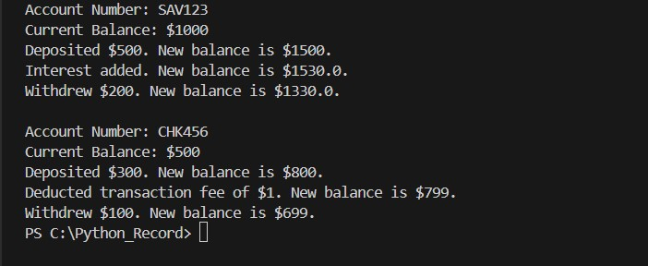

**DATA**

**ANALYTICS**

**USING PYTHON**

**Program #2.1**

**Date :**

**/06/**

**24**

**24**

**Implementation of MySQL connection using Python**

**SOURCE CODE**

**:**

#pip install mysql

-

connector

-

python "install myqsl using this command"

import sys

sys.path.append('C:

\

\

Users

\

\

vargh

\

\

AppData

\

\

Local

\

\

Packages

\

\

PythonSoftwareFoundation.Python.3.1

2

_qbz5n2kfra8p

0

\

\

LocalCache

\

\

local

-

packages

\

\

python312

\

\

site

-

packages')

import mysql.connector

from mysql.connector import Error

# Function to create a MySQL connection

def create_connection(host_name, user_name, user_password, db_name):

connection = None

try:

connection = mysql.connector.connect(

host=host_name,

user=user_name,

passwd=user_password,

database=db_name

)

print("Connection to MySQL DB

successful")

except Error as e:

print(f"The error '{e}' occurred")

return connection

# Function to execute a single query (e.g., creating a table)

def execute_query(connection, query):

cursor = connection.cursor()

try:

cursor.execute(query)

connection.commit()

print("Query executed successfully")

except Error as e:

print(f"The error '{e}' occurred")

# Function to execute a read query (e.g., selecting data)

def execute_read_query(connection, query):

cursor = connection.cursor()

result = None

try:

cursor.execute(query)

result = cursor.fetchall()

return result

except Error as e:

print(f"The error '{e}' occurred")

# Step 3: Create Connection

connection = create_connection("localhost", "root", "", "new_mysql")

# Step 4: Create a Table

create_table_query = """



**DATA**

**ANALYTICS**

**USING PYTHON**

CREATE TABLE IF NOT EXISTS users (

id INT AUTO_INCREMENT PRIMARY KEY,

name VARCHAR(100) NOT NULL,

age INT,

gender VARCHAR(10),

nationality VARCHAR(50)

)

;

"""

execute_query(connection, create_table_query)

# Step 5: Insert Data

insert_user_query = """

INSERT INTO users (name, age, gender, nationality) VALUES

(

'John Doe', 28, 'Male', 'USA'),

'Jane Smith', 25, 'Female', 'Canada');

(

"""

execute_query(connection, insert_user_query)

# Step 6: Select Data

select_users_query = "SELECT * FROM users"

users = execute_read_query(connection, select_users_query)

for user in users:

print(user)

**OUTPUT :**

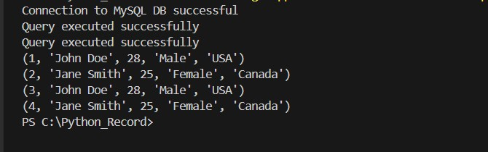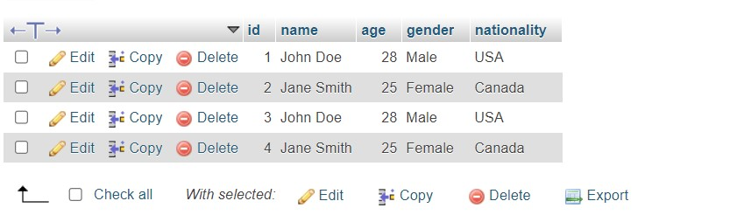

**DATA**

**ANALYTICS**

**USING PYTHON**

**Program #2.2**

**Date :24/06/24**

**Implementation of SqLite3 connection using Python**

**SOURCE CODE:**

import sqlite3

from sqlite3 import Error

# Function to create a connection to the SQLite database

def create_connection(db_file):

connection = None

try:

connection = sqlite3.connect(db_file)

print("Connection to SQLite DB successful")

except Error as e:

print(f"The error '{e}' occurred")

return connection

# Function to execute a single query (CREATE, UPDATE, DELETE)

def execute_query(connection, query, data=None):

cursor = connection.cursor()

try:

if data:

cursor.execute(query, data)

else:

cursor.execute(query)

connection.commit()

print("Query executed successfully")

except Error as e:

print(f"The error '{e}' occurred")

# Function to execute a read query (SELECT)

def execute_read_query(connection, query):

cursor = connection.cursor()

result = None

try:

cursor.execute(query)

result = cursor.fetchall()

return result

except Error as e:

print(f"The error '{e}' occurred")

# Step 2: Create Connection

connection = create_connection("test_database.sqlite")

# Step 3: Create a Table



**DATA**

**ANALYTICS**

**USING PYTHON**

create_table_query = """

CREATE TABLE IF NOT EXISTS users (

id INTEGER PRIMARY KEY AUTOINCREMENT,

name TEXT NOT NULL,

age INTEGER,

gender TEXT,

nationality TEXT

)

;

"""

execute_query(connection, create_table_query)

# Step 4: Insert Data (Create)

insert_user_query = """

INSERT INTO users (name, age, gender, nationality)

VALUES (?, ?, ?, ?)

"""

user_data = ("John Doe", 28, "Male", "USA")

execute_query(connection, insert_user_query, user_data)

# Step 5: Select Data (Read)

select_users_query = "SELECT * FROM users"

users = execute_read_query(connection, select_users_query)

print("Users in the database:")

for user in users:

print(user)

# Step 6: Update Data (Update)

update_user_query = """

UPDATE users

SET age = ?

WHERE name = ?

"""

updated_data = (35, "John Doe")

execute_query(connection, update_user_query, updated_data)

# Step 7: Delete Data (Delete)

delete_user_query = "DELETE FROM users WHERE name = ?"

delete_user_data = ("John Doe",)

execute_query(connection, delete_user_query, delete_user_data)

# Step 8: Confirm deletion

users = execute_read_query(connection, select_users_query)

print("Users after deletion:")

for user in users:

print(user)



**DATA**

**ANALYTICS**

**USING PYTHON**

**OUTPUT :**

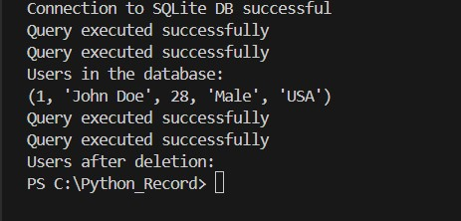

**DATA**

**ANALYTICS**

**USING PYTHON**

**Program #2.3**

**Date :24/06/24**

**Write a program to implement CRUD operations using Python**

**SOURCE CODE**

**:**

import sys

sys.path.append('C:

\

\

Users

\

\

vargh

\

\

AppData

\

\

Local

\

\

Packages

\

\

PythonSoftwareFoundation.Python

.3.12

_qbz5n2kfra8p

0

\

\

LocalCache

\

\

local

-

packages

\

\

python312

\

\

site

-

packages')

import mysql.connector

from mysql.connector import Error

# Function to create a MySQL connection

def create_connection(host_name, user_name, user_password, db_name):

connection = None

try:

connection = mysql.connector.connect(

host=host_name,

user=user_name,

passwd=user_password,

database=db_name

)

print("Connection to MySQL DB successful")

except Error as e:

print(f"The error '{e}' occurred")

return connection

# Function to execute a single query (CREATE, UPDATE, DELETE)

def

execute_query(connection, query, data=None):

cursor = connection.cursor()

try:

if data:

cursor.execute(query, data)

else:

cursor.execute(query)

connection.commit()

print("Query executed successfully")

except Error as e:

print(f"The error '{e}' occurred")

# Function to execute a read query (SELECT)

def execute_read_query(connection, query):

cursor = connection.cursor()

result = None

try:

cursor.execute(query)

result = cursor.fetchall()

return result



**DATA**

**ANALYTICS**

**USING PYTHON**

except Error as e:

print(f"The error '{e}' occurred")

# Establishing connection

connection = create_connection("localhost", "root", "", "CRUD")

# Step 1: Create Table

create_users_table = """

CREATE TABLE IF NOT EXISTS users (

id INT AUTO_INCREMENT PRIMARY KEY,

name VARCHAR(100) NOT NULL,

age INT,

gender VARCHAR(10),

nationality VARCHAR(50)

)

;

"""

execute_query(connection, create_users_table)

# Step 2: Create (Insert Data)

insert_user_query = """

INSERT INTO users (name, age, gender, nationality) VALUES (%s, %s, %s, %s)

"""

user_data = ("Alice", 30, "Female", "USA")

execute_query(connection, insert_user_query, user_data)

# Step 3: Read (Select Data)

select_users_query = "SELECT * FROM users"

users = execute_read_query(connection, select_users_query)

print("Users in the database:")

for user in users:

print(user)

# Step 4: Update (Modify Data)

update_user_query = """

UPDATE users

SET age = %s

WHERE name = %s

"""

updated_data = (35, "Alice")

execute_query(connection, update_user_query, updated_data)

# Step 5: Read again to confirm update

users =

execute_read_query(connection, select_users_query)

print("Users after update:")

for user in users:

print(user)

# Step 6: Delete (Remove Data)



**DATA**

**ANALYTICS**

**USING PYTHON**

delete_user_query = "DELETE FROM users WHERE name = %s"

delete_user_data = ("Alice",)

execute_query(connection, delete_user_query, delete_user_data)

# Step 7: Read again to confirm deletion

users = execute_read_query(connection, select_users_query)

print("Users after deletion:")

for user in users:

print(user)

**OUTPUT :**

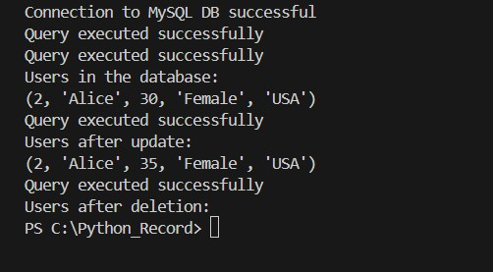

**DATA**

**ANALYTICS**

**USING PYTHON**

**Program #**

**3.1**

**Date :**

**26**

**/06/**

**24**

**Create a Login form using CGI and display the input on a different page.**

**SOURCE CODE**

**:**

Index.html

DOCTYPE html

>

<!

>

<

html lang="en"

<

head

>

<

meta charset="UTF

-

>

"

8

meta name="viewport" content="width=device

<

-

width, initial

-

scale=1.0">

<

title>Login</title

>

<

style

>

body{

display: flex;

flex

-

direction: column;

gap: 1rem;

align

-

items: center;

justify

-

content: center;

height: 88svh;

font

-

family: sans

-

serif;

}

form{

display: flex;

flex

-

direction: column;

gap: .725rem;

}

<

/style

>

>

/head

<

body

<

>

1>

h1>LOGIN</h

<

>

<

form action="dbHandler.py" method="get"

<

input type="text" id="username" name="username" placeholder="username"

>

<

input type="password" id="password" name="password" placeholder="password"

>

<

>

input type="submit" value="Submit"

>

/form

<

>

<

/body

<

>

/html

Dbhandler.py

#!C:

\

wamp64

\

www

\

python

-

cgi

\

venv

\

Scripts

\

python.exe

import cgi

import cgitb

import MySQLdb

cgitb.enable()

try:



**DATA**

**ANALYTICS**

**USING PYTHON**

myDb = MySQLdb.connect(host="localhost",user="root",password="",db="test")

myCursor = myDb.cursor()

form = cgi.FieldStorage()

username = form.getvalue('username')

password = form.getvalue('password')

sql = "INSERT INTO user (`username`, `password`) VALUES(%s,%s)"

myCursor.execute(sql,(username,password))

myDb.commit()

print("Content

-

type:text/html")

print()

print(f'''<!DOCTYPE html>

<

>

html lang='en'

>

head

<

<

meta charset='UTF

-

>

8

'

<

meta name='viewport' content='width=device

-

width, initial

-

scale=1.0'>

<

>

title>Welcome</title

<

/head

>

>

<

body

>

<

center

<

h1>Welcome, {username}!</h

1>

>

<

p>Your login was successful.</p

<

>

a href='index.html'>Back to Login</a

>

/center

<

<

/body

>

<

/html>'''

)

except Exception as e:

print(e)

finally:

myDb.close(

)



**DATA**

**ANALYTICS**

**USING PYTHON**

**OUTPUT :**

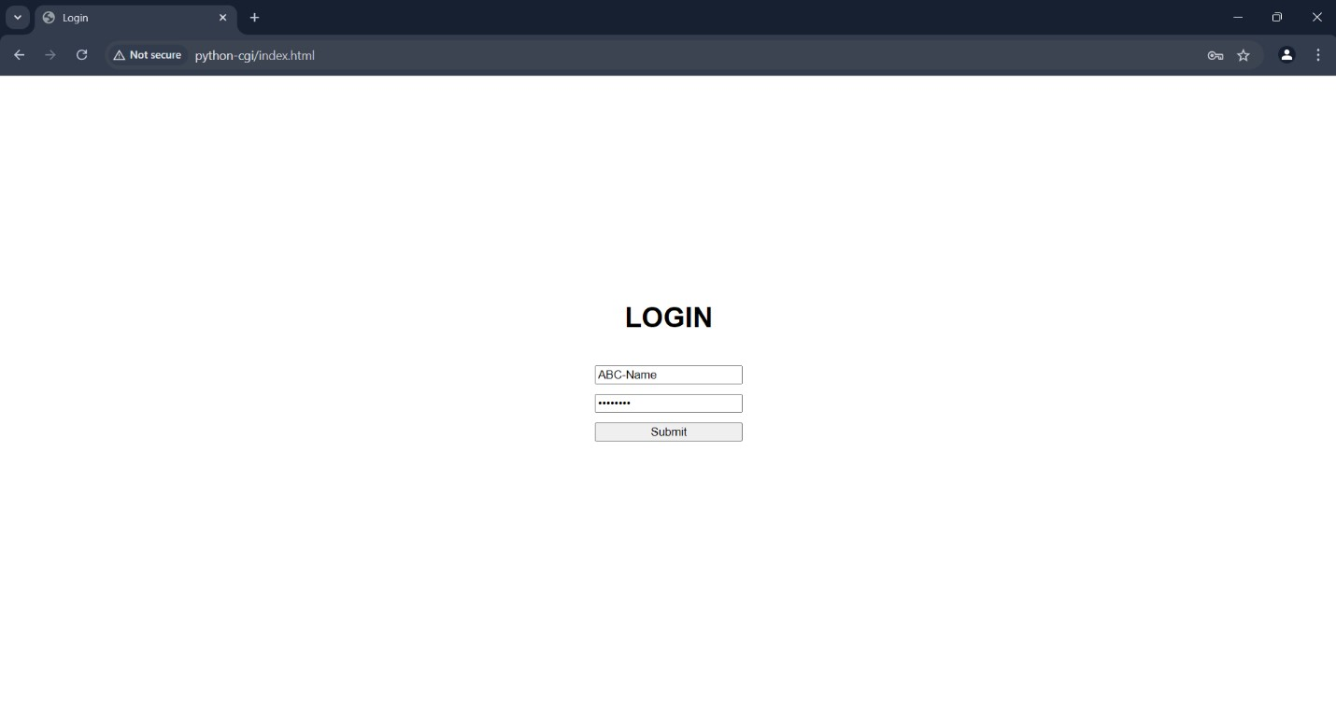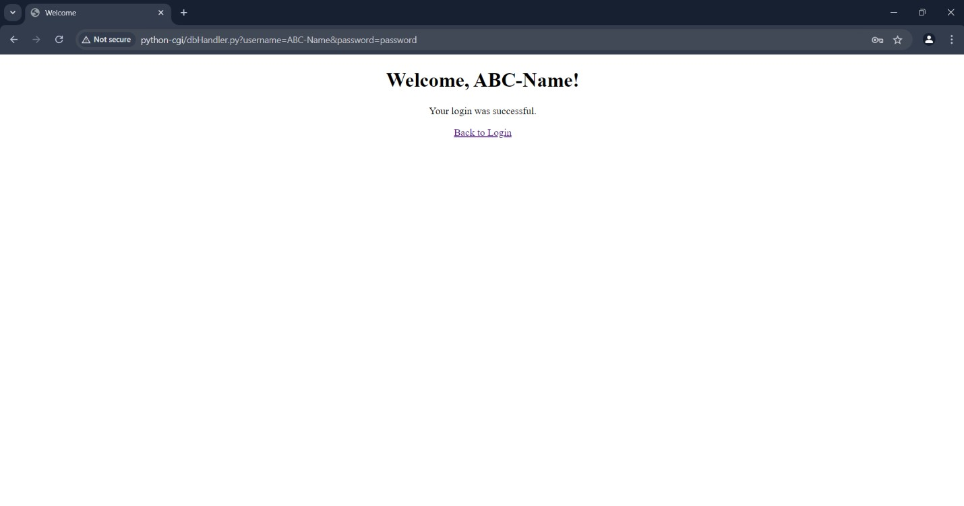

**DATA**

**ANALYTICS**

**USING PYTHON**

**Program #**

**3.2**

**Date :**

**26**

**/06/**

**24**

**Create a registration form for MCA admission and display the inserted data on the web page.**

**SOURCE CODE**

**:**

Index.html

>

DOCTYPE html

<!

<

html lang="en"

>

<

head

>

meta charset="UTF

<

-

>

"

8

meta name="viewport" content="width=device

<

-

width, initial

-

scale=1.0">

<

title>MCA | ADMISSION</title

>

<

style

>

body{

display: flex;

flex

-

direction: column;

gap: 1rem;

align

-

items: center;

justify

-

content: center;

height: 88svh;

font

-

family: sans

-

serif;

}

h1{

color: green;

}

form{

display: flex;

flex

-

direction: column;

gap: .725rem;

}

>

<

/style

<

/head

>

<

body

>

h1>REGISTER

<

-

MCA admission 2024</h1>

>

form action="mcaHandler.py" method="get"

<

>

input type="email" id="email" name="email" placeholder="email"

<

<

input type="text" id="username" name="username" placeholder="username"

>

<

input type="password" id="password" name="password" placeholder="password"

>

<

input type="submit" value="register"

>

<

/form

>

<

/body

>

<

/html

>

Db

-

handler.py



**DATA**

**ANALYTICS**

**USING PYTHON**

#!C:

\

wamp64

\

www

\

python

-

cgi

\

venv

\

Scripts

\

python.exe

import cgi

import cgitb

import MySQLdb

cgitb.enable()

try:

myDb = MySQLdb.connect(host="localhost",user="root",password="",db="test")

myCursor = myDb.cursor()

form = cgi.FieldStorage()

username = form.getvalue('username')

password = form.getvalue('password')

email = form.getvalue("email")

sql = "INSERT INTO user (`username`, `password`) VALUES(%s,%s)"

myCursor.execute(sql,(username,password))

myDb.commit()

print("Content

-

type:text/html")

print()

print(f'''<!DOCTYPE html>

<

html lang='en'

>

<

head

>

meta charset='UTF

<

-

8

'

>

<

meta name='viewport' content='width=device

-

width, initial

-

scale=1.0'>

<

title>Welcome</title

>

<

/head

>

>

body

<

>

center

<

1>

h1>Welcome, {username}!</h

<

<

p>Your Registration was successful! check verification sent on {email}</p

>

<

p style='color:blue;'>Continue With registration</p

>

<

/center

>

<

/body

>

<

/html>'''

)

except Exception as e:

print(e)

finally:

myDb.close()



**DATA**

**ANALYTICS**

**USING PYTHON**

**OUTPUT**

**:**

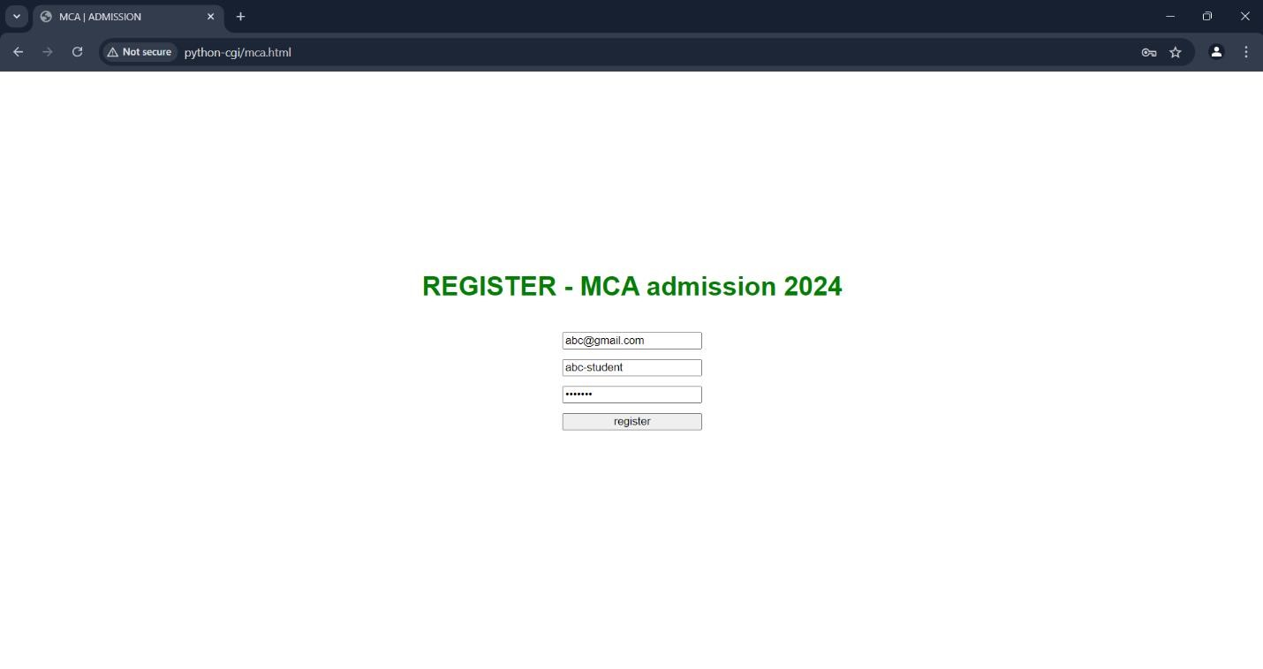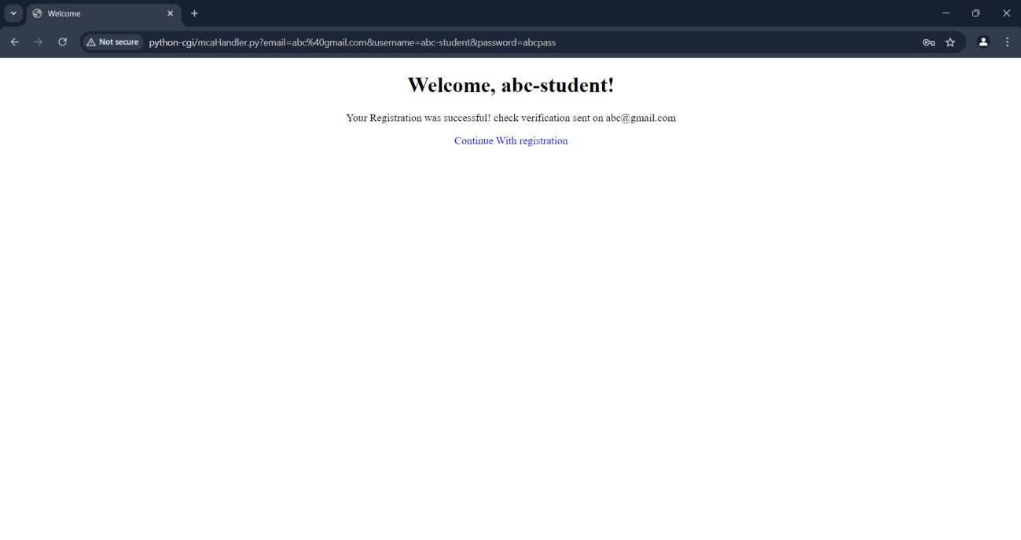

**DATA**

**ANALYTICS**

**USING PYTHON**

**Program #**

**3**

**.3**

**Date :**

**26**

**/06/**

**24**

**Create a MySQL database and perform INSERT, UPDATE, DESTROY, and SELECT (display) operations using**

**the CGI**

**interface.**

**SOURCE CODE**

**:**

Index.html

>

<!

DOCTYPE html

html lang="en"

<

>

<

head

>

<

meta charset="UTF

-

8

"

>

meta name="viewport" content="width=device

<

-

width, initial

-

scale=1.0">

>

title>CRUD Operations</title

<

<

>

style

body {

display: flex;

flex

-

direction: column;

gap: 1rem;

align

-

items: center;

justify

-

content: center;

height: 88svh;

font

-

family: sans

-

serif;

}

.content {

display: flex;

flex

-

wrap: wrap;

gap: 10rem;

align

-

items: center;

justify

-

content: center;

font

-

family: sans

-

serif;

}

form {

display: flex;

flex

-

direction: column;

gap: .725rem;

}

<

/style

>

<

/head

>

<

body

>

<

h1>CRUD OPERATIONS



**DATA**

**ANALYTICS**

**USING PYTHON**

<

hr

>

<

/h

1>

div class="content"

>

<

<

div

>

<

h2>Create</h

2>

form action="crud.py" method="post"

<

>

>

<

input type="text" name="username" placeholder="Username" required

<

input type="password" name="password" placeholder="Password" required

>

input type="submit" name="action" value="Create"

>

<

>

/form

<

>

/div

<

<

div

>

2>

<

h2>Read</h

<

form action="crud.py" method="post"

>

>

input type="text" name="username" placeholder="Username to display" required

<

>

input type="submit" name="action" value="Read"

<

<

>

/form

<

/div

>

<

div

>

2>

h2>Update</h

<

>

form action="crud.py" method="post"

<

<

input type="text" name="old_username" placeholder="Current Username" required

>

<

input type="text" name="new_username" placeholder="New Username" required

>

>

input type="password" name="new_password" placeholder="New Password" required

<

>

input type="submit" name="action" value="Update"

<

>

/form

<

<

/div

>

<

div

>

<

2>

h2>Delete</h

form action="crud.py" method="post"

<

>

<

input type="text" name="username" placeholder="Username to delete" required

>

>

input type="submit" name="action" value="Delete"

<

/form

>

<

<

/div

>

<

/div

>

<

div id="result"></div

>

<

/body

>

<

/html

>



**DATA**

**ANALYTICS**

**USING PYTHON**

Db

-

handler.py

#!C:

\

wamp64

\

www

\

python

-

cgi

\

venv

\

Scripts

\

python.exe

import cgi

import cgitb

import MySQLdb

cgitb.enable()

def connect_db():

return MySQLdb.connect(host="localhost", user="root", password="", db="test")

def create_user(cursor, username, password):

sql = "INSERT INTO user (`username`, `password`) VALUES (%s, %s)"

cursor.execute(sql, (username, password))

def read_user(cursor, username):

sql = "SELECT * FROM user WHERE username = %s"

cursor.execute(sql, (username,))

return cursor.fetchall()

def update_user(cursor, old_username, new_username, new_password):

sql = "UPDATE user SET username = %s, password = %s WHERE username = %s"

cursor.execute(sql, (new_username, new_password, old_username))

def delete_user(cursor, username):

sql = "DELETE FROM user WHERE username = %s"

cursor.execute(sql, (username,))

print("Content

-

type:text/html")

print()

try:

form = cgi.FieldStorage()

myDb = connect_db()

myCursor = myDb.cursor()

action = form.getvalue('action')

if action == 'Create':

username = form.getvalue('username')

password = form.getvalue('password')



**DATA**

**ANALYTICS**

**USING PYTHON**

create_user(myCursor, username, password)

myDb.commit()

print(f"<p>User {username} created successfully!</p>")

elif action == 'Read':

username = form.getvalue('username')

user_data = read_user(myCursor, username)

if user_data:

for row in user_data:

print(f"<p>Username: {row[0]}, Password: {row[1]}</p>")

else:

print("<p>No user found.</p>")

elif action == 'Update':

old_username = form.getvalue('old_username')

new_username = form.getvalue('new_username')

new_password = form.getvalue('new_password')

update_user(myCursor, old_username, new_username, new_password)

myDb.commit()

print(f"<p>User {old_username} updated successfully!</p>")

elif action == 'Delete':

username = form.getvalue('username')

delete_user(myCursor, username)

myDb.commit()

print(f"<p>User {username} deleted successfully!</p>")

except Exception as e:

print(f"<p>Error: {e}</p>")

finally:

myDb.close()



**DATA**

**ANALYTICS**

**USING PYTHON**

**OUTPUT**

**:**

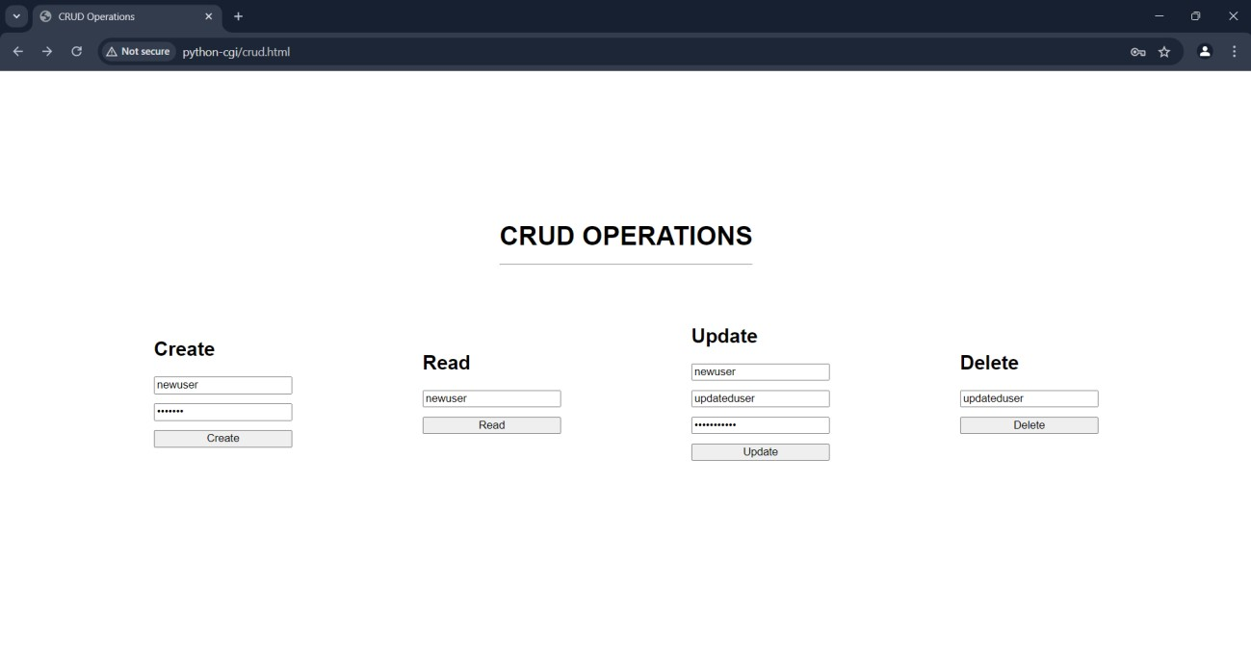

**DATA**

**ANALYTICS**

**USING PYTHON**

**Program #**

**4.1.1**

**Date :**

**/07/**

**24**

**22**

**Create a numpy array filled with all ones by defining its shape.**

**SOURCE CODE**

**:**

import numpy as np

shape=(3,3)

ones_array=np.ones(shape)

print(ones_array)

**OUTPUT**

**:**

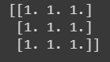

**DATA**

**ANALYTICS**

**USING PYTHON**

**Program #**

**4.1.2**

**Date :**

**24**

**/07/**

**22**

**How do you remove rows from a Numpy array that contains non**

**-**

**numeric values?**

**SOURCE CODE**

**:**

import numpy as np

arr=np.array([

[1

,2,3,4],

[

'a','b',4,7],

[11,12

,

13,14]

)

,dtype=object

]

def safe_convert(value):

try:

return float(value)

except ValueError:

return np.nan

arr_numeric

=

)

np.vectorize(safe_convert)(arr

filtered_arr=arr_numeric[~np.isnan(arr_numeric).any(axis=1)]

print("original array:",arr)

print("Filtered Array:",filtered_arr)

**OUTPUT**

**:**

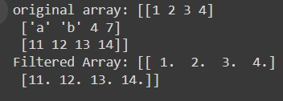

**DATA**

**ANALYTICS**

**USING PYTHON**

**Program #**

**4.1.3**

**Date :**

**22**

**/07/**

**24**

**Remove single**

**-**

**dimensional entries from the shape of an array**

**SOURCE CODE**

**:**

import numpy as np

# Example array with

single

-

dimensional entries

arr = np.array([[[1], [2], [3]]])

print("Original array shape:", arr.shape)

# Remove single

-

dimensional entries from the shape

squeezed_arr = np.squeeze(arr)

print("Squeezed array shape:", squeezed_arr.shape)

print("Squeezed array:

\

n", squeezed_arr)

**OUTPUT**

**:**

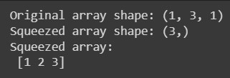

**DATA**

**ANALYTICS**

**USING PYTHON**

**Program #**

**4.1.4**

**Date :**

**22**

**/07/**

**24**

**How do you check whether specified values are present in the NumPy array?**

**SOURCE CODE**

**:**

import numpy as np

#

Create a NumPy array

arr = np.array([1, 2, 3, 4, 5, 6, 7, 8, 9])

# Values to check

values_to_check = [3, 5, 10]

# Check for presence of specified values

presence = np.isin(values_to_check, arr)

print("Values to check:", values_to_check)

print("Presence in the array:", presence)

**OUTPUT**

**:**

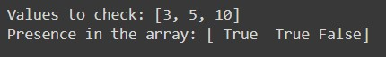

**DATA**

**ANALYTICS**

**USING PYTHON**

**Program #**

**4.1.5**

**Date :**

**24**

**/07/**

**22**

**Write a program to get all 2D diagonals of a 3D NumPy array?**

**SOURCE CODE**

**:**

import numpy as np

# Create a 3D NumPy

array

array_3d = np.array([

[[1

, 2, 3],

[4

, 5, 6],

[7

, 8, 9]],

[[10

, 11, 12],

, 14, 15],

[13

, 17, 18]],

[16

[[19

, 20, 21],

[22

, 23, 24],

[25

, 26,

27]]

])

# Function to get all 2D diagonals of a 3D NumPy

array

def get_2d_diagonals(arr):

diagonals = []

# Iterate over the first dimension of the 3D array

for i in range(arr.shape[0]):

# Get the diagonal of each 2D slice

diag = np.diagonal(arr[i], axis1=0, axis2=1)

diagonals.append(diag)

return diagonals

# Get all 2D diagonals

diagonals_2d = get_2d_diagonals(array_3d)

# Print the results

print("3D Array:

\

n", array_3d)

print("

\

n2D Diagonals:")

for index, diag in enumerate(diagonals_2d):

print(f"Diagonal from slice {index}:

\

n{diag}")



**DATA**

**ANALYTICS**

**USING PYTHON**

**OUTPUT**

**:**

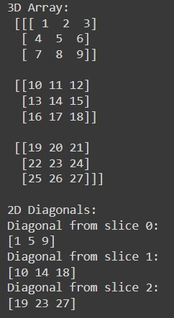

**DATA**

**ANALYTICS**

**USING PYTHON**

**Program #**

**4.1.6**

**Date :**

**22**

**/07/**

**24**

**Write a NumPy program to sort a given array of shape 2 along the first axis, last axis, and flattened**

**array.**

**SOURCE CODE**

**:**

import numpy as np

# Create a sample array of shape (2, 3)

array = np.array([[3, 1, 2],

5]])

[6

, 4,

print("Original array:

\

n", array)

# Sort along the first axis (axis=0)

sorted_first_axis = np.sort(array, axis=0)

print("

\

nSorted along the first axis (axis=0):

\

n", sorted_first_axis)

# Sort along the last axis (axis=1)

sorted_last_axis = np.sort(array, axis=1)

print("

\

nSorted along the last axis (axis=1):

\

n", sorted_last_axis)

# Flatten the array and sort

flattened_sorted = np.sort(array.flatten())

print("

\

nSorted flattened array:

\

n", flattened_sorted)

**OUTPUT**

**:**

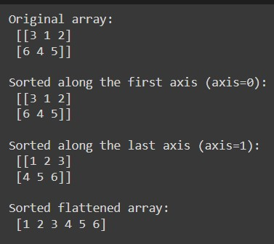

**DATA**

**ANALYTICS**

**USING PYTHON**

**Program #**

**4.1.7**

**Date :**

**24**

**/07/**

**22**

**Write a NumPy program to create a structured array from a given student name, height, class, and**

**data type. Now sort by**

**class, then height if the classes are equal.**

**SOURCE CODE**

**:**

import numpy as np

# Define the data type for the structured array

dtype = [('name', 'U20'), ('height', 'f4'), ('class', 'i4')]

# Create a structured array with student data

student_data = np.array([

(

'Alice', 5.5, 2),

'Bob', 6.0, 1),

(

'Charlie', 5.7, 2),

(

'David', 5.9, 1),

(

'Eve', 5.4,

2)

(

)

, dtype=dtype

]

print("Original structured array:

\

n", student_data)

# Sort the structured array by 'class' and then by 'height'

sorted_students = np.sort(student_data, order=['class', 'height'])

print("

\

nSorted structured array:

\

n", sorted_students)

**OUTPUT**

**:**

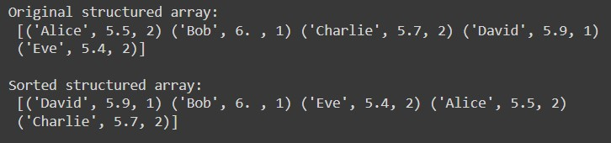

**DATA**

**ANALYTICS**

**USING PYTHON**

**Program #**

**4.1.8**

**Date :**

**22**

**/07/**

**24**

**Write a NumPy program to sort a given complex array using the real part first, then the imaginary**

**part.**

**SOURCE CODE**

**:**

import numpy as np

# Create a complex NumPy array

complex_array = np.array([3 + 2j, 1 + 4j, 2 + 3j, 1 + 2j, 2 + 1j])

print("Original complex array:

\

n", complex_array)

# Sort by real part, then by imaginary part

sorted_indices =

np.lexsort((complex_array.imag, complex_array.real))

sorted_complex_array = complex_array[sorted_indices]

print("

\

nSorted complex array:

\

n", sorted_complex_array)

**OUTPUT**

**:**

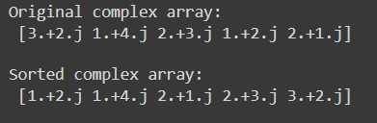

**DATA**

**ANALYTICS**

**USING PYTHON**

**Program #**

**4.1.9**

**Date :**

**/07/**

**24**

**24**

**Write a NumPy program to sort a given array by the nth column.**

**SOURCE CODE**

**:**

import numpy as np

# Create a sample 2D

NumPy array

array = np.array([[3, 1, 2],

[6

, 4, 5],

, 7, 8],

[1

3]])

, 0,

[9

print("Original array:

\

n", array)

# Specify the column index to sort by (0

-

indexed)

n = 1 # Sort by the second column

# Sort the array by the nth column

sorted_array = array[array[:, n].argsort()]

print(f"

\

nArray sorted by column {n}:

\

n", sorted_array)

**OUTPUT**

**:**

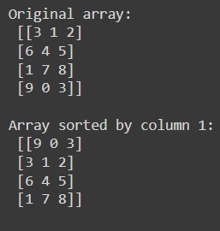

**DATA**

**ANALYTICS**

**USING PYTHON**

**Program #**

**4.1.10**

**Date :**

**24**

**/07/**

**24**

**Calculate the sum of the diagonal elements of a NumPy array**

**SOURCE CODE**

**:**

import numpy as np

# Create a sample 2D

NumPy array

array = np.array([[1, 2, 3],

, 5, 6],

[4

9]])

, 8,

[7

print("Original array:

\

n", array)

# Calculate the sum of the diagonal elements

diagonal_sum = np.sum(np.diagonal(array))

print("Sum of diagonal

elements:", diagonal_sum)

**OUTPUT**

**:**

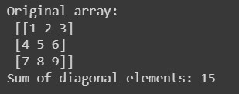

**DATA**

**ANALYTICS**

**USING PYTHON**

**Program #**

**4.1.11**

**Date :**

**24**

**24**

**/07/**

**Write a program for Matrix Multiplication in NumPy**

**SOURCE CODE**

**:**

import numpy as np

# Create two sample matrices

matrix_a = np.array([[1, 2, 3],

[4

, 5,

6]])

matrix_b = np.array([[7, 8],

, 10],

[9

12]])

,

[11

print("Matrix A:

\

n", matrix_a)

print("

\

nMatrix B:

\

n", matrix_b)

# Method 1: Using numpy.dot()

result_dot = np.dot(matrix_a, matrix_b)

print("

\

nMatrix Multiplication using np.dot():

\

n", result_dot)

# Method 2: Using the @ operator

result_at = matrix_a @ matrix_b

print("

\

nMatrix Multiplication using @ operator:

\

n", result_at)

**OUTPUT**

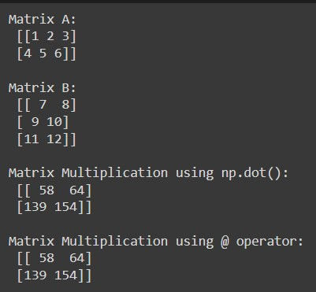

**DATA**

**ANALYTICS**

**USING PYTHON**

**Program #**

**4.1.12**

**Date :**

**/07/**

**24**

**24**

**Multiply matrices of complex numbers using NumPy in Python**

**.**

**SOURCE CODE**

**:**

import numpy as np

#

Create two sample matrices with complex numbers

matrix_a = np.array([[1 + 2j, 2 + 3j],

[3

+ 4j, 4 +

5j]])

matrix_b = np.array([[5 + 6j, 6 + 7j],

9j]])

+ 8j, 8 +

[7

print("Matrix A:

\

n", matrix_a)

print("

\

nMatrix B:

\

n", matrix_b)

# Perform matrix multiplication

result = np.dot(matrix_a, matrix_b)

# Alternatively, you can use the @ operator

# result = matrix_a @ matrix_b

print("

\

nMatrix Multiplication Result:

\

n", result)

**OUTPUT**

**:**

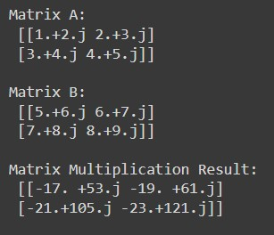

**DATA**

**ANALYTICS**

**USING PYTHON**

**Program #**

**4.1.13**

**Date :**

**24**

**/07/**

**24**

**Calculate the inner, outer, and cross products of matrices and vectors using NumPy.**

**SOURCE CODE**

**:**

import numpy as n

p

# Define two vectors

vector_a = np.array([1, 2, 3])

vector_b = np.array([4, 5, 6])

# Calculate the inner product

inner_product = np.inner(vector_a, vector_b)

print("Inner Product of vector_a and vector_b:", inner_product)

# Calculate the

outer product

outer_product = np.outer(vector_a, vector_b)

print("

\

nOuter Product of vector_a and vector_b:

\

n", outer_product)

# Calculate the cross pr

o

duct

cross_product = np.cross(vector_a, vector_b)

print("

\

nCross Product of vector_a and vector_b:", cross_product)

# Define two matrices

matrix_a = np.array([[1, 2],

,

4]])

[3

matrix_b = np.array([[5, 6],

8]])

,

[7

# Calculate the inner product of matrices (dot product)

matrix_inner_product = np.dot(matrix_a, matrix_b)

print("

\

nInner Product (Dot Product) of matrix_a and matrix_b:

\

n", matrix_inner_product)

# Calculate the outer product of the first column of matrix_a and the first column of matrix_b

outer_product_matrix = np.outer(matrix_a[:, 0], matrix_b[:, 0])

print("

\

nOuter Product of the first columns of matrix_a and matrix_b:

\

n", outer_product_matrix)



**DATA**

**ANALYTICS**

**USING PYTHON**

**OUTPUT**

**:**

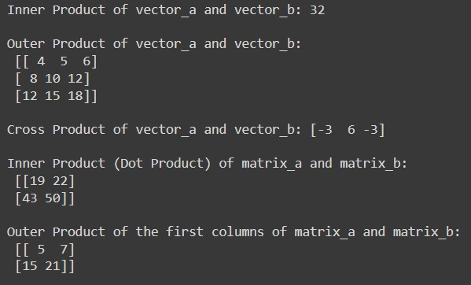

**DATA**

**ANALYTICS**

**USING PYTHON**

**Program #**

**4.1.14**

**Date :**

**24**

**/07/**

**24**

**Compute the covariance matrix of two given NumPy arrays.**

**SOURCE CODE**

**:**

import numpy as np

# Define two sample NumPy

arrays (samples of two variables)

data1 = np.array([1, 2, 3, 4, 5])

data2 = np.array([5, 4, 3, 2, 1])

# Stack the arrays vertically to create a 2D array

data = np.vstack((data1, data2))

# Compute the covariance matrix

covariance_matrix = np.cov(data)

print("Data 1:

\

n", data1)

print("Data 2:

\

n", data2)

print("

\

nCovariance Matrix:

\

n", covariance_matrix)

**OUTPUT**

**:**

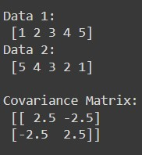

**DATA**

**ANALYTICS**

**USING PYTHON**

**Program #**

**4.1.15**

**Date :**

**24**

**/07/**

**24**

**Convert covariance matrix to correlation matrix using Python**

**.**

**SOURCE CODE**

**:**

import numpy as np

# Define a sample

covariance matrix

covariance_matrix = np.array([[4, 2],

[2

3]])

,

print("Covariance Matrix:

\

n", covariance_matrix)

# Calculate the standard deviations for each variable

std_devs = np.sqrt(np.diagonal(covariance_matrix))

# Create a correlation matrix

correlation_matrix = covariance_matrix / std_devs[:, None] / std_devs[None, :]

print("

\

nCorrelation Matrix:

\

n", correlation_matrix)

**OUTPUT**

**:**

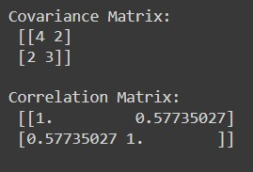

**DATA**

**ANALYTICS**

**USING PYTHON**

**Program #**

**4.1.16**

**Date :**

**24**

**/07/**

**24**

**Write a NumPy program to compute the histogram of nums against the bins.**

**SOURCE CODE**

import numpy as np

import

matplotlib.pyplot as plt

# Define a sample array of numbers (nums)

nums = np.array([1, 2, 1, 3, 4, 5, 6, 5, 4, 3, 2, 1])

# Define the bins

bins = np.array([0, 1, 2, 3, 4, 5, 6, 7])

# Compute the histogram

histogram, bin_edges = np.histogram(nums, bins)

print("Histogram:", histogram)

print("Bin edges:", bin_edges)

# Plotting the histogram

plt.hist(nums, bins=bins, edgecolor='black', alpha=0.7)

plt.title("Histogram of nums")

plt.xlabel("Value")

plt.ylabel("Frequency")

plt.xticks(bin_edges)

plt.show()

**OUTPUT**

**:**

Histogram: [0 3 2 2 2 2 1]

Bin edges: [0 1 2 3 4 5 6 7]

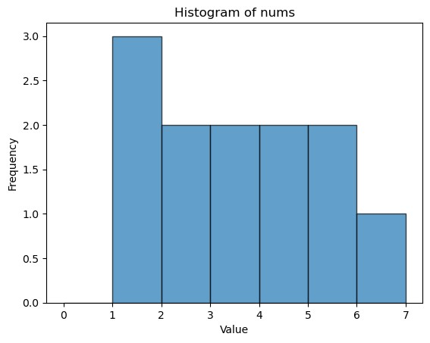

**DATA**

**ANALYTICS**

**USING PYTHON**

**Program #**

**4.1.17**

**Date :**

**24**

**/07/**

**24**

**Write a NumPy program to compute the cross**

**-**

**correlation of two given arrays**

**.**

**SOURCE CODE**

**:**

import numpy as np

import matplotlib.pyplot as plt

# Define two sample arrays

array_x = np.array([1, 2, 3, 4, 5])

array_y = np.array([5, 4, 3, 2, 1])

#

Compute the cross

-

correlation

cross_correlation = np.correlate(array_x, array_y, mode='full')

print("Array X:", array_x)

print("Array Y:", array_y)

print("

\

nCross

-

Correlation:", cross_correlation)

# Plotting the cross

-

correlation

plt.stem(cross_correlation)

plt.title("Cross

-

Correlation")

plt.xlabel("Lag")

plt.ylabel("Cross

-

Correlation Value")

plt.grid()

plt.show()

**OUTPUT**

**:**

Array X: [1 2 3 4 5]

Array Y: [5 4 3 2 1]

Cross

-

Correlation: [ 1 4 10 20 35 44 46 40 25]

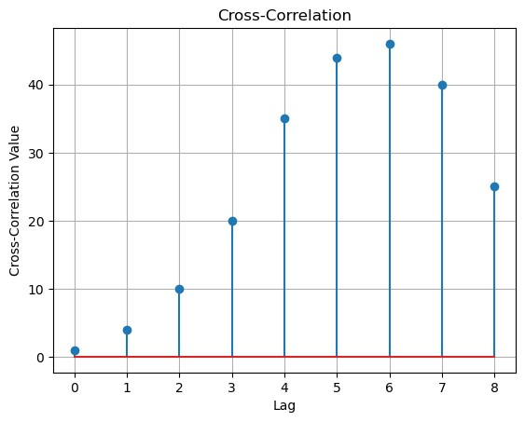

**DATA**

**ANALYTICS**

**USING PYTHON**

**Program #**

**4.1.18**

**Date :**

**24**

**24**

**/07/**

**Write a NumPy program to compute the mean, standard deviation, and variance of a given array**

**along the second axis.**

**SOURCE CODE**

**:**

import numpy as np

# Define a sample 2D array

array = np.array([[1, 2, 3],

[4

, 5, 6],

[7

9]])

, 8,

print("Original Array:

\

n", array)

# Compute the mean along the second axis (axis 1)

mean = np.mean(array, axis=1)

print("

\

nMean along the second axis:", mean)

# Compute the standard deviation along the second axis (axis 1)

std_deviation = np.std(array, axis=1)

print("Standard Deviation along the second axis:", std_deviation)

# Compute the variance along the

second axis (axis 1)

variance = np.var(array, axis=1)

print("Variance along the second axis:", variance)

**OUTPUT**

**:**

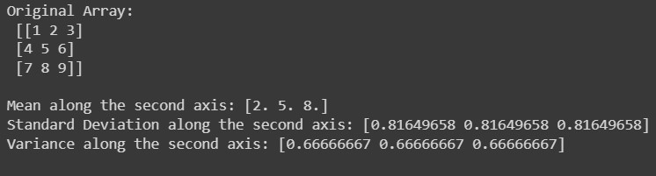

**DATA**

**ANALYTICS**

**USING PYTHON**

**Program #**

**4.1.19**

**Date :**

**24**

**/07/**

**24**

**Write a NumPy program to compute the 80th percentile for all elements in a given array along the**

**second axis.**

**SOURCE CODE**

**:**

import numpy as np

# Define a sample 2D array

array = np.array([[1, 2, 3],

[4

, 5, 6],

9]])

, 8,

[7

print("Original Array:

\

n", array)

# Compute the 80th percentile along the second axis (axis 1)

percentile_80 = np.percentile(array, 80, axis=1)

print("

\

n80th Percentile along the second axis:", percentile_80)

**OUTPUT**

**:**

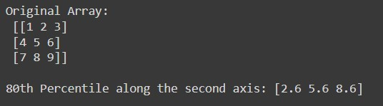

**DATA**

**ANALYTICS**

**USING PYTHON**

**Program #**

**4.2.1**

**Date :**

**29**

**/07/24**

**Write a Pandas program to add, subtract, multiply, and divide two Pandas Series.**

**SOURCE CODE**

**:**

import pandas as pd

series1 = pd.Series([10, 20, 30, 40, 50])

series2 = pd.Series([5, 10, 15, 20, 25])

addition = series1 + series2

print("Addition of two Series:")

print(addition)

subtraction = series1

-

series2

print("

\

nSubtraction of two Series:")

print(subtraction)

multiplication = series1 * series2

print("

\

nMultiplication of two Series:")

print(multiplication)

division = series1 / series2

print("

\

nDivision of two Series:")

print(division)

**OUTPUT**

**:**

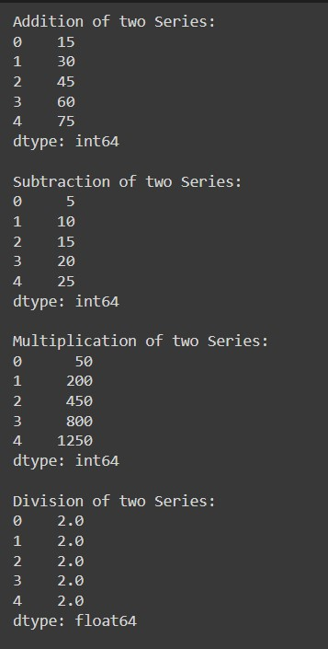

**DATA**

**ANALYTICS**

**USING PYTHON**

**Program #**

**4.2.2**

**Date :**

**29**

**/07/24**

**Write a Pandas program to convert a dictionary to a Pandas series.**

**SOURCE CODE**

**:**

import pandas as pd

my_dict={'a':10,'b':12,'c':30}

print("Dictionary:",my_dict)

my_series=pd.Series(my_dict)

print("Series:",my_series)

**OUTPUT**

**:**

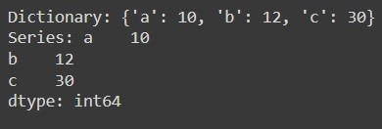

**DATA**

**ANALYTICS**

**USING PYTHON**

**Program #**

**4.2.3**

**Date :**

**29**

**/07/24**

**Write a Pandas program to convert the first column of a data frame into a Series**

**.**

**SOURCE CODE**

**:**

import pandas as pd

#

Sample DataFrame

my_data = {'Column1': [10, 20, 30, 40], 'Column2': [100, 200, 300, 400]}

df = pd.DataFrame(my_data)

# Convert the first column into a Series

series = df.iloc[:, 0]

# Display the Series

print(series)

**OUTPUT**

**:**

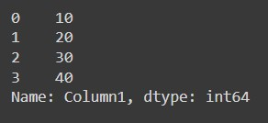

**DATA**

**ANALYTICS**

**USING PYTHON**

**Program #**

**4.2.4**

**Date :**

**29**

**/07/24**

**Write a Pandas program to convert a Series of lists into one Series.**

**SOURCE CODE**

**:**

import pandas as pd

#

Sample Series of lists

series_of_lists = pd.Series([[1, 2, 3], [4, 5], [6, 7, 8]])

# Convert Series of lists into one Series

flattened_series = series_of_lists.explode().reset_index(drop=True)

# Display the result

print(flattened_series)

**OUTPUT**

**:**

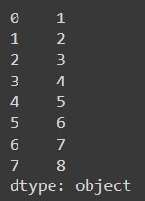

**DATA**

**ANALYTICS**

**USING PYTHON**

**Program #**

**4.2.5**

**Date :**

**29**

**/07/24**

**Write a Pandas program to create a subset of a given series based on value and condition.**

**SOURCE CODE**

**:**

import pandas as pd

data=pd.Series([1,2,3,4,5,6,7,8])

subset=data[data>5]

print(subset)

**OUTPUT**

**:**

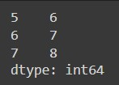

**DATA**

**ANALYTICS**

**USING PYTHON**

**Program #**

**4.2.6**

**Date :**

**29**

**/07/24**

**Write a Pandas program to get the items that are not common in two given series.**

**SOURCE CODE**

**:**

import pandas as pd

#

Sample Series

series1 = pd.Series([1, 2, 3, 4, 5])

series2 = pd.Series([4, 5, 6, 7, 8])

# Get items that are not common in both series

uncommon_items = pd.concat([series1[~series1.isin(series2)], series2[~series2.isin(series1)]])

# Display the result

print(uncommon_items)

**OUTPUT**

**:**

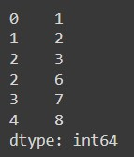

**DATA**

**ANALYTICS**

**USING PYTHON**

**Program #**

**4.2.7**

**Date :**

**29**

**/07/24**

**Write a Pandas program to calculate the frequency counts of each unique value of a given series**

**.**

**SOURCE CODE**

**:**

import pandas as pd

# Sample Series

data = pd.Series([1, 2, 2, 3, 4, 4, 4, 5, 5])

# Calculate frequency counts of each unique value

frequency_counts = data.value_counts()

# Display the result

print(frequency_counts)

**OUTPUT**

**:**

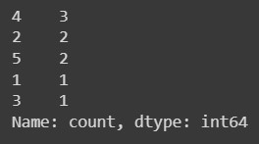

**DATA**

**ANALYTICS**

**USING PYTHON**

**Program #**

**4.2.8**

**Date :**

**29**

**/07/24**

**Write a Pandas program to filter words from a given series that contain at least two vowels.**

**SOURCE**

**CODE**

**:**

import pandas as pd

# Sample Series

data = pd.Series(['apple', 'banana', 'grape', 'kiwi', 'pear', 'mango'])

# Function to count vowels in a word

def count_vowels(word):

vowels = set('aeiouAEIOU')

return sum(1 for char in word if char in vowels)

# Filter words with at least two vowels

filtered_words = data[data.apply(lambda word: count_vowels(word) >= 2)]

# Display the result

print(filtered_words)

**OUTPUT**

**:**

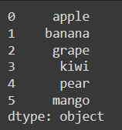

**DATA**

**ANALYTICS**

**USING PYTHON**

**Program #**

**4.2.9**

**Date :**

**29**

**/07/24**

**Write a Pandas program to find the index of the first occurrence of the smallest and largest values**

**of a given series.**

**SOURCE CODE**

**:**

import pandas as pd

data=pd.Series([2,67,100,0,3,7,8])

min_index=data.idxmin()

max_index=data.idxmax()

print("index of minimum value",min_index)

print("index of max value",max_index)

**OUTPUT**

**:**

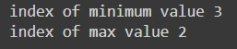

**DATA**

**ANALYTICS**

**USING PYTHON**

**Program #**

**4.2.10**

**Date :**

**29**

**/07/24**

**Write a Pandas program to get the first 3 rows of a given data frame.**

**SOURCE CODE**

**:**

import pandas as pd

# Sample data

for the DataFrame

data = {

'Name': ['Alice', 'Bob', 'Charlie', 'David', 'Eva'],

'Age': [25, 30, 35, 40, 28],

'City': ['New York', 'Los Angeles', 'Chicago', 'Houston', 'Phoenix']

}

# Creating a DataFrame

df = pd.DataFrame(data)

# Displaying the first 3 rows

first_three_rows = df.head(3)

print(first_three_rows)

**OUTPUT**

**:**

Name

Age City

Alice

0

25

New York

Bob

1

30

Los Angeles

2

Charlie 35

Chicago



**DATA**

**ANALYTICS**

**USING PYTHON**

**Program #**

**4.2.11**

**Date :**

**31**

**/07/**

**24**

**Write a Pandas program to select the 'name' and 'score' columns from a data frame.**

**SOURCE CODE**

**:**

import pandas as pd

data={'name':['varghese','kuku','aami'],

'rollno':[12,45,19],

'age':[21,22,23]}

df=pd.DataFrame(data)

selected_columns=df[['name','age']]

print(selected_columns)

**OUTPUT**

**:**

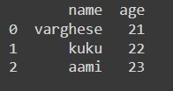

**DATA**

**ANALYTICS**

**USING PYTHON**

**Program #**

**4.2.12**

**Date :**

**31**

**/07/**

**24**

**Write a Pandas program to count the number of rows and columns in a data frame.**

**SOURCE CODE**

**:**

import pandas as pd

data={'name':['varghese','kuku','aami'],

'rollno':[34,78,12],

'age':[14,34,23]}

df=pd.DataFrame(data)

num_rows=df.shape[0]

num_cols=df.shape[1]

print("no of rows:",num_rows)

print("no of columns",num_cols)

**OUTPUT**

**:**

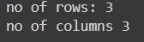

**DATA**

**ANALYTICS**

**USING PYTHON**

**Program #**

**4.2.13**

**Date :**

**31**

**/07/**

**24**

**Write a Pandas program to add one row to an existing data frame**

**.**

**SOURCE CODE**

**:**

import pandas as pd

data={'name':['varghese','kuku','aami'],

'rollno':[23,12,45],

'age':[22,21,20]}

df=pd.DataFrame(data)

print("original data frame",df)

new_row={'name':'roy','rollno':62,'age':24}

df = pd.concat([df,

pd.DataFrame([new_row])], ignore_index=True)

print("DataFtame after adding new row:",df)

**OUTPUT**

**:**

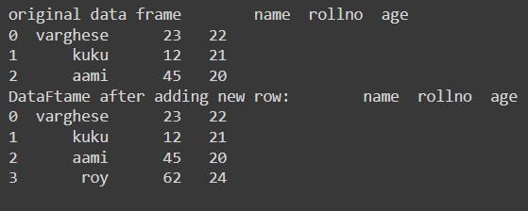

**DATA**

**ANALYTICS**

**USING PYTHON**

**Program #**

**4.2.14**

**Date :**

**31**

**/07/**

**24**

**Write a Pandas program to write a data frame to a CSV file using a tab separator.**

**SOURCE CODE**

**:**

import pandas as pd

# Creating a sample DataFrame

data = {'name': ['varghese', 'kuku', 'aami'],

'rollno': [23, 12, 45],

'age': [22, 21, 20]}

df = pd.DataFrame(data)

# Writing the DataFrame to a CSV file using a tab separator

df.to_csv('output_file.csv', sep='

\

t', index=False)

print("DataFrame has been written to 'output_file.csv' using a tab separator.")

**OUTPUT**

**:**



**DATA**

**ANALYTICS**

**USING PYTHON**

**Program #**

**4.2.15**

**Date :**

**24**

**/07/**

**31**

**Write a Pandas program to replace all the NaN values with Zeros in a column of a data frame. Write**

**a Pandas program to drop a list of rows from a specified data frame.**

**SOURCE CODE**

**:**

import pandas as pd

import numpy as np

# Creating a sample DataFrame with NaN values

data = {'name': ['John', 'Emily', 'Michael', 'Sara', 'David'],

'score': [85, np.nan, 78, np.nan, 95],

'age': [20, 21, 19, 22, 20]}

df = pd.DataFrame(data)

# Display original DataFrame

print("Original DataFrame with NaN values:")

print(df)

# Replacing NaN values with zeros in the 'score' column without using inplace

df['score'] = df['score'].fillna(0)

# Display DataFrame after replacing NaN values

print("

\

nDataFrame after replacing NaN values with zeros in 'score' column:")

print(df)

# Dropping rows with index 1 (Emily) and 3 (Sara)

rows_to_drop = [1, 3]

df = df.drop(rows_to_drop)

# Display DataFrame after dropping the specified rows

print("

\

nDataFrame after dropping rows with index 1 and 3:")

print(df)



**DATA**

**ANALYTICS**

**USING PYTHON**

**OUTPUT**

**:**

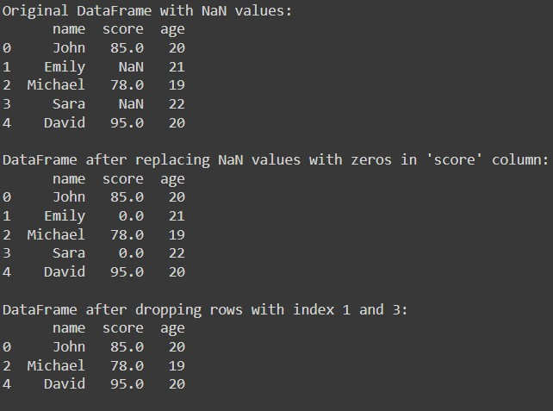

**DATA**

**ANALYTICS**

**USING PYTHON**

**Program #**

**4.2.16**

**Date :**

**31**

**/07/**

**24**

**Write a Pandas program to shuffle a given data frame row.**

**SOURCE CODE**

**:**

import pandas as pd

# Creating a sample DataFrame

data = {

'name': ['John', 'Emily', 'Michael', 'Sara', 'David'],

'score': [85, 92, 78, 88, 95],

'age': [20, 21, 19, 22, 20]

}

df = pd.DataFrame(data)

# Display original DataFrame

print("Original DataFrame:")

print(df)

# Shuffling the

DataFrame rows

shuffled_df = df.sample(frac=1).reset_index(drop=True)

# Display shuffled DataFrame

print("

\

nShuffled DataFrame:")

print(shuffled_df)

**OUTPUT**

**:**

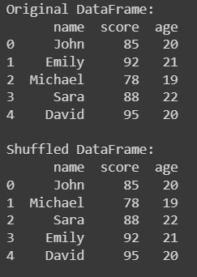

**DATA**

**ANALYTICS**

**USING PYTHON**

**Program #**

**4.2.17**

**Date :**

**31**

**/07/**

**24**

**Write a Pandas program to find the row where the value of a given column is maximum.**

**SOURCE CODE**

**:**

import pandas as pd

#

Creating a sample DataFrame

data = {

'name': ['John', 'Emily', 'Michael', 'Sara', 'David'],

'score': [85, 92, 78, 88, 95],

'age': [20, 21, 19, 22, 20]

}

df = pd.DataFrame(data)

# Display original DataFrame

print("Original

DataFrame:")

print(df)

# Finding the row where the value of the 'score' column is maximum

max_score_index = df['score'].idxmax()

max_score_row = df.loc[max_score_index]

# Display the row with the maximum score

print("

\

nRow where the value of 'score' is maximum:")

print(max_score_row)

**OUTPUT**

**:**

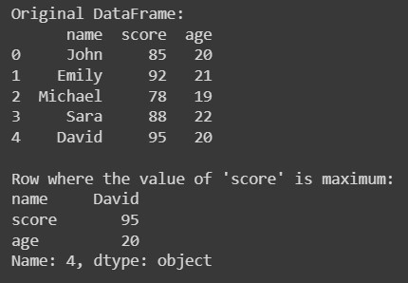

**DATA**

**ANALYTICS**

**USING PYTHON**

**Program #**

**4.2.18**

**Date :**

**/07/**

**24**

**31**

**Write a Pandas program to check whether a given column is present in a data frame or not.**

**SOURCE CODE**

**:**

import pandas as pd

# Creating a sample DataFrame

data = {

'name': ['John', 'Emily', 'Michael', 'Sara', 'David'],

'score': [85, 92, 78, 88, 95],

'age': [20, 21, 19, 22, 20]

}

df = pd.DataFrame(data)

# Display original DataFrame

print("Original

DataFrame:")

print(df)

# Column to check

column_to_check = 'score'

# Checking if the column is present in the DataFrame

if column_to_check in df.columns:

print(f"

\

nThe column '{column_to_check}' is present in the DataFrame.")

else:

print(f"

\

nThe column '{column_to_check}' is not present in the DataFrame.")

**OUTPUT**

**:**

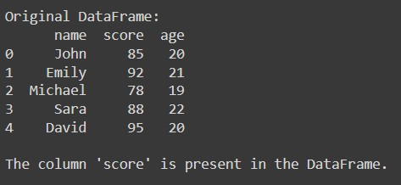

**DATA**

**ANALYTICS**

**USING PYTHON**

**Program #**

**4.2.19**

**Date :**

**/07/**

**31**

**24**

**Write a Pandas program to append data to an empty data frame.**

**SOURCE CODE**

**:**

import pandas as pd

# Creating an empty

DataFrame

df = pd.DataFrame(columns=['name', 'score', 'age'])

# Display the empty DataFrame

print("Empty DataFrame:")

print(df)

# Data to append

data_to_append = [

'name': 'John', 'score': 85, 'age': 20},

{

'name': 'Emily', 'score': 92, 'age': 21},

{

'name': 'Michael', 'score': 78, 'age': 19},

{

{

'name': 'Sara', 'score': 88, 'age': 22},

{

'name': 'David', 'score': 95, 'age'

: 20}

]

# Creating a DataFrame from the data to append

data_df = pd.DataFrame(data_to_append)

# Appending data to the DataFrame using pd.concat

df = pd.concat([df, data_df], ignore_index=True)

# Display the DataFrame after appending data

print("

\

nDataFrame after appending data:")

print(df)

**OUTPUT**

**:**

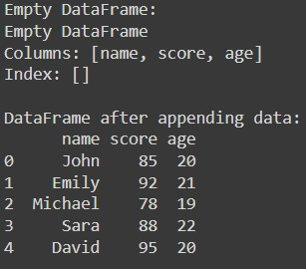

**DATA**

**ANALYTICS**

**USING PYTHON**

**Program #**

**4.2.20**

**Date :**

**31**

**/07/**

**24**

**Write a Pandas program to convert continuous values of a column in a given data frame to**

**categorical. Input: { 'Name': ['Alberto Franco','Gino Mcneill','Ryan Parkes', 'Eesha Hinton', 'Syed**

**Wharton'], 'Age': [18, 22, 40, 50, 80, 5] }**

**SOURCE CODE**

**:**

import pandas as pd

# Creating a sample DataFrame

data = {

'Name': ['Alberto Franco', 'Gino Mcneill', 'Ryan Parkes', 'Eesha Hinton', 'Syed Wharton'],

'Age': [18, 22, 40, 50, 80]

}

df = pd.DataFrame(data)

# Display the original DataFrame

print("Original DataFrame:")

print(df)

# Define bins and labels for the age categories

bins = [0, 18, 35, 50, 80] # Define the edges of

the bins

labels = ['Child', 'Young Adult', 'Adult', 'Senior'] # Define the labels for each bin

# Convert the 'Age' column to categorical using pd.cut

df['Age Category'] = pd.cut(df['Age'], bins=bins, labels=labels, right=False)

# Display the DataFrame with the new categorical column

print("

\

nDataFrame with Age Categories:")

print(df)

**OUTPUT**

**:**

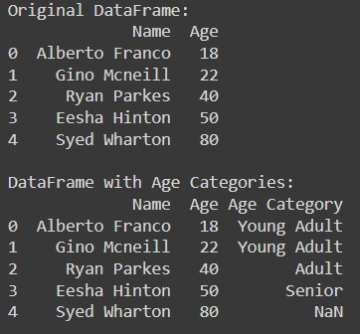

**DATA**

**ANALYTICS**

**USING PYTHON**

**Program #**

**4.2.21**

**Date :**

**24**

**/07/**

**31**

**Write a Pandas program to create data frames that contain random values, missing values,**

**datetime values, and mixed values.**

**SOURCE CODE**

**:**

import pandas as pd

import numpy as np

import random

from datetime import datetime, timedelta

# Set a seed for reproducibility

np.random.seed(42)

# Create a DataFrame with random values

random_values_df = pd.DataFrame({

'Random Numbers': np.random.randint(1, 100, size=10),

'Floats': np.random.rand(10),

})

# Create a DataFrame with missing values

missing_values_df = pd.DataFrame({

'A': [1, 2, np.nan, 4, 5],

'B': [np.nan, 'two', 'three', np.nan, 'five'],

})

# Create a DataFrame with datetime values

dates = [datetime.now() + timedelta(days=i) for i in range(10)]

datetime_values_df = pd.DataFrame({

'Date': dates,

'Value': np.random.rand(10)

})

# Create a DataFrame with mixed values

mixed_values_df = pd.DataFrame({

'Integers': [1, 2, 3, 4, 5],

'Strings': ['one', 'two', 'three', 'four', 'five'],

'Booleans': [True, False, True, False, True],

})

# Display the DataFrames

print("DataFrame with Random Values:")

print(random_values_df)

print("

\

nDataFrame with Missing Values:")

print(missing_values_df)

print("

\

nDataFrame with Datetime Values:")



**DATA**

**ANALYTICS**

**USING PYTHON**

print(datetime_values_df)

print("

\

nDataFrame with Mixed Values:")

print(mixed_values_df)

**OUTPUT**

**:**

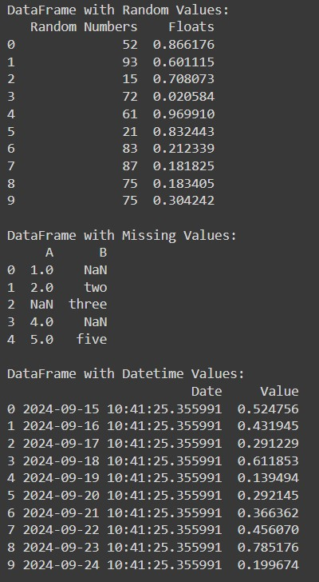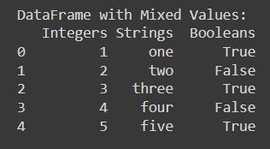

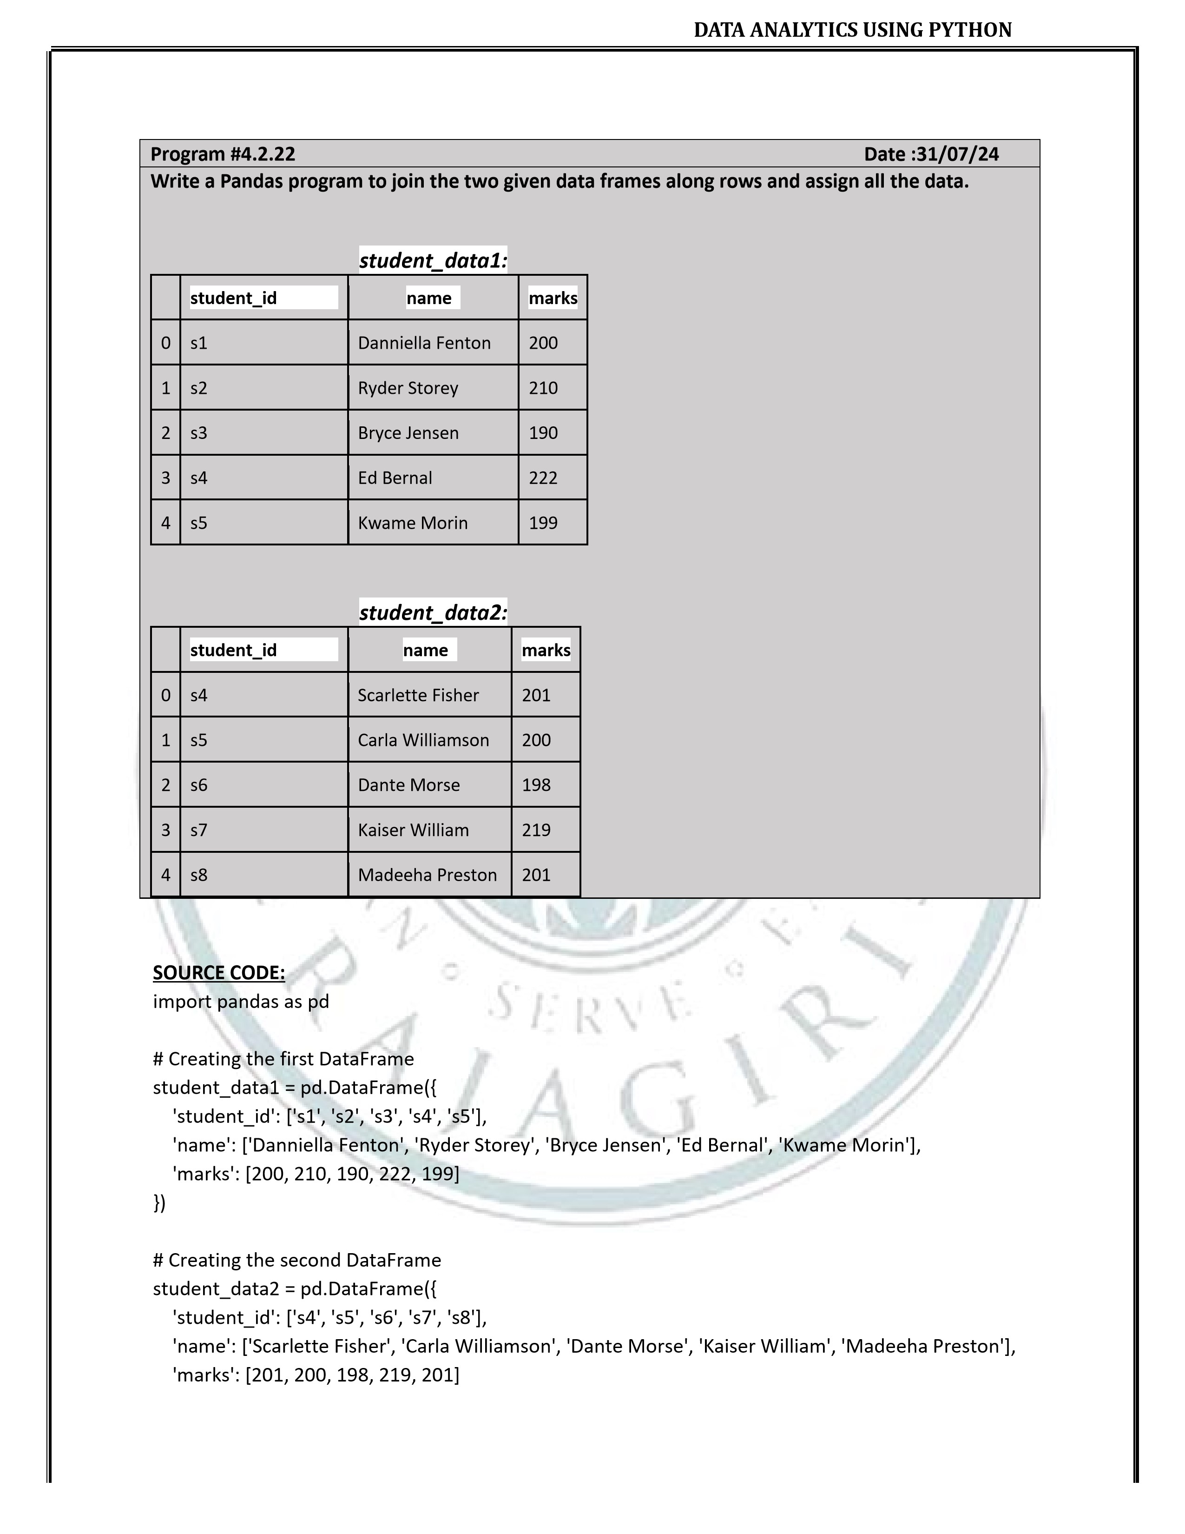



**DATA**

**ANALYTICS**

**USING PYTHON**

})

# Displaying the original DataFrames

print("Student Data 1:")

print(student_data1)

print("

\

nStudent Data 2:")

print(student_data2)

# Joining the two DataFrames along rows

combined_data = pd.concat([student_data1, student_data2], ignore_index=True)

# Displaying the combined DataFrame

print("

\

nCombined Student Data:")

print(combined_data)

**OUTPUT**

**:**

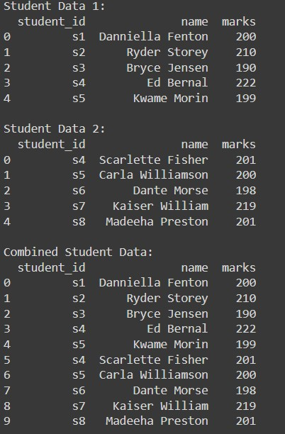

**DATA**

**ANALYTICS**

**USING PYTHON**

**Program #**

**4.2.23**

**Date :**

**31**

**24**

**/07/**

**Write a Pandas program to join the two given data frames along columns and assign all the data.**

**)**

**(**

**Use the same dataset as above.**

**SOURCE CODE**

**:**

import pandas as pd

# Creating the first DataFrame

student_data1 = pd.DataFrame({

'student_id': ['s1', 's2', 's3', 's4', 's5'],

'name': ['Danniella Fenton', 'Ryder Storey', 'Bryce Jensen', 'Ed Bernal', 'Kwame Morin'],

'marks': [200, 210, 190, 222, 199]

})

# Creating the second DataFrame

student_data2 = pd.DataFrame({

'student_id': ['s4', 's5', 's6', 's7', 's8'],

'name': ['Scarlette Fisher', 'Carla Williamson', 'Dante Morse', 'Kaiser William', 'Madeeha Preston'],

'marks': [201, 200, 198, 219, 201]

})

# Displaying the original DataFrames

print("Student Data 1:")

print(student_data1)

print("

\

nStudent Data 2:")

print(student_data2)

# Joining the two DataFrames along columns

combined_data_columns = pd.concat([student_data1, student_data2], axis=1)

# Displaying the combined DataFrame along columns

print("

\

nCombined Student Data (along columns):")

print(combined_data_columns)



**DATA**

**ANALYTICS**

**USING PYTHON**

**OUTPUT**

**:**

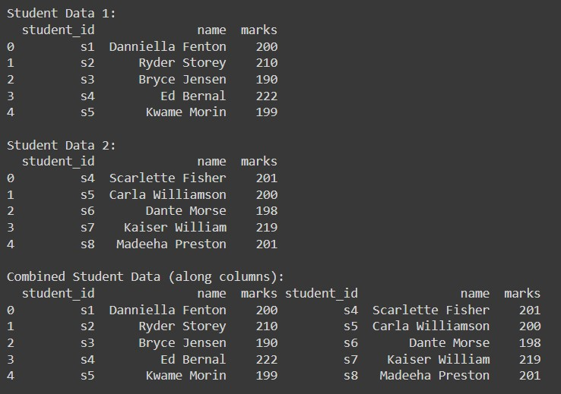

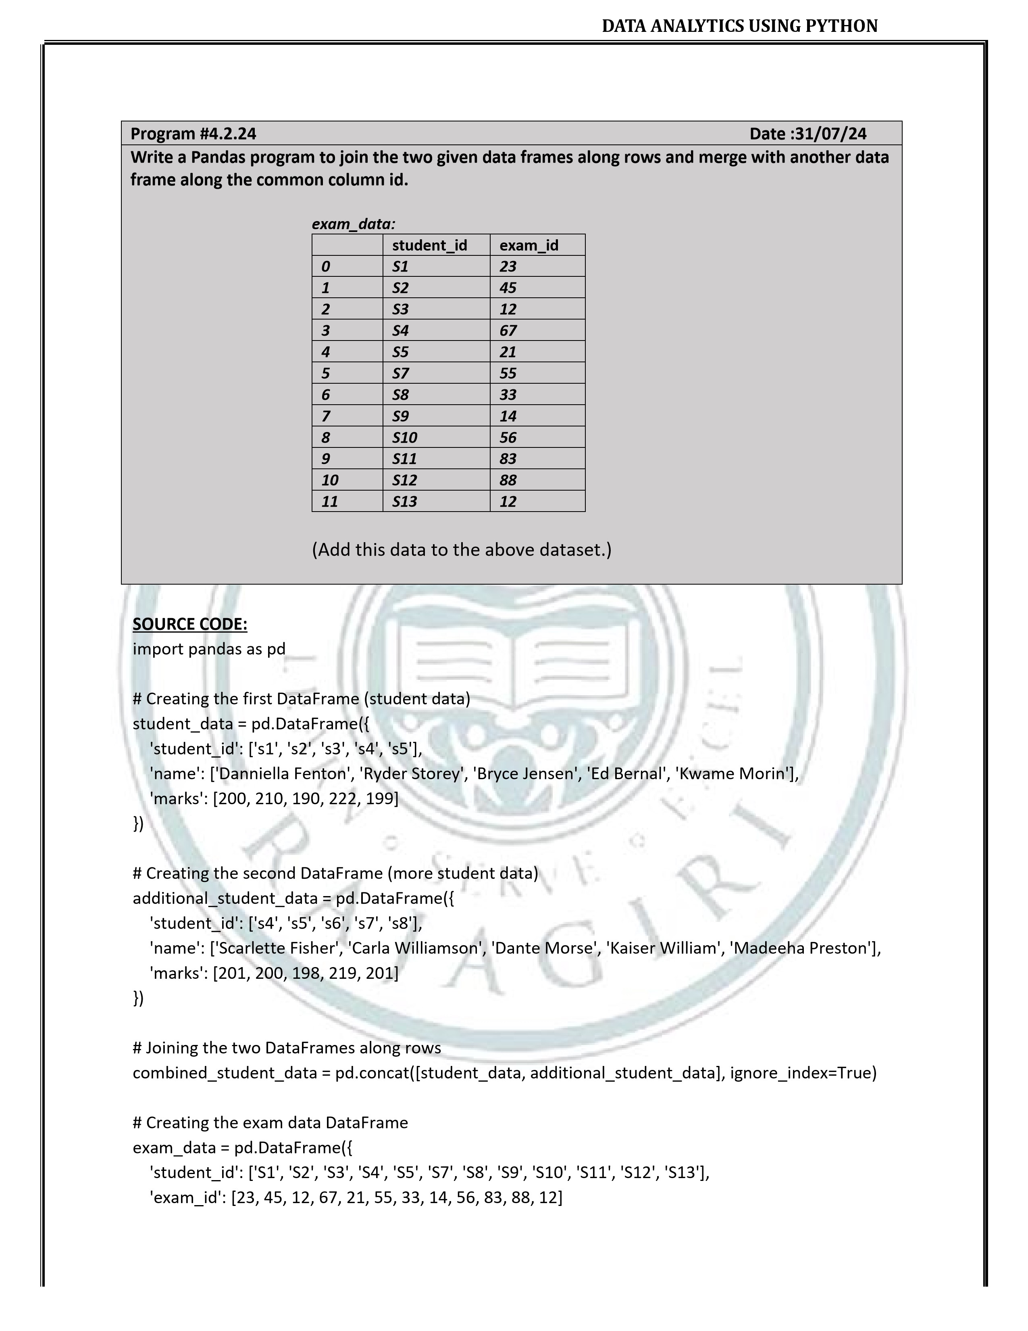



**DATA**

**ANALYTICS**

**USING PYTHON**

})

# Displaying the combined student data

print("Combined Student Data:")

print(combined_student_data)

# Merging the combined student data with exam data along the common column 'student_id'

# First, we need to ensure student_id in exam_data matches the format in combined_student_data

exam_data['student_id'] = exam_data['student_id'].str.lower() # Convert to lowercase

# Merging the DataFrames

merged_data = pd.merge(combined_student_data, exam_data, on='student_id', how='inner')

# Displaying the merged data

print("

\

nMerged Data (on common column 'student_id'):")

print(merged_data)

**OUTPUT**

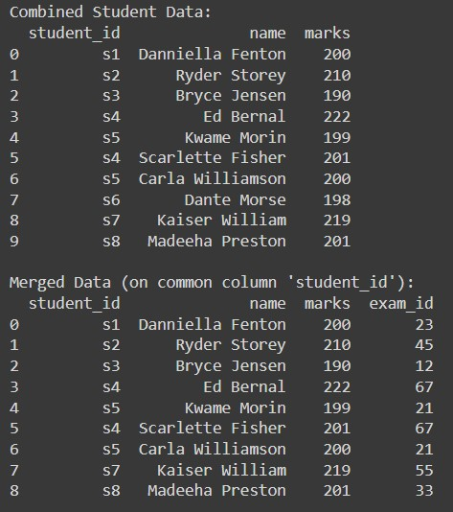

**DATA**

**ANALYTICS**

**USING PYTHON**

**Program #**

**4.2.25**

**Date :**

**24**

**/07/**

**31**

**Write a Pandas program to join the two data frames with matching records from both sides, where**

**available. (Same dataset as above.)**

**SOURCE CODE**

**:**

import pandas as pd

# Creating the first DataFrame (student data)

student_data = pd.DataFrame({

'student_id': ['s1', 's2', 's3', 's4', 's5'],

'name': ['Danniella Fenton', 'Ryder Storey', 'Bryce Jensen', 'Ed Bernal', 'Kwame Morin'],

'marks': [200, 210, 190, 222, 199]

})

# Creating the second DataFrame (additional student data)

additional_student_data = pd.DataFrame({

'student_id': ['s4', 's5', 's6', 's7', 's8'],

'name': ['Scarlette Fisher', 'Carla Williamson', 'Dante Morse', 'Kaiser William', 'Madeeha Preston'],

'marks': [201, 200, 198, 219, 201]

})

# Joining the two DataFrames along rows

combined_student_data = pd.concat([student_data, additional_student_data], ignore_index=True)

# Creating the exam data DataFrame

exam_data = pd.DataFrame({

'student_id': ['s1', 's2', 's3', 's4', 's5', 's7', 's8', 's9', 's10', 's11', 's12', 's13'],

'exam_id': [23, 45, 12, 67, 21, 55, 33, 14, 56, 83, 88, 12]

})

# Displaying the combined student data

print("Combined Student Data:")

print(combined_student_data)

# Merging the combined student data with exam data on common column 'student_id'

# Use an inner join to keep matching records from both sides

merged_data = pd.merge(combined_student_data, exam_data, on='student_id', how='inner')

# Displaying the merged data with matching records

print("

\

nMerged Data (matching records from both sides):")

print(merged_data)



**DATA**

**ANALYTICS**

**USING PYTHON**

**OUTPUT**

**:**

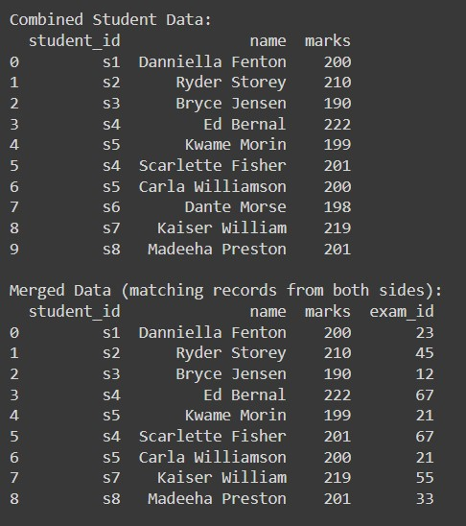

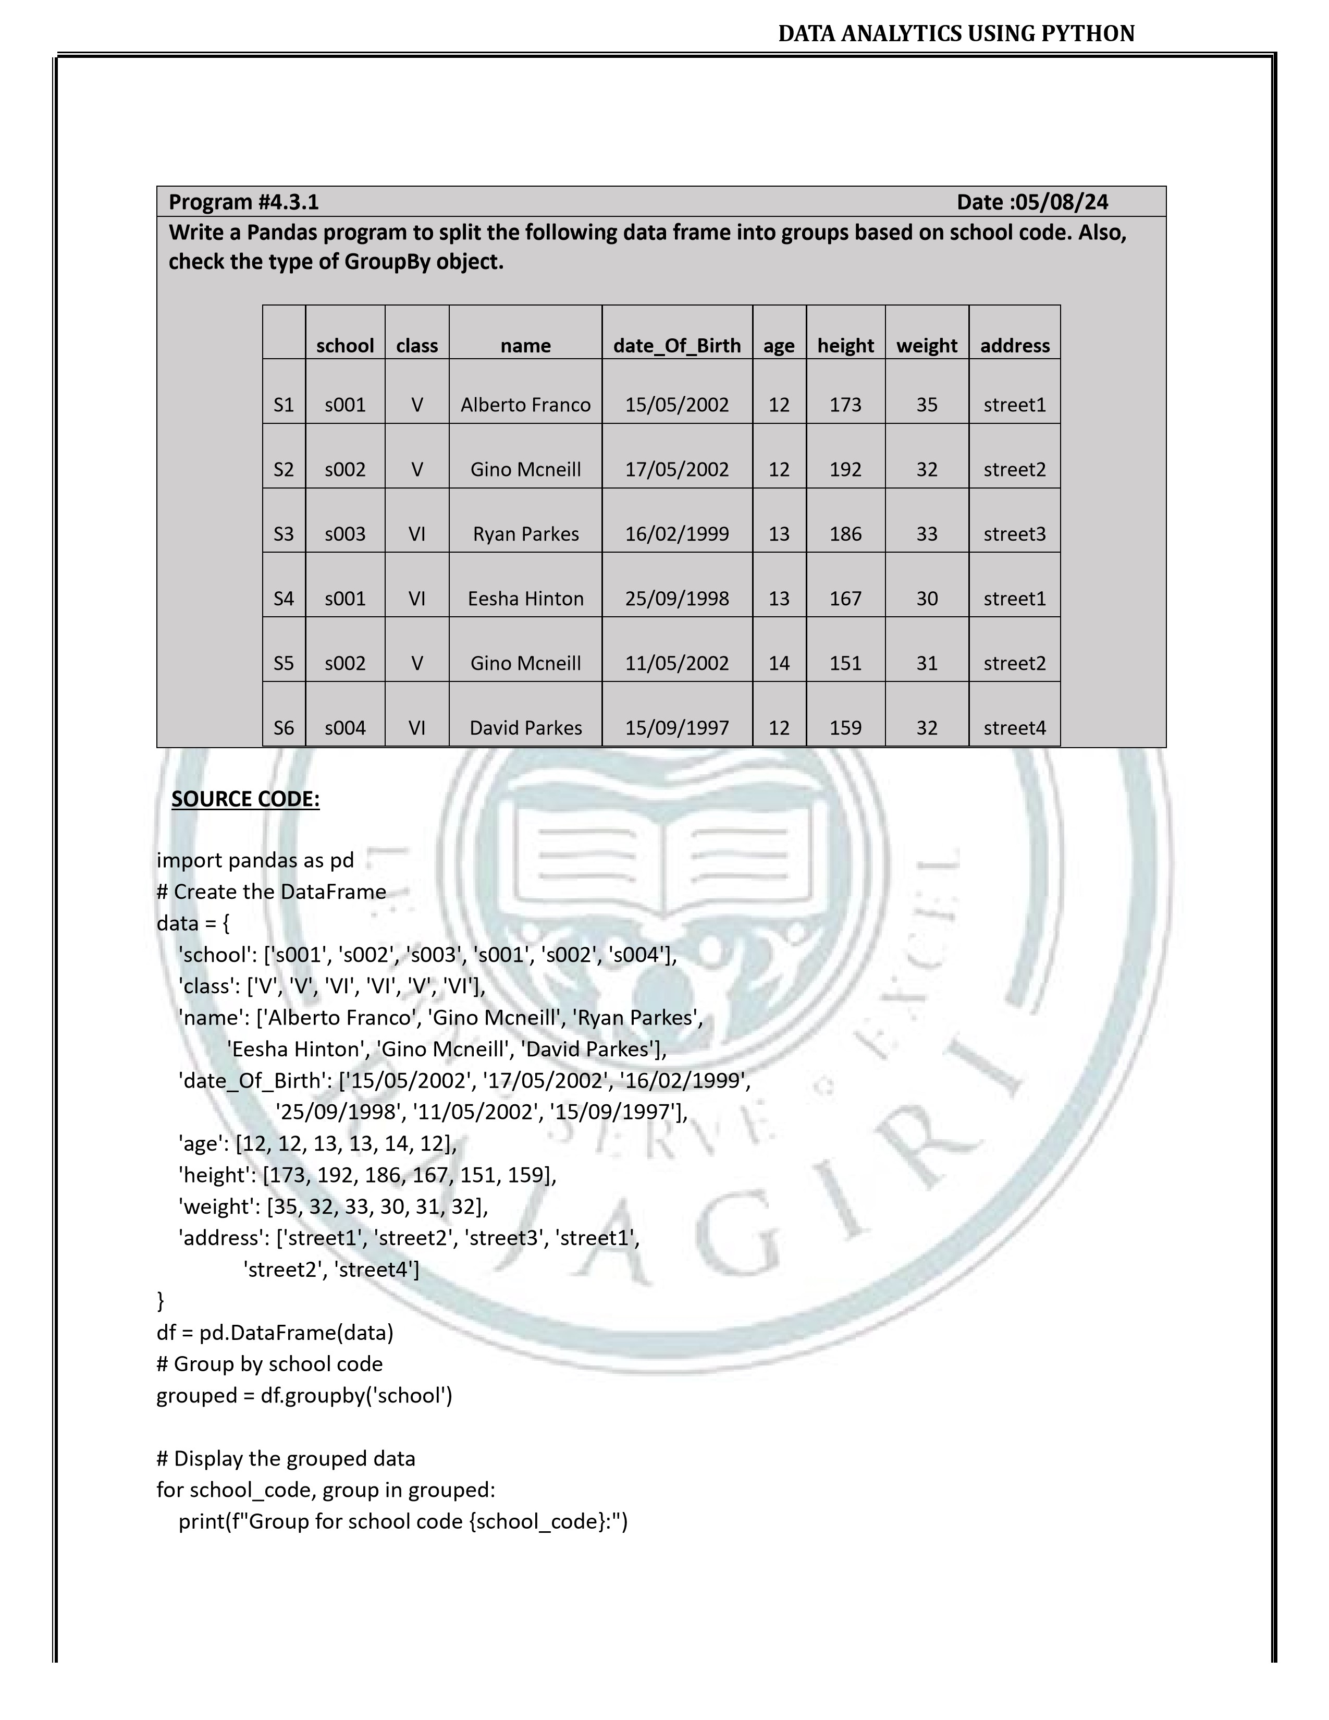



**DATA**

**ANALYTICS**

**USING PYTHON**

print(group)

print()

# Check the type of GroupBy object

print(f"Type of GroupBy object: {type(grouped)}")

**OUTPUT**

**:**

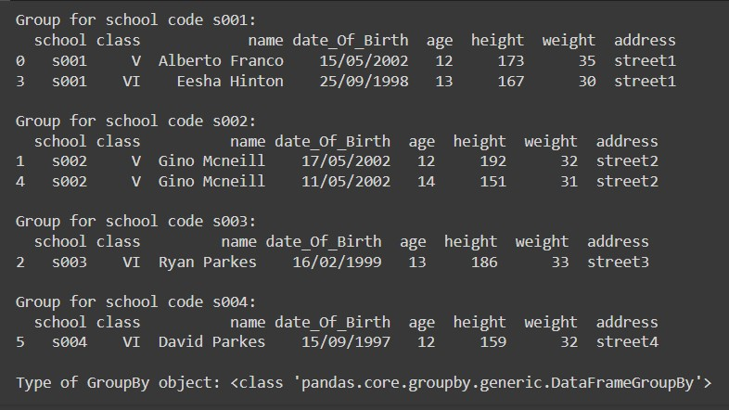

**DATA**

**ANALYTICS**

**USING PYTHON**

**Program #**

**4.3.2**

**Date :**

**0**

**5**

**/08/24**

**Write a Pandas program to split the following data frame by school code and get the mean, min,**

**and max values of age for each school. (Use the above dataset.)**

**SOURCE CODE**

**:**

import pandas as pd

# Create the DataFrame

data = {

'school': ['s001', 's002', 's003', 's001', 's002', 's004'],

'class': ['V', 'V', 'VI', 'VI', 'V', 'VI'],

'name': ['Alberto Franco', 'Gino Mcneill', 'Ryan Parkes',

'Eesha Hinton', 'Gino Mcneill', 'David Parkes'],

'date_Of_Birth': ['15/05/2002', '17/05/2002', '16/02/1999',

'25/09/1998', '11/05/2002', '15/09/1997'],

'age': [12, 12, 13, 13, 14, 12],

'height': [173, 192, 186, 167, 151, 159],

'weight': [35, 32, 33, 30, 31, 32],

'address': ['street1', 'street2', 'street3', 'street1',

'street2', 'street4']

}

df = pd.DataFrame(data)

# Group by school code and calculate mean, min, and max for age

age_stats = df.groupby('school')['age'].agg(['mean', 'min', 'max']

# Display the result

print(age_stats)

**OUTPUT**

**:**

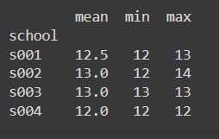

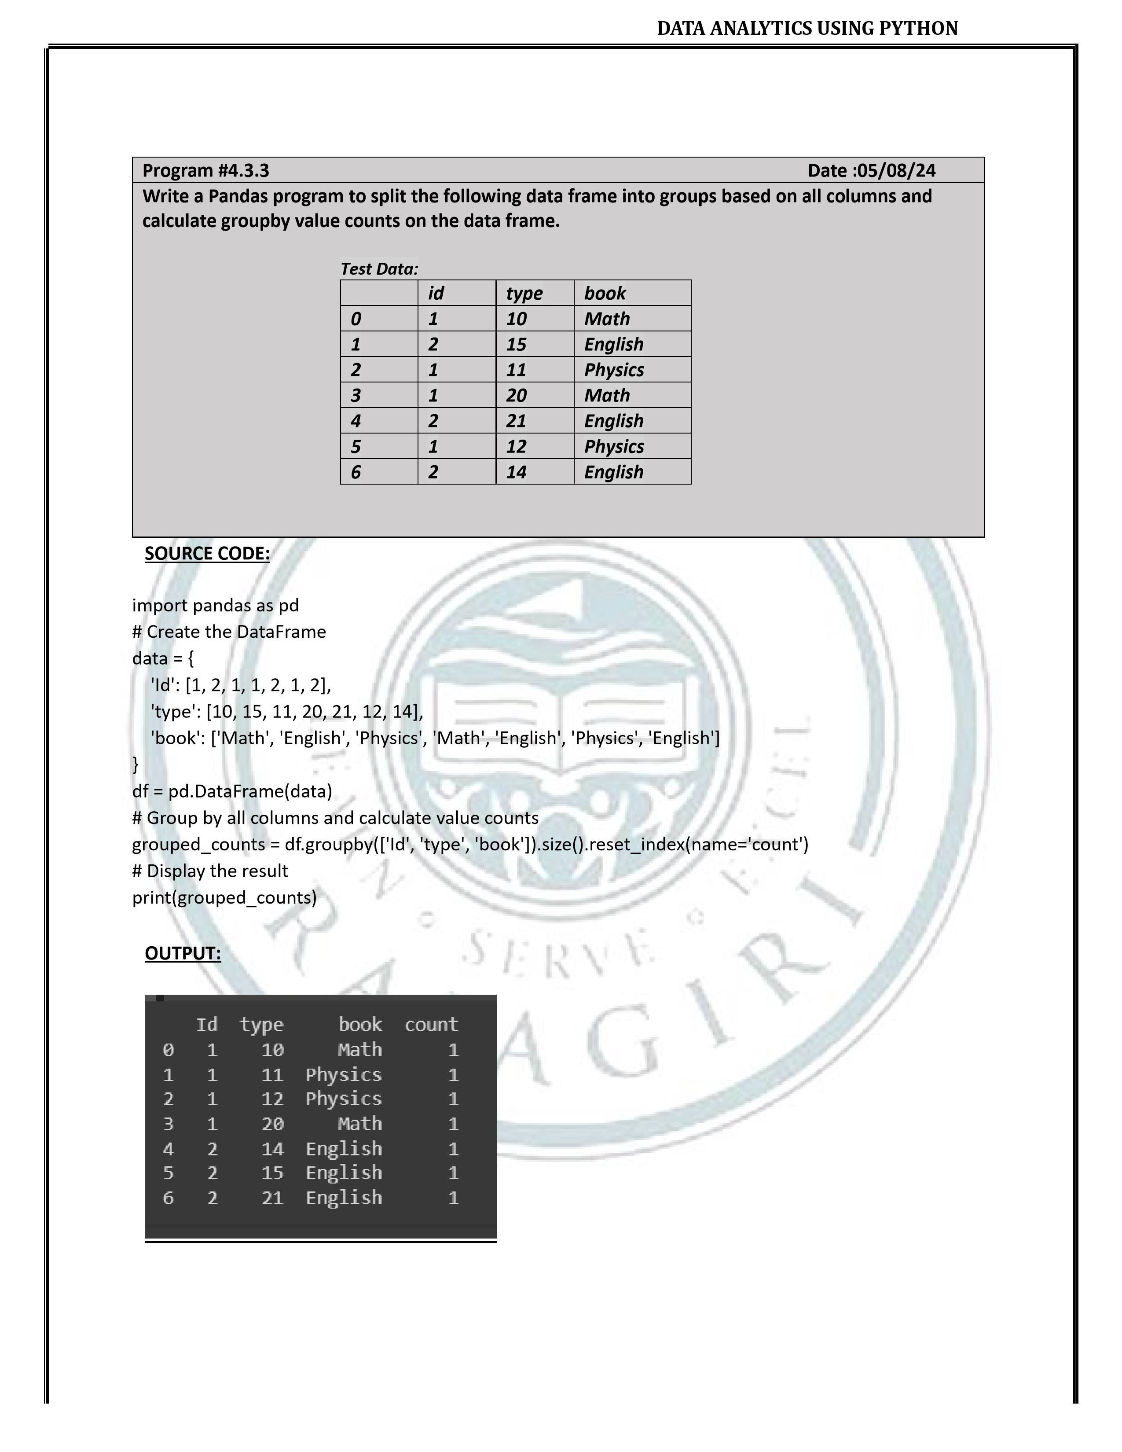



**DATA**

**ANALYTICS**

**USING PYTHON**

**Program #**

**4.3.4**

**Date :**

**0**

**5**

**/08/24**

**Write a Pandas program to split the following data frame into groups by school code and get the**

**mean, min, and max values of age with customized column names for each school.**

**SOURCE CODE**

**:**

import pandas as pd

# Create the DataFrame

data = {

'school': ['s001', 's002', 's003', 's001', 's002', 's004'],

'class': ['V', 'V', 'VI', 'VI', 'V', 'VI'],

'name':

'Alberto Franco', 'Gino Mcneill', 'Ryan Parkes',

[

'Eesha Hinton', 'Gino Mcneill', 'David Parkes'],

'date_Of_Birth': ['15/05/2002', '17/05/2002', '16/02/1999',

'25/09/1998', '11/05/2002', '15/09/1997'],

'age': [12, 12, 13, 13, 14, 12],

'height': [173, 192, 186, 167, 151, 159],

'weight': [35, 32, 33, 30, 31, 32],

'address': ['street1', 'street2', 'street3', 'street1',

'street2', 'street4']

}

df = pd.DataFrame(data)

# Group by school code and calculate mean, min, and max for age

age_stats = df.groupby('school')['age'].agg(mean_age='mean', min_age='min',

max_age='max').reset_index()

# Display the result

print(age_stats)

**OUTPUT**

**:**

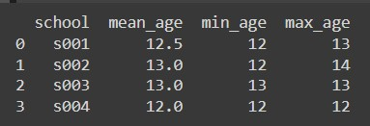

**DATA**

**ANALYTICS**

**USING PYTHON**

**Program #**

**4.4.1**

**Date :**

**0**

**7**

**/08/24**

**Visualize the following using the given dataset (alphabet_stock_data.csv),**

**4.4.1.1**

**Create a line plot of the historical stock prices of Alphabet Inc. between two specific dates.**

**4.4.1.2**

**Create a bar plot of the trading volume of Alphabet Inc. stock between two specific dates.**

**4.4.1.3**

**Create a stacked histogram plot with more bins of opening, closing, high, and low stock**

**stock**

**prices of Alphabet Inc. between two specific dates.**

**4.4.1.4**

**Create a scatter plot of the trading volume/stock prices of Alphabet Inc. stock between two**

**two**

**specific dates.**

**SOURCE CODE**

**1.1**

**:**

# Step

1

:

Import libraries

import pandas as pd

import matplotlib.pyplot as plt

# Step

2

:

Load the dataset

df =

pd.read_csv('alphabet_stock_data.csv')

# Step

3

Convert the date column to datetime

:

df['Date'] = pd.to_datetime(df['Date'])

# Step

4

:

Set the start and end dates for filtering

start_date = '2023

-

01

-

'

01

# Replace with your start date

end_date = '2023

-

12

-

31

'

# Replace with your end date

# Filter the DataFrame for the date range

filtered_df = df[(df['Date'] >= start_date) & (df['Date'] <= end_date)]

# Step

5

:

Plot the historical stock prices

plt.figure(figsize=(12, 6))

plt.plot(filtered_df['Date'], filtered_df['Close'], label='Closing Price', color='blue')

plt.title('Historical Stock Prices of Alphabet Inc.')

plt.xlabel('Date')

plt.ylabel('Stock Price (USD)')

plt.xticks(rotation=45)

plt.legend()

plt.grid()

plt.tight_layout()

plt.show()



**DATA**

**ANALYTICS**

**USING PYTHON**

**OUTPUT**

**:**

**SOURCE CODE**

**1.2**

**:**

# Plot the trading volume

plt.figure(figsize=(12, 6))

plt.bar(filtered_df['Date'], filtered_df['Volume'], color='orange')

plt.title('Trading Volume of Alphabet Inc. Stock')

plt.xlabel('Date')

plt.ylabel('Trading Volume')

plt.xticks(rotation=45)

plt.grid(axis='y')

plt.tight_layout()

plt.show()

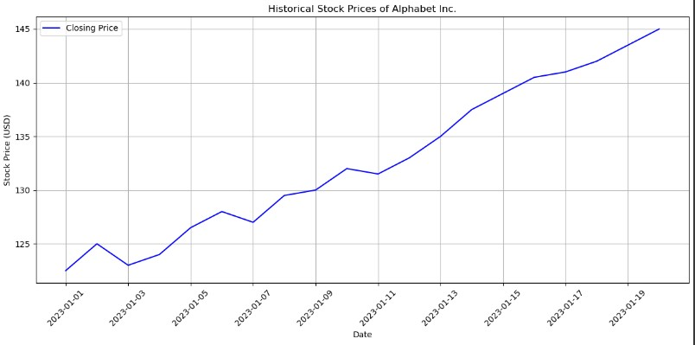

**DATA**

**ANALYTICS**

**USING PYTHON**

**OUTPUT**

**:**

**SOURCE CODE**

**1.3**

**:**

# Create a stacked histogram

plt.figure(figsize=(12, 6))

plt.hist(filtered_df['Open'], bins=30, alpha=0.5, label='Opening Price', color='blue')

plt.hist(filtered_df['Close'], bins=30, alpha=0.5, label='Closing Price', color='green')

plt.hist(filtered_df['High'], bins=30, alpha=0.5, label='High Price', color='orange')

plt.hist(filtered_df['Low'], bins=30, alpha=0.5, label='Low Price', color='red')

plt.title('Stacked Histogram of Alphabet Inc. Stock Prices')

plt.xlabel('Stock Price (USD)')

plt.ylabel('Frequency')

plt.legend(loc='upper right')

plt.grid(axis='y')

plt.tight_layout()

plt.show()

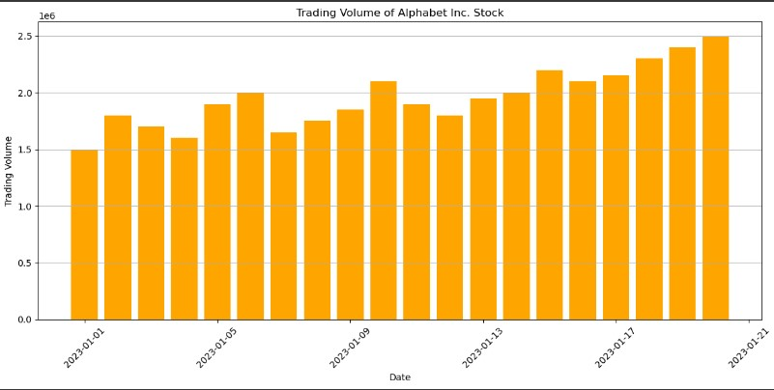

**DATA**

**ANALYTICS**

**USING PYTHON**

**OUTPUT**

**:**

**SOURCE CODE**

**1.4**

**:**

#Create a scatter plot

plt.figure(figsize=(12, 6))

plt.scatter(filtered_df['Close'], filtered_df['Volume'], color='purple', alpha=0.5)

plt.title('Scatter Plot of Trading Volume vs. Closing Prices of Alphabet Inc.')

plt.xlabel('Closing Price (USD)')

plt.ylabel('Trading Volume')

plt.grid()

plt.tight_layout()

plt.show()

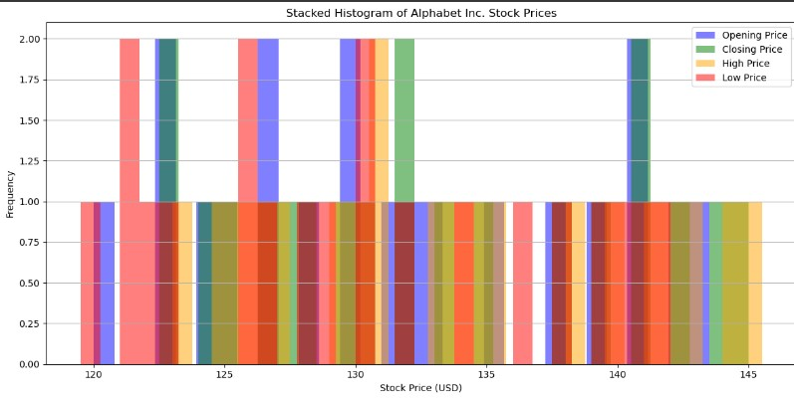

**DATA**

**ANALYTICS**

**USING PYTHON**

**OUTPUT**

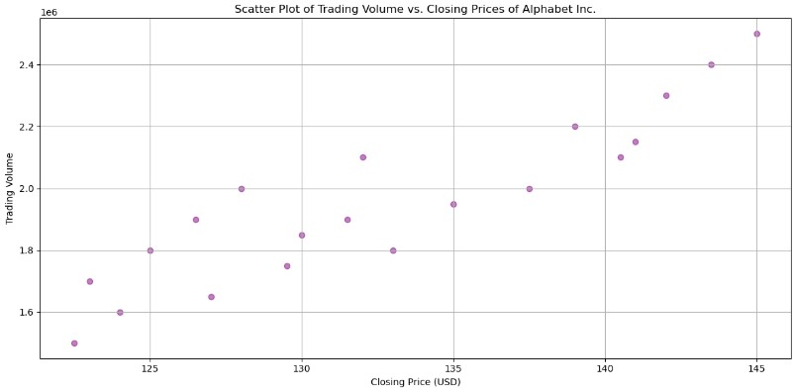

**DATA**

**ANALYTICS**

**USING PYTHON**

**Program #**

**4.4.2**

**Date :**

**0**

**7**

**/08/24**

**Write a Python program to draw a line with a suitable label on the x**

**-**

**axis, y**

**-**

**axis, and title.**

**SOURCE CODE**

**:**

import matplotlib.pyplot as plt

# Sample data for the line plot

x = [1, 2, 3, 4, 5]

# X

-

axis data

y = [2, 3, 5, 7, 11]

# Y

-

axis data

# Create the line plot

plt.figure(figsize=(10, 5))

plt.plot(x, y, marker='o', linestyle='

-

', color='b')

# You can

customize marker and linestyle

# Adding labels and title

plt.title('Sample Line Plot')

plt.xlabel('X

-

axis Label')

# Replace with your x

-

axis label

plt.ylabel('Y

-

axis Label')

# Replace with your y

-

axis label

# Show grid

plt.grid()

# Show the plot

plt.tight_layout()

plt.show()

**OUTPUT**

**:**

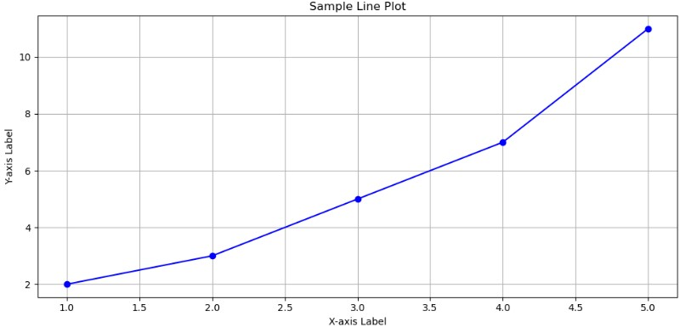

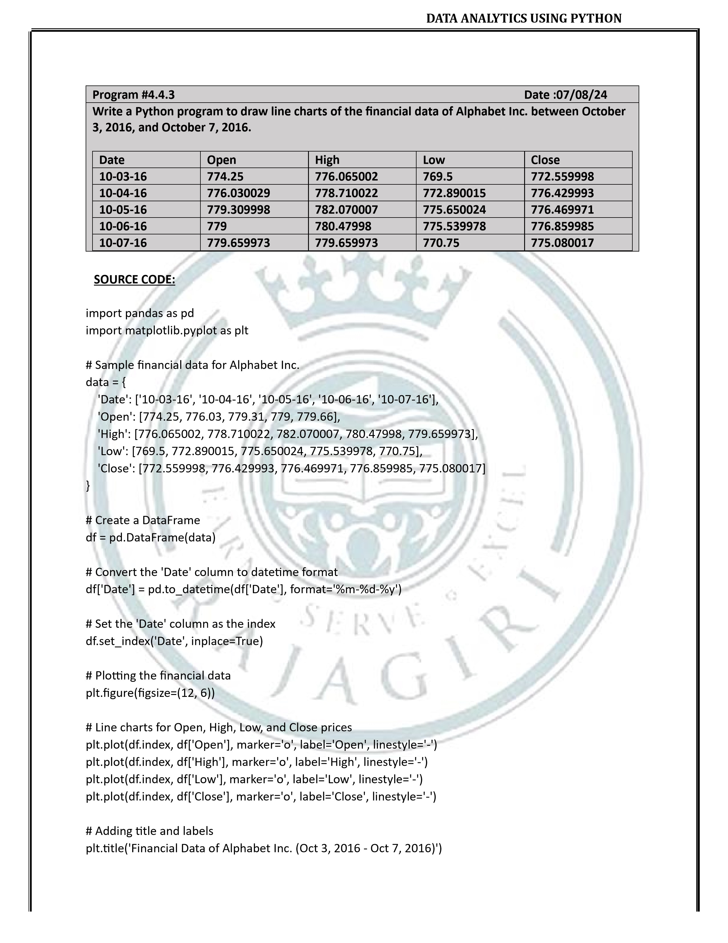



**DATA**

**ANALYTICS**

**USING PYTHON**

plt.xlabel('Date')

plt.ylabel('Stock Price (USD)')

plt.xticks(rotation=45)

plt.grid()

plt.legend()

# Show legend

plt.tight_layout()

# Show the plot

plt.show()

**OUTPUT**

**:**

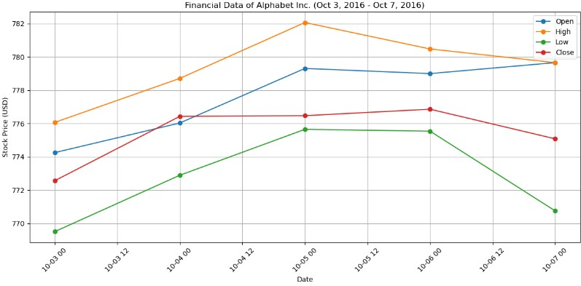

**DATA**

**ANALYTICS**

**USING PYTHON**

**Program #**

**4.4.4**

**Date :**

**0**

**7**

**/08/24**

**Write a Python program to draw a line with a suitable label on the x**

**-**

**axis, and y**

**-**

**axis and a title.**

**Create the code**

**snippet that gives the output shown in the following screenshot:**

**SOURCE CODE**

**:**

import matplotlib.pyplot as plt

# Data for plotting

x = [10, 20, 30]

y1 = [20, 40, 10] # Blue line data (touches lower boundary at 10)

y2 = [40, 10, 30] # Red line data (touches upper boundary at 40)

# Create the plot with specific line styles

plt.plot(x, y1, 'b:', label='line1

-

dotted', linewidth=1)

# Blue dotted line, thinner

plt.plot(x, y2, 'r

--

', label='line2

-

dashed', linewidth=5)

# Red dashed line, thicker

# Add labels and title

plt.xlabel('x

-

axis')

plt.ylabel('y

-

axis')

plt.title('Plot with two or more lines with different styles')

# Set x and y

-

axis limits to

ensure the lines touch the boundaries

plt.xlim(10, 30)

plt.ylim(10, 40)

# Add a legend

plt.legend()

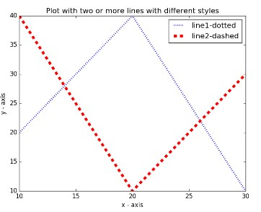

**DATA**

**ANALYTICS**

**USING PYTHON**

# Show the plot

plt.show()

**OUTPUT**

**:**

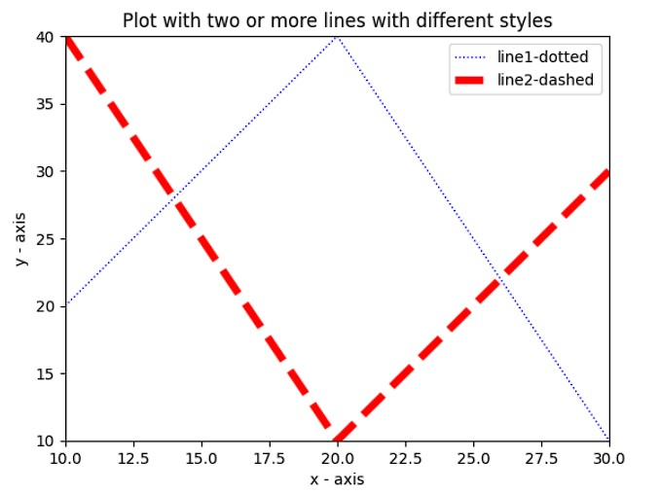

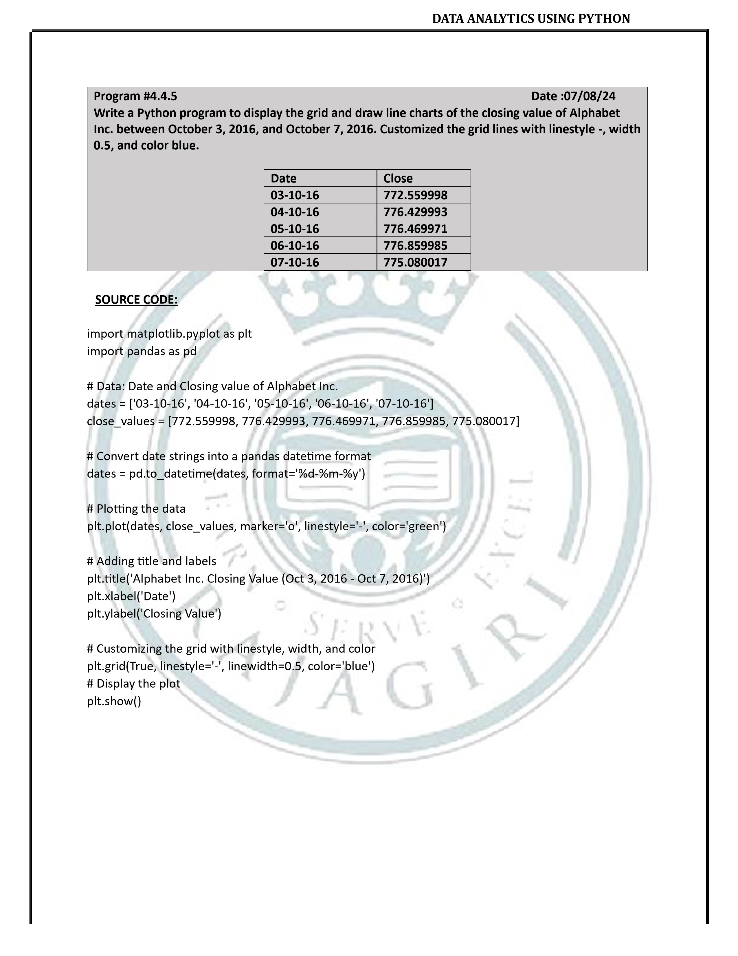



**DATA**

**ANALYTICS**

**USING PYTHON**

**OUTPUT**

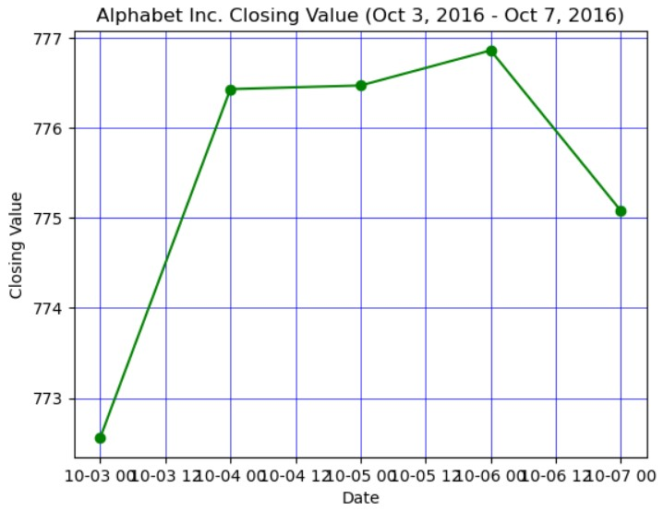

**DATA**

**ANALYTICS**

**USING PYTHON**

**Program #**

**4.4.6**

**Date :**

**12**

**/08/24**

**Write a Python program to create multiple plots as in the screenshot (use any method).**

**SOURCE CODE**

**:**

import matplotlib.pyplot as plt

# Create figure

fig = plt.figure(figsize=(8, 6))

# Add the large plot (1 row, 1 column)

ax1 = plt.subplot2grid((2, 3), (0, 0), colspan=3)

# Add the three smaller plots below (3 columns)

ax2 = plt.subplot2grid((2, 3), (1, 0))

ax3 = plt.subplot2grid((2, 3), (1, 1))

ax4 = plt.subplot2grid((2, 3), (1, 2))

# Plot dummy data (optional)

ax1.plot([0, 1], [0, 1])

ax1.set_title('Large Plot')

ax2.plot([0, 1], [0, 1])

ax2.set_title('Small Plot 1')

ax3.plot([0, 1], [0, 1])

ax3.set_title('Small Plot 2')

ax4.plot([0, 1], [0, 1])

ax4.set_title('Small Plot 3')

# Adjust layout

plt.tight_layout()

# Show plot

plt.show()



**DATA**

**ANALYTICS**

**USING PYTHON**

**OUTPUT**

**:**

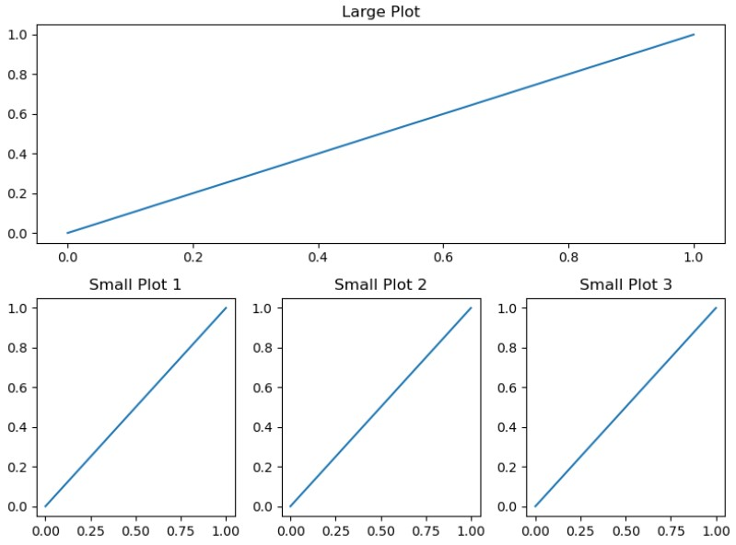

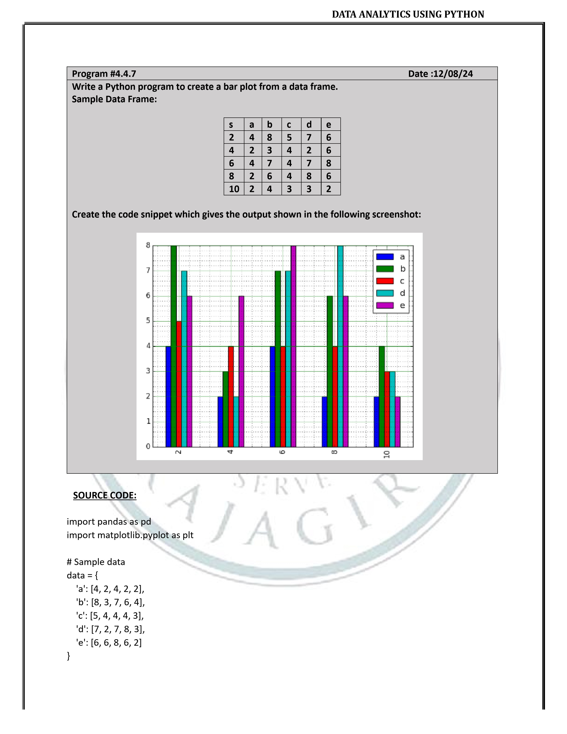



**DATA**

**ANALYTICS**

**USING PYTHON**

# Create DataFrame

index = [2, 4, 6, 8, 10]

df = pd.DataFrame(data, index=index)

# Plotting the bar plot

df.plot(kind='bar', width=0.8)

# Adding legend, labels, and grid

plt.legend(title="s", loc='best')

plt.grid(True)

plt.show()

**OUTPUT**

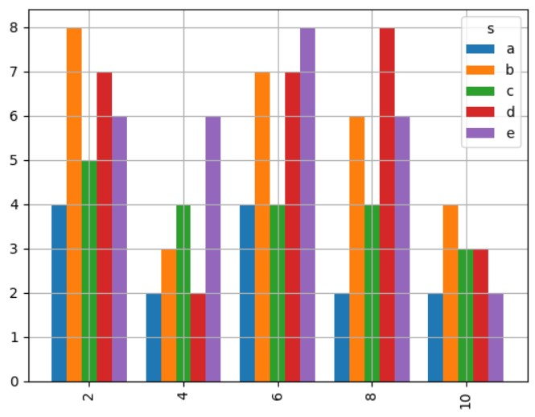

**DATA**

**ANALYTICS**

**USING PYTHON**

**Program #**

**4.4.8**

**Date :**

**12**

**/08/24**

**Write a Python program to create a stacked bar plot with error bars. Note: Use the bottom to stack**

**the women's bars on top of the men's bars.**

**Sample Data:**

**Means (men) = (22, 30, 35, 35, 26)**

**Means (women) = (25, 32, 30, 35, 29)**

**Men's Standard deviation = (4, 3, 4, 1, 5)**

**Women's Standard deviation = (3, 5, 2, 3, 3)**

**Create the code snippet that gives the output shown in the following screenshot:**

**SOURCE CODE**

**:**

import numpy as np

import matplotlib.pyplot as plt

#

Data

means_men = (22, 30, 35, 35, 26)

means_women = (25, 32, 30, 35, 29)

std_men = (4, 3, 4, 1, 5)

std_women = (3, 5, 2, 3, 3)

# Group labels

groups = ('Group1', 'Group2', 'Group3', 'Group4', 'Group5')

# X locations for the groups

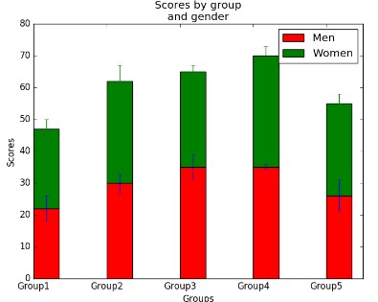

**DATA**

**ANALYTICS**

**USING PYTHON**

x = np.arange(len(groups))

# Plotting the men's bars

plt.bar(x, means_men, yerr=std_men, color='r', width=0.6, label='Men')

# Plotting the women's bars on top of the men's bars (stacked)

plt.bar(x, means_women, yerr=std_women, color='g', width=0.6, bottom=means_men, label='Women')

# Adding labels and title

plt.ylabel('Scores')

plt.title('Scores by group

\

nand gender')

# Adding group labels to the x

-

axis

plt.xticks(x, groups)

# Adding a legend

plt.legend()

# Display the plot

plt.show()

**OUTPUT**

**:**

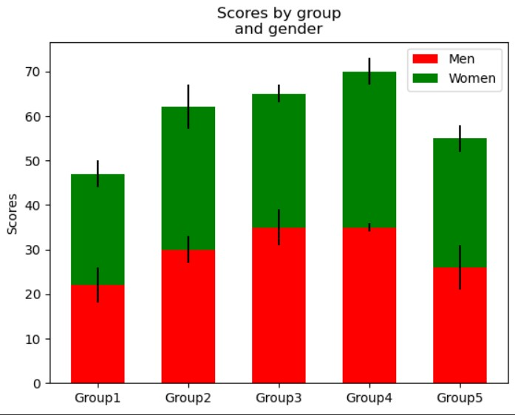

**DATA**

**ANALYTICS**

**USING PYTHON**

**Program #**

**4.4.9**

**Date :**

**12**

**/08/24**

**Write a Python program to create stack bar plot and add labels to each section.**

**Sample data:**

**people = ('G1','G2','G3','G4','G5','G6','G7','G8')**

**segments = 4**

**# multi**

**-**

**dimensional data**

**data = [[ 3.40022085, 7.70632498, 6.4097905, 10.51648577, 7.5330039, 7.1123587, 12.77792868,**

**,**

**3.44773477], [ 11.24811149, 5.03778215, 6.65808464, 12.32220677, 7.45964195, 6.79685302**

**,**

**7.24578743, 3.69371847], [ 3.94253354, 4.74763549, 11.73529246, 4.6465543**

**,**

**12.9952182**

**4.63832778, 11.16849999, 8.56883433], [ 4.24409799, 12.71746612, 11.3772169, 9.00514257**

**,**

**10.47084185, 10.97567589, 3.98287652, 8.80552122]]**

**Create the code snippet that gives the output shown in the following screenshot:**

**SOURCE CODE**

**:**

import numpy as np

import matplotlib.pyplot as plt

# Sample data

people = ('G1','G2','G3','G4','G5','G6','G7','G8')

segments = 4

data = np.array([

[

3.40022085, 7.70632498, 6.4097905, 10.51648577, 7.5330039, 7.1123587, 12.77792868,

3.44773477]

,

11.24811149, 5.03778215, 6.65808464, 12.32220677, 7.45964195, 6.79685302, 7.24578743,

[

,

3.69371847]

[

3.94253354, 4.74763549, 11.73529246, 4.6465543, 12.9952182, 4.63832778, 11.16849999,

8.56883433]

,

[

4.24409799, 12.71746612, 11.3772169, 9.00514257, 10.47084185, 10.97567589, 3.98287652,

8.80552122]

])

# Assign colors for each segment

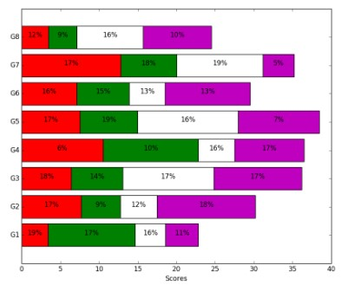

**DATA**

**ANALYTICS**

**USING PYTHON**

colors = ['red', 'green', 'white', 'purple']

# Set up the bar positions

index = np.arange(len(people))

# Initialize the bottom positions for stacking

bottom = np.zeros(len(people))

# Create the plot

fig, ax = plt.subplots()

#

Plot each segment

for i in range(segments):

ax.barh(index, data[i], left=bottom, color=colors[i % len(colors)], label=f'Segment {i+1}')

# Add text labels on each segment

for j in range(len(people)):

ax.text(bottom[j] + data[i][j]/2, j, f'{int(data[i][j])}%', ha='center', va='center', color='black')

bottom += data[i]

# Add labels and title

ax.set(yticks=index, yticklabels=people, xlabel='Scores')

ax.set_title('Stacked Bar Plot with Labels')

# Display the legend

ax.legend()

# Show the plot

plt.show()

**OUTPUT**

**:**

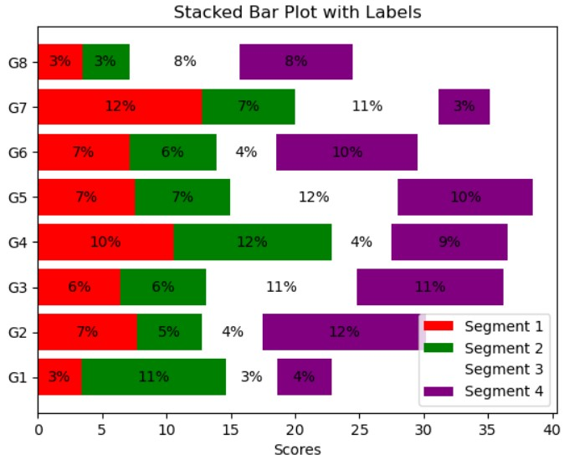

**DATA**

**ANALYTICS**

**USING PYTHON**

**Program #**

**4.4.10**

**Date :**

**12**

**/08/24**

**Write a Python program to add textures (black and white) to bars and wedges. Note: Use the**

**bottom to stack the**

**women's bars on top of the men's bars. Create the code snippet that gives the**

**output shown in the following screenshot:**

**SOURCE CODE**

**:**

import matplotlib.pyplot as plt

import numpy as np

# Sample data

men_means = [2, 3, 4, 5, 6, 7, 8, 9, 10, 11]

women_means = [1, 2, 3, 4, 5, 6, 7, 8, 9, 10]

# Define x

-

axis labels

x = np.arange(len(men_means))

# Define hatch patterns (textures)

hatch_patterns = ['/', '

\

\

', '|', '

-

', '+', 'x', 'o', 'O', '.', '*']

fig, ax = plt.subplots()

# Plot men's bars with black edge and white face

bars_men = ax.bar(x, men_means, color='white', edgecolor='black', hatch=hatch_patterns)

# Plot women's bars on top of men's bars using the bottom parameter, also black and white

bars_women = ax.bar(x, women_means, bottom=men_means, color='white', edgecolor='black',

hatch=hatch_patterns)

# Set labels and title

ax.set_xlabel('X')

ax.set_ylabel('Y')

ax.set_title('Bar Plot with Black and White Textures')

# Display the plot

plt.show()

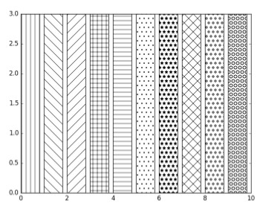

**DATA**

**ANALYTICS**

**USING PYTHON**

**OUTPUT**

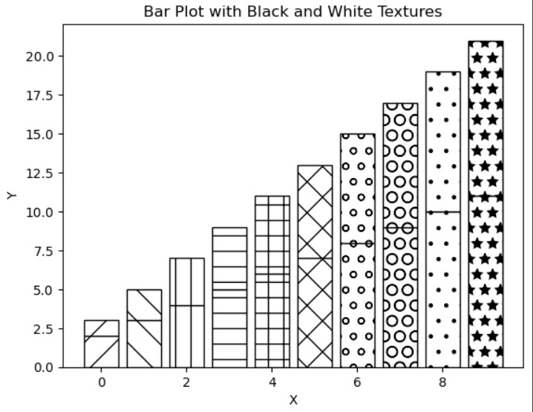

**DATA**

**ANALYTICS**

**USING PYTHON**

**Program #**

**5**

**.1**

**Date :**

**14**

**/08/24**

**Handle the given dataset (Data.csv) with adequate preprocessing steps mentioned and visualize**

**the dataset with appropriate graphs.**

**5.1.1**

**Handle Missing Data Values**

**5.1.2**

**Encode the categorical data**

**5.1.3**

**Scale your features**

**SOURCE CODE**

**:**

import pandas as pd

import numpy as np

from sklearn.preprocessing import LabelEncoder, StandardScaler

import

matplotlib.pyplot as plt

import seaborn as sns

# Step 1: Load the dataset from the local CSV file

data = pd.read_csv('Data.csv')

# Ensure the Data.csv file is in the same directory as the script

print("Original Dataset:

\

n", data)

# Step 5.1.1: Handle Missing Data Values

# Filling missing Age and Salary with the mean of the respective columns

data['Age'] = data['Age'].fillna(data['Age'].mean())

# Assign the result back to the 'Age' column

data['Salary'] = data['Salary'].fillna(data['Salary'].mean())

# Assign the result back to the 'Salary' column

print("

\

nDataset after handling missing values:

\

n", data)

# Step 5.1.2: Encode the categorical data

# Encoding 'Country' and 'Purchased' columns

label_encoder = LabelEncoder()

# Encode Purchased

(

Yes/No) into 1/

0

data['Purchased'] = label_encoder.fit_transform(data['Purchased'])

# Encode 'Country' using OneHotEncoding (creates separate columns for each category)

data = pd.get_dummies(data, columns=['Country'], drop_first=True)

# drop_first to avoid dummy

variable trap

print("

\

nDataset after encoding categorical variables:

\

n", data)

# Step 5.1.3: Scale your features

scaler = StandardScaler()

data[['Age', 'Salary']] = scaler.fit_transform(data[['Age', 'Salary']])

print("

\

nDataset after scaling features:

\

n", data)



**DATA**

**ANALYTICS**

**USING PYTHON**

# Step 5.1.4: Visualization

# Visualization of the dataset using various plots

# Plot 1: Age distribution

plt.figure(figsize=(8, 4))

sns.histplot(data['Age'], kde=True)

plt.title('Age Distribution')

plt.show()

# Plot 2: Salary

distribution

plt.figure(figsize=(8, 4))

sns.histplot(data['Salary'], kde=True, color='red')

plt.title('Salary Distribution')

plt.show()

# Plot 3: Count of Purchases (Purchased or Not)

plt.figure(figsize=(6, 4))

sns.countplot(x='Purchased', data=data)

plt.title('Count of Purchases (Yes/No)')

plt.show()

# Plot 4: Country

-

wise Purchase

plt.figure(figsize=(8, 4))

sns.barplot(x='Purchased', y='Salary', hue='Country_France', data=data)

plt.title('Country

-

wise Salary of Purchasers')

plt.show()



**DATA**

**ANALYTICS**

**USING PYTHON**

**OUTPUT**

**:**

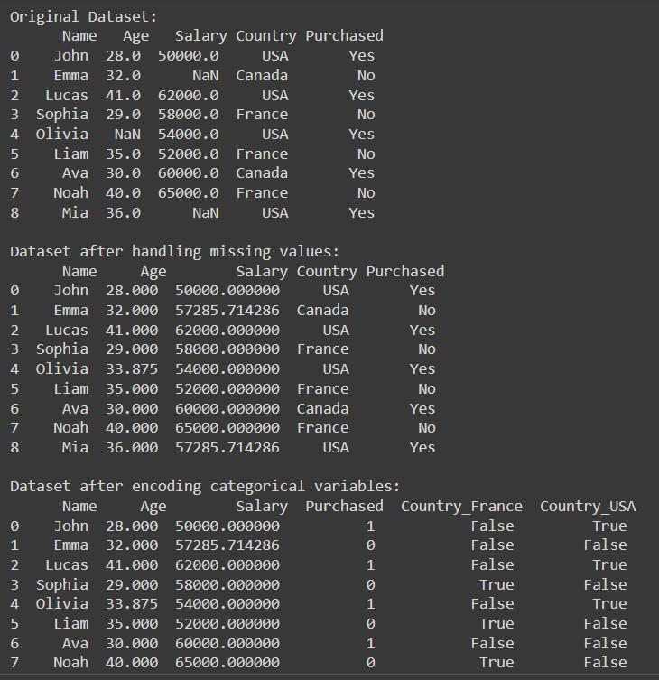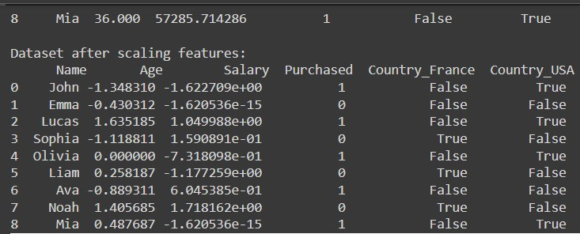

**DATA**

**ANALYTICS**

**USING PYTHON**

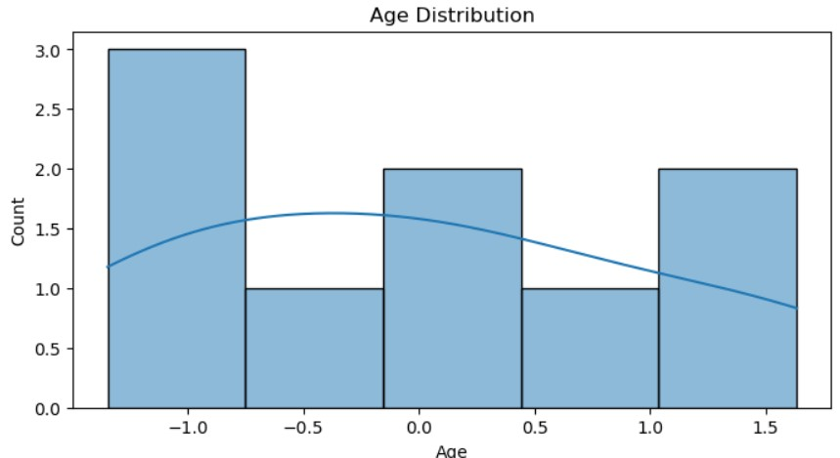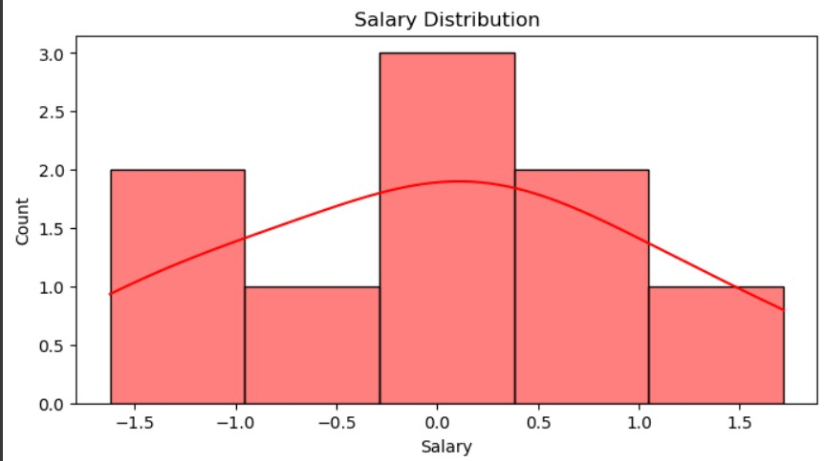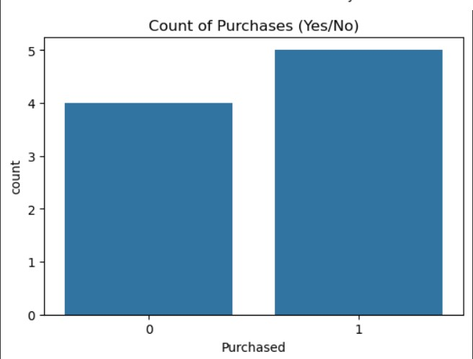

**DATA**

**ANALYTICS**

**USING PYTHON**

**Program #**

**5.2**

**Date :**

**1**

**4**

**/08/24**

**Using the given dataset (dirtydata.csv),**

**5.2.1**

**Handle the data with empty cells (Use dropna() and fillna())**

**5.2.2**

**Replace the**

**empty cells using mean, median, and mode.**

**5.2.3**

**Handle the data in the wrong format.**

**5.2.4**

**Handle the wrong data from the dataset.**

**5.2.5**

**Discover and remove duplicates.**

**SOURCE CODE**

**:**

import pandas as pd

import numpy as np

# Step 1: Load the dataset

data =

pd.read_csv('dirtydata.csv')

print("Original Dataset:

\

n", data)

# Step 5.2.1: Handle the data with empty cells

# Using dropna()

-

Drop rows with any missing values

data_dropped = data.dropna()

print("

\

nDataset after dropping rows with missing values:

\

n", data_dropped)

# Using fillna()

-

Fill missing values with a placeholder (e.g., 'Unknown')

data_filled = data.fillna("Unknown")

print("

\

nDataset after filling missing values with 'Unknown':

\

n", data_filled)

# Step 5.2.2: Replace empty cells using mean, median, and mode

# Filling missing 'Age' with mean, 'Salary' with median

data['Age'] = data['Age'].fillna(data['Age'].mean())

data['Salary'] = pd.to_numeric(data['Salary'], errors='coerce')

# Convert invalid salary to NaN

data['Salary'] = data['Salary'].fillna(data['Salary'].median())

print("

\

nDataset after filling missing values using mean for Age and median for Salary:

\

n", data)

# Step 5.2.3: Handle the data in the wrong format

# Correcting the date format by replacing 'wrong_date' with a valid date

or marking it as NaT (Not a

Time)

data['Date_of_Joining'] = pd.to_datetime(data['Date_of_Joining'], errors='coerce')

print("

\

nDataset after handling wrong date format:

\

n", data)

# Step 5.2.4: Handle wrong data in the dataset

# For example, invalid 'Salary' values have been set to NaN in step 5.2.2 using pd.to_numeric()

# You can also apply conditions to identify and correct wrong data



**DATA**

**ANALYTICS**

**USING PYTHON**

# Step 5.2.5: Discover and remove duplicates

# Checking for duplicates based on all columns

duplicates = data.duplicated()

print("

\

nDuplicate entries:

\

n", data[duplicates])

# Removing duplicates

data_cleaned = data.drop_duplicates()

print("

\

nDataset after removing duplicates:

\

n", data_cleaned)

**OUTPUT**

**:**

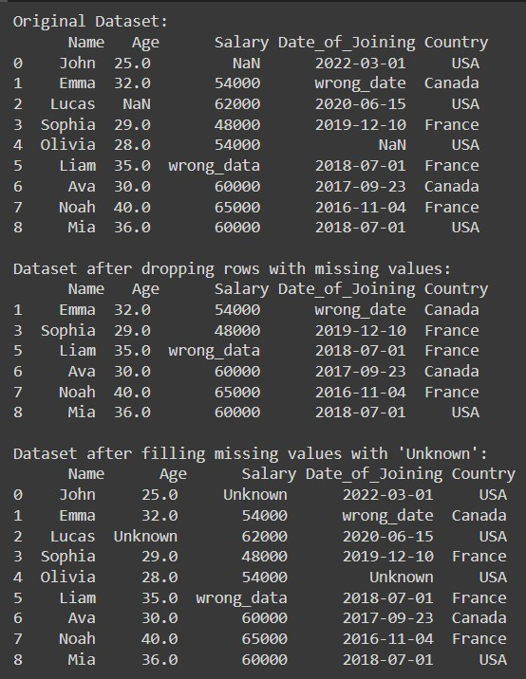

**DATA**

**ANALYTICS**

**USING PYTHON**

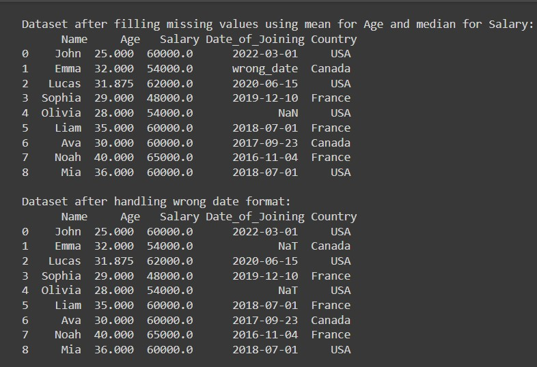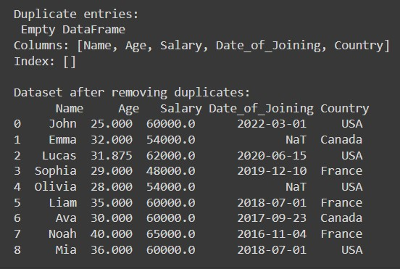

**DATA**

**ANALYTICS**

**USING PYTHON**

**Program #**

**5.3**

**Date :**

**1**

**4**

**/08/24**

**Create a cricketer dataset using a dictionary of lists, and create a new attribute ‘Experience**

**Category’ using ‘Age’ as the binning factor.**

**SOURCE CODE**

**:**

import pandas as pd

# Step 1: Create the cricketer dataset using a dictionary of lists

data = {

'Name': ['Virat Kohli', 'Rohit Sharma', 'MS Dhoni', 'Sachin Tendulkar', 'Hardik Pandya', 'Ravindra Jadeja',

'Shubman Gill', 'Rishabh Pant', 'Yuvraj Singh'],

'Age': [34, 36, 39, 47, 28, 32, 24, 26, 41],

'Runs': [12000, 10000, 10500, 18426, 3500, 2400, 1800, 2500, 8700],

'Wickets': [4, 8, 1, 154, 55, 185, 0, 0, 111],

'Matches': [250, 200, 350, 463, 80, 100,

30

300]

, 50,

}

# Convert the dictionary to a pandas DataFrame

cricketer_df = pd.DataFrame(data)

print("Original Cricketer Dataset:

\

n", cricketer_df)

# Step 2: Create 'Experience Category' using 'Age' as the binning factor

# Define the bins and labels for the experience category

bins = [0, 25, 35, 50]

labels = ['Young', 'Mid

-

level', 'Experienced']

# Create the new column 'Experience Category' by binning the 'Age'

cricketer_df['Experience Category'] = pd.cut(cricketer_df['Age'], bins=bins, labels=labels, right=False)

print("

\

nCricketer Dataset with 'Experience Category':

\

n", cricketer_df)

**OUTPUT**

**:**

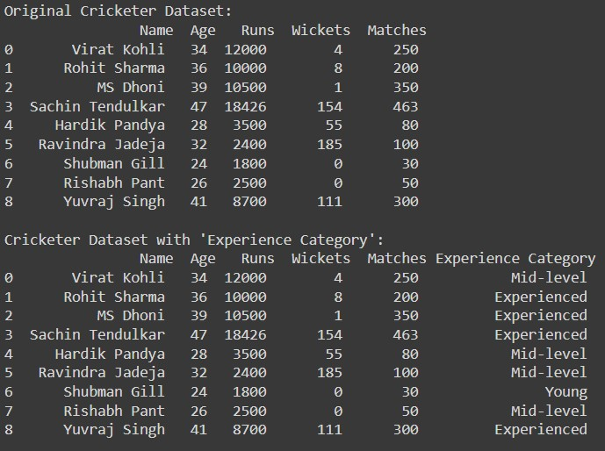

**DATA**

**ANALYTICS**

**USING PYTHON**

**Program #**

**5.4**

**Date :**

**1**

**9**

**/08/24**

**car_age = [5, 7, 8, 7, 2, 17, 2, 9, 4, 11, 12, 9, 6]**

**car_speed =**

**85,86]**

**,87,88,111,86,103,87,94,78,77,**

**[99,86**

**Using the given dataset,**

**5.4.1**

**Draw the line of linear regression**

**5.4.2**

**Evaluate how well the data fit in linear regression.**

**5.4.3**

**Predict the speed of a 10**

**-**

**year**

**-**

**old car.**

**SOURCE CODE**

**:**

import numpy as

np

import matplotlib.pyplot as plt

from sklearn.linear_model import LinearRegression

from sklearn.metrics import r2_score

# Data

car_age = np.array([5, 7, 8, 7, 2, 17, 2, 9, 4, 11, 12, 9, 6])

car_speed = np.array([99, 86, 87, 88, 111, 86, 103, 87, 94, 78, 77, 85, 86])

# Reshape data for sklearn

X = car_age.reshape(

-

1)

1

,

y = car_speed

# Fit the model

model = LinearRegression().fit(X, y)

y_pred = model.predict(X)

# Linear regression parameters

m = model.coef_[0]

c = model.intercept_

print(f'Regression Line: y = {m:.2f}x + {c:.2f}')

# Plot data points

plt.scatter(car_age, car_speed, color='blue', label='Data points')

# Plot regression line

x_values = np.linspace(min(car_age), max(car_age), 100)

y_values = m * x_values + c

plt.plot(x_values, y_values, color='red', label='Regression line')

plt.xlabel('Car Age')

plt.ylabel('Car Speed')

plt.title('Car Age vs Speed with Linear Regression Line')



**DATA**

**ANALYTICS**

**USING PYTHON**

plt.legend()

plt.show()

# Calculate R^2 score

r2 = r2_score(y, y_pred)

print(f'R^2 score: {r2:.2f}')

# Predict speed for a 10

-

year

-

old car

age_to_predict = 10

predicted_speed = model.predict([[age_to_predict]])[0]

print(f'Predicted speed for a {age_to_predict}

-

year

-

old car: {predicted_speed:.2f} mph')

**OUTPUT**

**:**

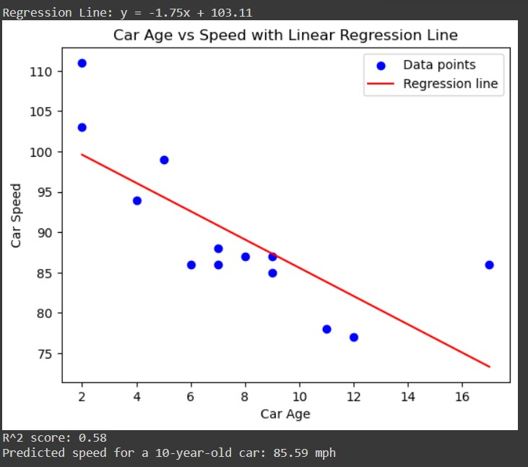

**DATA**

**ANALYTICS**

**USING PYTHON**

**Program #**

**5**

**.5**

**Date :**

**19**

**/08/24**

**Using the dataset (cars.csv),**

**5.5.1**

**Predict the CO2 emissions of a car with a weight of 2300 kg and volume of 1300**

**cm3.**

**5.5.2**

**Print the coefficient values of the regression object.**

**SOURCE CODE**

**:**

import pandas as pd

import numpy as np

from sklearn.linear_model import LinearRegression

# Load dataset

df = pd.read_csv('cars.csv')

# Display the first few rows of the dataframe to

understand its structure

print(df.head())

# Extract features and target variable

X = df[['Weight', 'Volume']]

y = df['CO2_Emissions']

# Create and fit the model

model = LinearRegression()

model.fit(X, y)

# Print the coefficients of the

regression model

print(f'Coefficients: {model.coef_}')

print(f'Intercept: {model.intercept_}')

# Create a DataFrame for the prediction

prediction_data = pd.DataFrame({'Weight': [2300], 'Volume': [1300]})

# Predict the CO2 emissions for the car with the given weight and volume

predicted_emissions = model.predict(prediction_data)

print(f'Predicted CO2 emissions for a car with weight 2300 kg and volume 1300 cm3:

predicted_emissions[0]:.2f} g/km'

{

)



**DATA**

**ANALYTICS**

**USING PYTHON**

**OUTPUT**

**:**

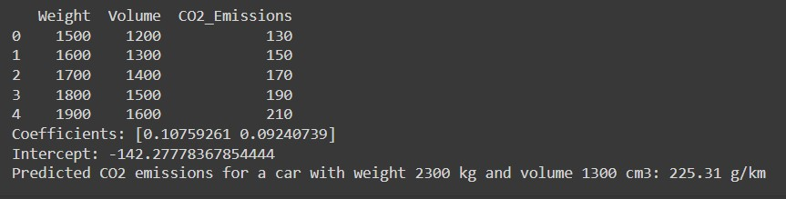

**DATA**

**ANALYTICS**

**USING PYTHON**

**Program #**

**5**

**.6**

**Date :**

**19**

**/08/24**

**Using the insurance dataset (insurance.csv) with adequate preprocessing steps,**

**5.6.1**

**Visualize the correlation among variables using a heatmap.**

**5.6.2**

**Create a linear regression model.**

**5.6.3**

**Evaluate the model.**

**)**

**Find MSE and R_square.**

**(**

**5.6.4**

**Predict the charges for a person with an age of 30, a BMI of 32.00, and who is a smoker.**

**SOURCE CODE**

**:**

# Step 5.

6.1

:

Visualize the

correlation among variables using a heatmap.

import pandas as pd

import seaborn as sns

import matplotlib.pyplot as plt

# Load the dataset

df = pd.read_csv('insurance.csv')

# Show basic information about the dataset

print(df.info())

# Display the first few rows of the dataset

print(df.head())

# Preprocess the data

# Convert categorical columns to numerical if needed (e.g., using one

-

hot encoding)

df_encoded = pd.get_dummies(df)

# Calculate the correlation matrix

corr_matrix = df_encoded.corr()

# Plot the heatmap

plt.figure(figsize=(10, 8))

sns.heatmap(corr_matrix, annot=True, cmap='coolwarm', fmt='.2f', linewidths=0.5)

plt.title('Correlation Heatmap')

plt.show()

# Step 5.

6.2

:

Create a linear regression model.

import pandas as pd

from

sklearn.model_selection import train_test_split

from sklearn.linear_model import LinearRegression

from sklearn.metrics import mean_squared_error, mean_absolute_error, r2_score

import matplotlib.pyplot as plt

import seaborn as sns



**DATA**

**ANALYTICS**

**USING PYTHON**

# Load the dataset

df =

pd.read_csv('insurance.csv')

# Show basic information about the dataset

print(df.info())

print(df.head())

# Preprocess the data

# Convert categorical columns to numerical using one

-

hot encoding

df_encoded = pd.get_dummies(df)

# Define features and target

# Assume 'charges' is the target variable and the rest are features

X = df_encoded.drop('charges', axis=1)

# Features

y = df_encoded['charges']

# Target variable

# Split the data into training and testing sets

X_train, X_test, y_train, y_test =

train_test_split(X, y, test_size=0.2, random_state=42)

# Initialize and train the Linear Regression model

model = LinearRegression()

model.fit(X_train, y_train)

# Make predictions

y_pred = model.predict(X_test)

# Evaluate the model

mse = mean_squared_error(y_test, y_pred)

mae = mean_absolute_error(y_test, y_pred)

r2 = r2_score(y_test, y_pred)

print(f'Mean Squared Error (MSE): {mse}')

print(f'Mean Absolute Error (MAE): {mae}')

print(f'R

-

squared (R2): {r2}')

# Optional: Plotting actual vs. predicted values

plt.figure(figsize=(10, 6))

plt.scatter(y_test, y_pred, alpha=0.5)

plt.xlabel('Actual Charges')

plt.ylabel('Predicted Charges')

plt.title('Actual vs. Predicted Charges')

plt.show()



**DATA**

**ANALYTICS**

**USING PYTHON**

# Step 5.

6.3

:

Evaluate the model.

)

Find MSE and R_square.

(

import pandas as pd

from sklearn.model_selection import train_test_split

from sklearn.linear_model import LinearRegression

from sklearn.metrics import mean_squared_error, r2_score

# Load the dataset

df =

pd.read_csv('insurance.csv')

# Preprocess the data

# Convert categorical columns to numerical using one

-

hot encoding

df_encoded = pd.get_dummies(df)

# Define features and target

X = df_encoded.drop('charges', axis=1)

# Features

y = df_encoded['charges']

# Target variable

# Split the data into training and testing sets

X_train, X_test, y_train, y_test = train_test_split(X, y, test_size=0.2, random_state=42)

# Initialize and train the Linear Regression model

model = LinearRegression()

model.fit(X_train, y_train)

# Make predictions

y_pred = model.predict(X_test)

# Evaluate the model

mse = mean_squared_error(y_test, y_pred)

r2 = r2_score(y_test, y_pred)

print(f'Mean Squared Error (MSE): {mse}')

print(f'R

-

squared (R2): {r2}')

# Step

5.

6.4 :

Predict the charges for a person with an age of 30, a BMI of 32.00, and who is a smoker.

import pandas as pd

from sklearn.model_selection import train_test_split

from sklearn.linear_model import LinearRegression

from sklearn.metrics import mean_squared_error, r2_score

# Load the dataset

df = pd.read_csv('insurance.csv')



**DATA**

**ANALYTICS**

**USING PYTHON**

# Preprocess the data

# Convert categorical columns to numerical using one

-

hot encoding

df_encoded = pd.get_dummies(df)

# Define features and target

X =

df_encoded.drop('charges', axis=1)

# Features

y = df_encoded['charges']

# Target variable

# Split the data into training and testing sets

X_train, X_test, y_train, y_test = train_test_split(X, y, test_size=0.2, random_state=42)

# Initialize and

train the Linear Regression model

model = LinearRegression()

model.fit(X_train, y_train)

# Retrieve feature names

feature_names = X_train.columns

# Define the input for the new person

# Create a DataFrame with all features, even if they are zero

new_person = pd.DataFrame([{

'age': 30,

'bmi': 32.00,

'sex_female': 0,

# Example, adjust based on encoding

'sex_male': 1,

# Example, adjust based on encoding

'smoker_no': 0,

# Example, adjust based on encoding

'smoker_yes': 1,

# Example, adjust based on encoding

'region_northeast': 0,

# Example, adjust based on encoding

'region_northwest': 0,

# Example, adjust based on encoding

'region_southeast': 0,

# Example, adjust based on encoding

'region_southwest': 0,

# Example, adjust based on encoding

'children': 0

# Add missing feature if necessary

}]

, columns=feature_names

)

# Predict the charges for the new person

predicted_charges = model.predict(new_person)

print(f'Predicted charges: ${predicted_charges[0]:,.2f}')



**DATA**

**ANALYTICS**

**USING PYTHON**

**OUTPUT**

**:**

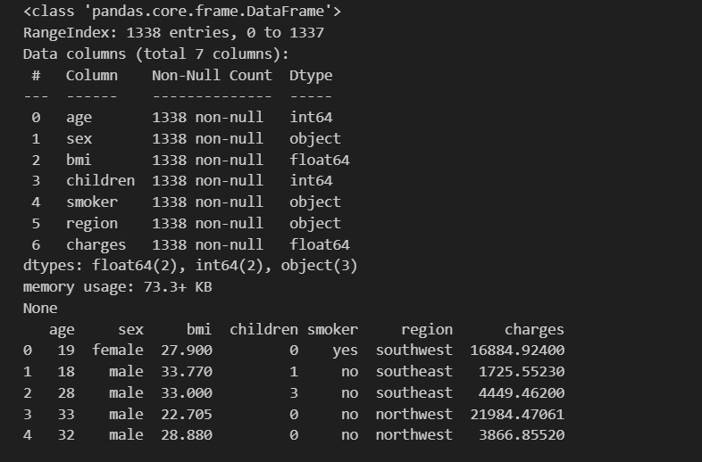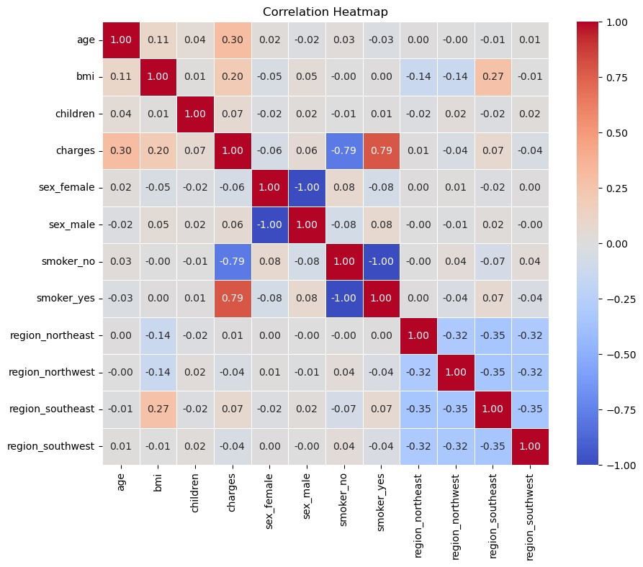

**DATA**

**ANALYTICS**

**USING PYTHON**

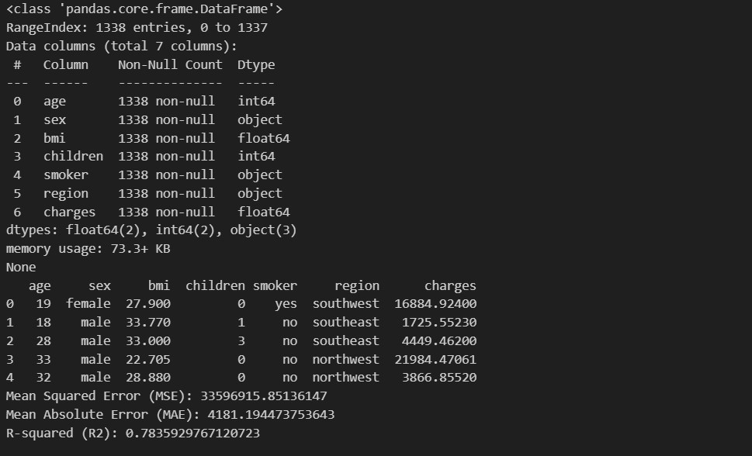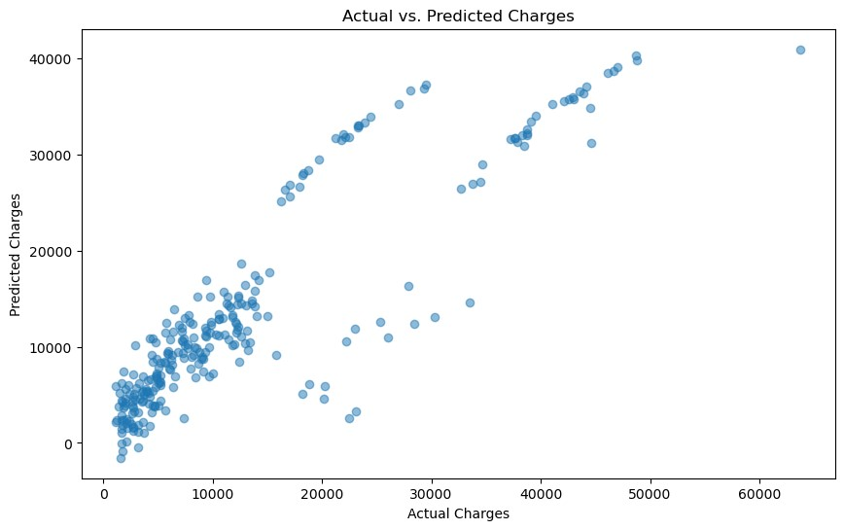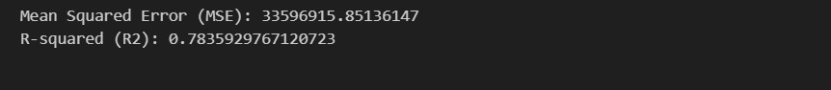

**DATA**

**ANALYTICS**

**USING PYTHON**

**Program #**

**5**

**.7**

**Date :**

**09**

**/0**

**9**

**/24**

**Evaluate the dataset (User_Data.csv) and predict whether a user will purchase the company's**

**product or not. (Use**

**logistic regression.)**

**SOURCE CODE**

**:**

import pandas as pd

from sklearn.model_selection import train_test_split

from sklearn.preprocessing import StandardScaler, LabelEncoder

from sklearn.linear_model import LogisticRegression

from

sklearn.metrics import accuracy_score, precision_score, recall_score, f1_score, confusion_matrix

import seaborn as sns

import matplotlib.pyplot as plt

# Load the dataset

df = pd.read_csv('User_Data.csv')

# Inspect the dataset

print(df.info())

print(df.head())

# Preprocess the data

# Handle missing values (if any)

df = df.dropna()

# Dropping missing values; you may choose to impute instead

# Convert categorical columns to numerical using Label Encoding or One

-

Hot Encoding

label_encoders = {}

for column in df.select_dtypes(include=['object']).columns:

le = LabelEncoder()

df[column] = le.fit_transform(df[column])

label_encoders[column] = le

# Define features and target

X = df.drop('Purchased', axis=1)

# Replace 'Purchased' with the actual name of the target column

y = df['Purchased']

# Replace 'Purchased' with the actual name of the target column

# Split the data into training and testing sets

X_train, X_test, y_train, y_test = train_test_split(X, y, test_size=0.2, random_state=42)

#

Standardize the features (optional but recommended for better performance)

scaler = StandardScaler()

X_train = scaler.fit_transform(X_train)

X_test = scaler.transform(X_test)



**DATA**

**ANALYTICS**

**USING PYTHON**

# Initialize and train the Logistic Regression model

model =

LogisticRegression()

model.fit(X_train, y_train)

# Make predictions

y_pred = model.predict(X_test)

# Evaluate the model

accuracy = accuracy_score(y_test, y_pred)

precision = precision_score(y_test, y_pred)

recall = recall_score(y_test, y_pred)

f1 = f1_score(y_test, y_pred)

conf_matrix = confusion_matrix(y_test, y_pred)

print(f'Accuracy: {accuracy:.2f}')

print(f'Precision: {precision:.2f}')

print(f'Recall: {recall:.2f}')

print(f'F1 Score: {f1:.2f}')

# Plot confusion matrix

plt.figure(figsize=(8, 6))

sns.heatmap(conf_matrix, annot=True, fmt='d', cmap='Blues',

xticklabels=['Not Purchased', 'Purchased'],

yticklabels=['Not Purchased', 'Purchased'])

plt.xlabel('Predicted')

plt.ylabel('Actual')

plt.title('Confusion Matrix')

plt.show()



**DATA**

**ANALYTICS**

**USING PYTHON**

**OUTPUT**

**:**

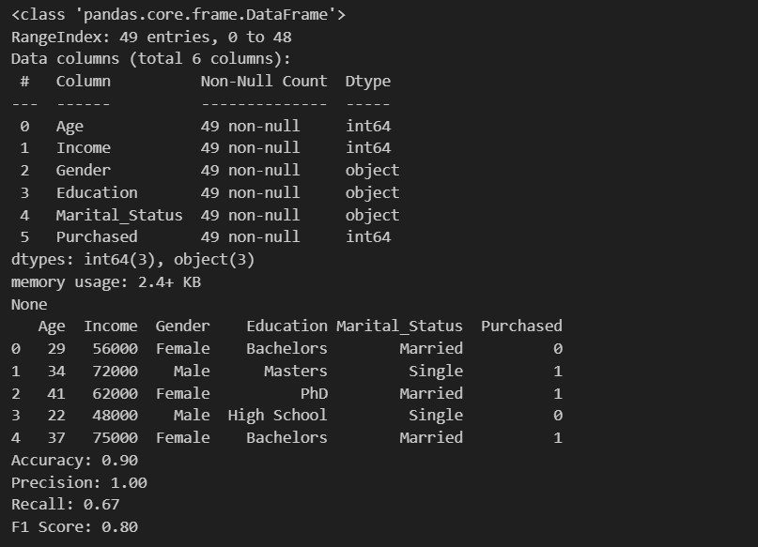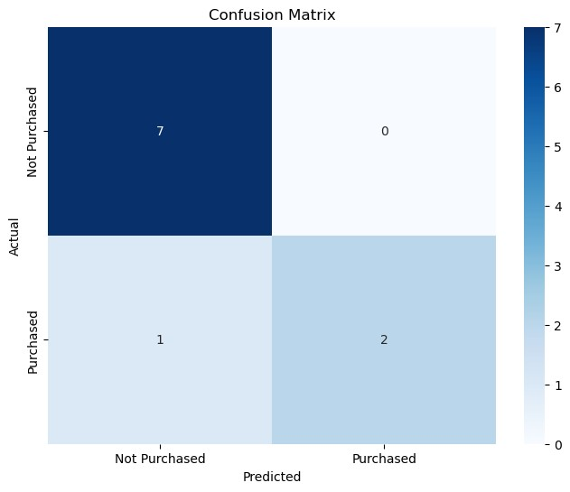

**DATA**

**ANALYTICS**

**USING PYTHON**

**Program #**

**5.8**

**Date :**

**0**

**9**

**/09/24**

**Use the Iris dataset to visualize a decision tree with a depth=4 and save the plot as a PNG file. Also,**

**print the confusion matrix and generate the classification report.**

**SOURCE CODE**

**:**

import pandas as pd

import matplotlib.pyplot as plt

from sklearn.datasets import load_iris

from sklearn.model_selection import train_test_split

from sklearn.tree import

DecisionTreeClassifier, plot_tree

from sklearn.metrics import confusion_matrix, classification_report

import seaborn as sns

# Load the Iris dataset

iris = load_iris()

X = iris.data

y = iris.target

feature_names = iris.feature_names

target_names = iris.target_names

# Split the data into training and testing sets

X_train, X_test, y_train, y_test = train_test_split(X, y, test_size=0.3, random_state=42)

# Initialize and train the Decision Tree Classifier

clf = DecisionTreeClassifier(max_depth=4, random_state=42)

clf.fit(X_train, y_train)

# Plot the decision tree

plt.figure(figsize=(20,10))

plot_tree(clf, feature_names=feature_names, class_names=target_names, filled=True)

plt.title('Decision Tree with Depth=4')

plt.savefig('decision_tree.png')

# Save the plot as a PNG file

plt.show()

# Make predictions

y_pred = clf.predict(X_test)

# Print the confusion matrix

conf_matrix = confusion_matrix(y_test, y_pred)

print("Confusion Matrix:")

print(conf_matrix)



**DATA**

**ANALYTICS**

**USING PYTHON**

# Print the

classification report

class_report = classification_report(y_test, y_pred, target_names=target_names)

print("Classification Report:")

print(class_report)

# Optionally, plot the confusion matrix

plt.figure(figsize=(8,6))

sns.heatmap(conf_matrix, annot=True, fmt='d', cmap='Blues', xticklabels=target_names,

yticklabels=target_names)

plt.xlabel('Predicted')

plt.ylabel('Actual')

plt.title('Confusion Matrix')

plt.show()

**OUTPUT**

**:**

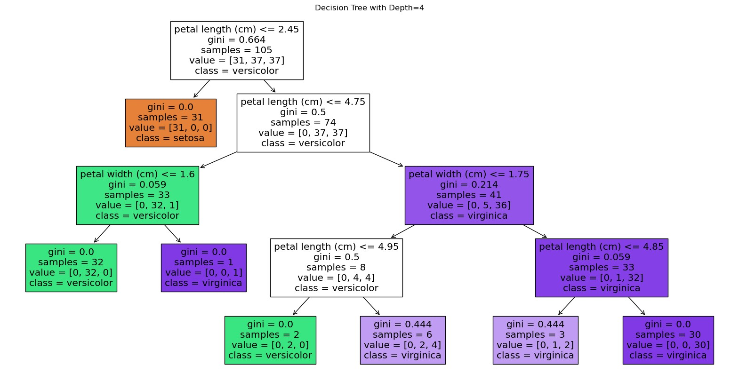

**DATA**

**ANALYTICS**

**USING PYTHON**

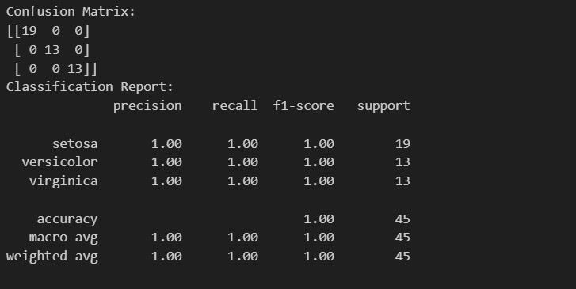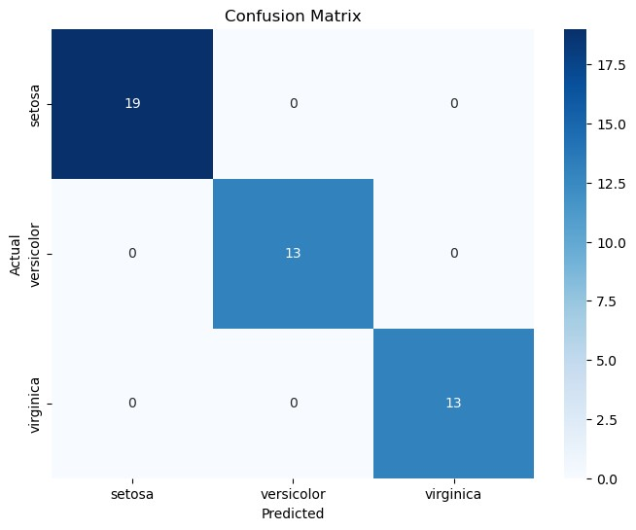

**DATA**

**ANALYTICS**

**USING PYTHON**

**Program #**

**5.9**

**Date :**

**0**

**9**

**/09/24**

**Use the KNN algorithm to train the model and predict the future using the Iris dataset. Also,**

**measure the accuracy of the model.**

**SOURCE CODE**

**:**

import numpy as np

import pandas as pd

from sklearn.datasets import load_iris

from sklearn.model_selection import train_test_split

from sklearn.neighbors import KNeighborsClassifier

from sklearn.metrics import

accuracy_score, classification_report, confusion_matrix

import seaborn as sns

import matplotlib.pyplot as plt

# Load the Iris dataset

iris = load_iris()

X = iris.data

y = iris.target

feature_names = iris.feature_names

target_names =

iris.target_names

# Split the data into training and testing sets

X_train, X_test, y_train, y_test = train_test_split(X, y, test_size=0.3, random_state=42)

# Initialize the KNN Classifier

# You can experiment with different values of k

k = 5

#

Choose the number of neighbors

knn = KNeighborsClassifier(n_neighbors=k)

# Train the model

knn.fit(X_train, y_train)

# Make predictions

y_pred = knn.predict(X_test)

# Measure the accuracy

accuracy = accuracy_score(y_test, y_pred)

print(f'Accuracy of KNN model with k={k}: {accuracy:.2f}')

# Print the classification report

print("Classification Report:")

print(classification_report(y_test, y_pred, target_names=target_names))



**DATA**

**ANALYTICS**

**USING PYTHON**

# Print the confusion matrix

conf_matrix = confusion_matrix(y_test, y_pred)

print("Confusion Matrix:")

print(conf_matrix)

# Plot the confusion matrix

plt.figure(figsize=(8,6))

sns.heatmap(conf_matrix, annot=True, fmt='d', cmap='Blues', xticklabels=target_names,

yticklabels=target_names)

plt.xlabel('Predicted')

plt.ylabel('Actual')

plt.title('Confusion Matrix for KNN')

plt.show()

**OUTPUT**

**:**

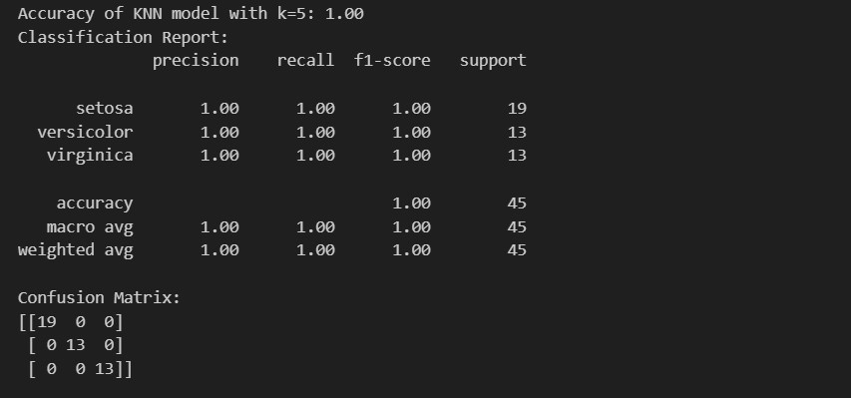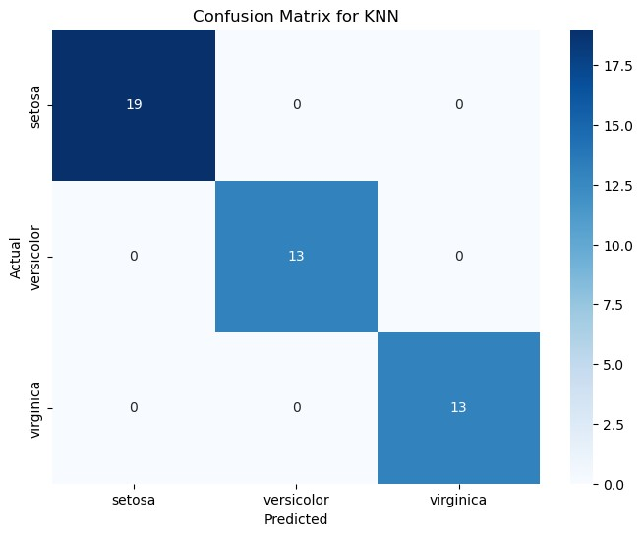

**DATA**

**ANALYTICS**

**USING PYTHON**

**Program #**

**5.10**

**Date :**

**0**

**9**

**/09/24**

**Analyze the given dataset (gym_data.csv) using RandomForestRegressor and visualize the ‘Effect of**

**n_estimators.**

**SOURCE CODE**

**:**

import pandas as pd

import numpy as np

import matplotlib.pyplot as plt

from sklearn.model_selection import train_test_split

from sklearn.ensemble import RandomForestRegressor

from sklearn.metrics import mean_squared_error

# Load the

dataset

df = pd.read_csv('gym_data.csv')

# Inspect the dataset

print(df.head())

print(df.info())

# Assume that the dataset has columns 'feature1', 'feature2', ..., 'featureN', and 'target'

# You need to replace 'feature1', ..., 'featureN', and

'target' with the actual column names

X = df.drop('target', axis=1)

# Replace 'target' with the actual target column name

y = df['target']

# Replace 'target' with the actual target column name

# Split the data into training and testing sets

X_train, X_test, y_train, y_test = train_test_split(X, y, test_size=0.3, random_state=42)

# Define different values for n_estimators

n_estimators_list = [10, 50, 100, 200, 300]

mse_list = []

# Train and evaluate RandomForestRegressor with different n_estimators

for n in n_estimators_list:

rf = RandomForestRegressor(n_estimators=n, random_state=42)

rf.fit(X_train, y_train)

y_pred = rf.predict(X_test)

mse = mean_squared_error(y_test, y_pred)

mse_list.append(mse)

print(f'n_estimators: {n}, MSE: {mse:.2f}')

# Plot the effect of n_estimators on MSE



**DATA**

**ANALYTICS**

**USING PYTHON**

plt.figure(figsize=(10, 6))

plt.plot(n_estimators_list, mse_list, marker='o')

plt.xlabel('Number of Estimators')

plt.ylabel('Mean Squared Error')

plt.title('Effect of n_estimators on RandomForestRegressor Performance')

plt.grid(True)

plt.show()

**OUTPUT**

**:**

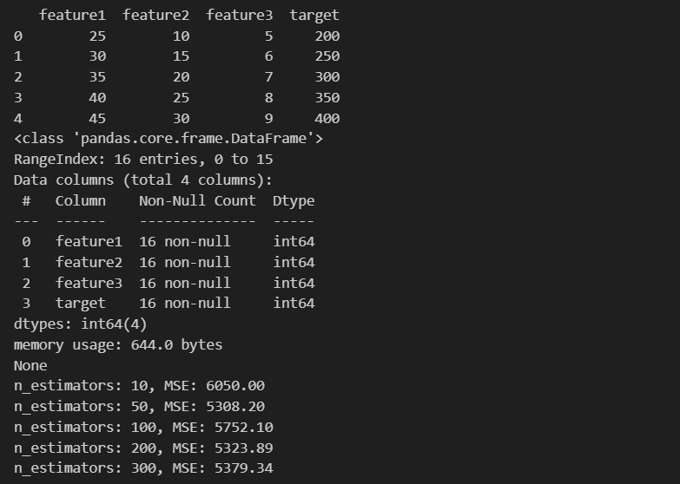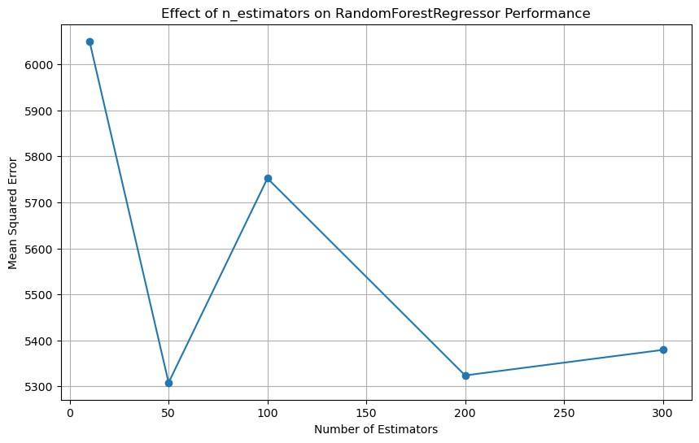

**DATA**

**ANALYTICS**

**USING PYTHON**

**Program #**

**5.11**

**Date :**

**11**

**/09/24**

**Visualize a 3**

**-**

**dimensional cluster using the given dataset ‘Mall_Customers.csv’, where**

**no_of_clusters = 5.**

**SOURCE CODE**

**:**

import pandas as pd

import numpy as np

import matplotlib.pyplot as plt

from mpl_toolkits.mplot3d import Axes3D

from sklearn.preprocessing import StandardScaler

from sklearn.cluster import KMeans

from sklearn.decomposition import PCA

# Load the

dataset

df = pd.read_csv('Mall_Customers.csv')

# Display the first few rows of the dataset

print(df.head())

# Select relevant features for clustering

# Ensure these columns exist in your dataset; adjust names if needed

X = df[['Annual Income (k$)',

'Spending Score (1

-

100)

', 'Age'

]]

# Standardize the features

scaler = StandardScaler()

X_scaled = scaler.fit_transform(X)

# Apply K

-

Means clustering

n_clusters = 5

kmeans = KMeans(n_clusters=n_clusters, random_state=42)

df['Cluster'] = kmeans.fit_predict(X_scaled)

# Reduce dimensions to 3D using PCA for visualization

pca = PCA(n_components=3)

X_pca = pca.fit_transform(X_scaled)

# Create a 3D scatter plot

fig = plt.figure(figsize=(12, 8))

ax = fig.add_subplot(111, projection='3d')

# Plot the data points



**DATA**

**ANALYTICS**

**USING PYTHON**

scatter = ax.scatter(X_pca[:, 0], X_pca[:, 1], X_pca[:, 2], c=df['Cluster'], cmap='viridis', marker='o')

# Add color bar

legend1 = ax.legend(*scatter.legend_elements(), title="Clusters")

ax.add_artist(legend1)

# Label the axes and add a title

ax.set_xlabel('Principal Component 1')

ax.set_ylabel('Principal Component 2')

ax.set_zlabel('Principal Component 3')

ax.set_title('3D Clustering Visualization (K

-

Means with n_clusters=5)')

plt.show()

**OUTPUT**

**:**

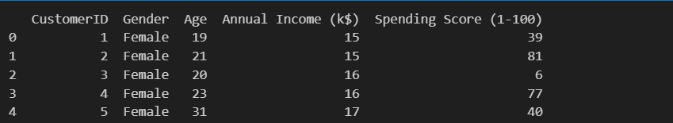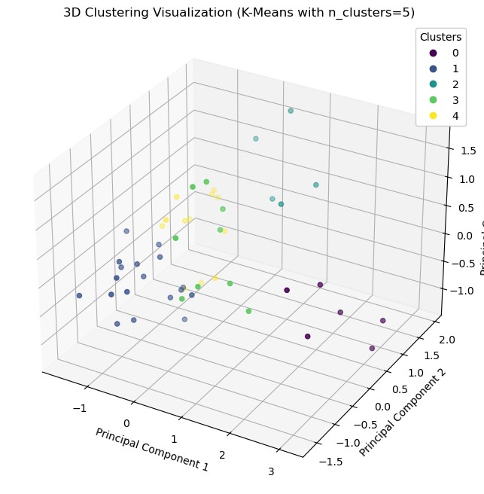

**DATA**

**ANALYTICS**

**USING PYTHON**

**Program #**

**5.12**

**Date :**

**11**

**/09/24**

**Using the dataset provided (Online Retail.xlsx),**

**5.12.1**

**Split the data according to the region of the**

**transaction.**

**5.12.2**

**Build the models using the apriori algorithm.**

**5.12.3**

**Develop the association rules.**

**5.12.4**

**Find the most frequent items in any one of the regions.**

**SOURCE CODE**

**:**

import pandas as pd

from mlxtend.preprocessing import TransactionEncoder

from

mlxtend.frequent_patterns import apriori, association_rules

# Load the CSV dataset

file_path = 'Online Retail.csv'

df = pd.read_csv(file_path)

# Display the first few rows of the dataset

print(df.head())

# Split the data by region (assuming

'Country' is the region column)

regions = df['Country'].unique()

region_dfs = {region: df[df['Country'] == region] for region in regions}

# Example: data for one region, e.g., 'United Kingdom'

uk_data = region_dfs['United Kingdom']

# Prepare the data for Apriori

def prepare_data(df):

df = df.dropna(subset=['InvoiceNo', 'Description'])

basket = df.groupby(['InvoiceNo',

'Description'])['Quantity'].sum().unstack().reset_index().fillna(0).set_index('InvoiceNo')

basket = basket.apply(lambda x: x > 0)

# Convert to boolean

return basket

basket_uk = prepare_data(uk_data)

# Apply the Apriori algorithm

frequent_itemsets = apriori(basket_uk, min_support=0.01, use_colnames=True)

print('Frequent Itemsets:')

print(frequent_itemsets.head())

#

Generate association rules

rules = association_rules(frequent_itemsets, metric='confidence', min_threshold=0.5)



**DATA**

**ANALYTICS**

**USING PYTHON**

print('Association Rules:')

print(rules.head())

# Find the most frequent items

most_frequent_items = frequent_itemsets.sort_values(by='support', ascending=False)

print('Most Frequent Items:')

print(most_frequent_items.head())

**OUTPUT**

**:**

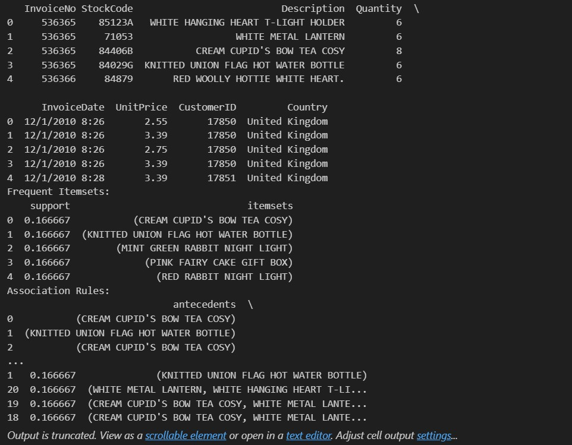

**DATA**

**ANALYTICS**

**USING PYTHON**

**P**

**RO**

**GRAM**

**#**

**6**

**Date :**

**24**

**16**

**/09/**

**PROJECT :**

**Effect of climate in agriculture**

**SOURCE CODE**

**:**

import pandas as pd

import numpy as np

import seaborn as sns

import matplotlib.pyplot as plt

from sklearn.model_selection import train_test_split

from sklearn.linear_model import LinearRegression

from sklearn.metrics import mean_squared_error, r2_score

from google.colab import drive

drive.mount('/content/drive')

file_path='/content/drive/MyDrive/Python dataset/climate_change_agriculture_dataset.csv'

data=pd.read_csv(file_path)

data.head()

print("

\

nMissing values in the dataset:")

print(data.isnull().sum())

Missing values in the dataset:

Temperature 0

Precipitation 0

CO2 Levels 0

Crop Yield 0

Soil Health 0

Extreme Weather Events 0

Crop Disease Incidence 0

Water Availability 0

Food Security 0

Economic Impact 0

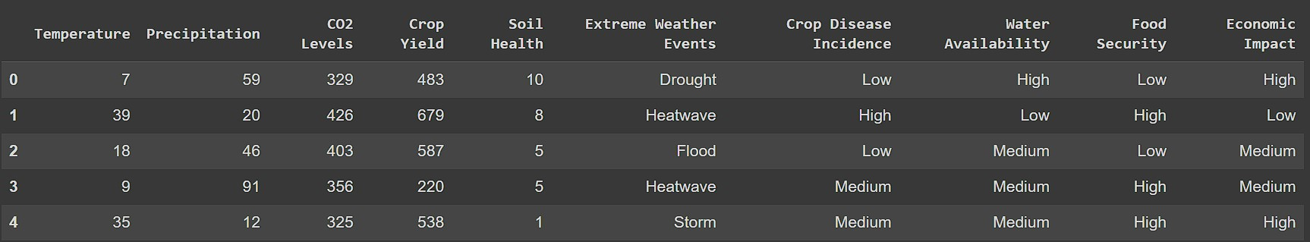

**DATA**

**ANALYTICS**

**USING PYTHON**

dtype: int64

plt.figure(figsize=(10, 8))

corr_matrix = data_encoded.corr()

sns.heatmap(corr_matrix, annot=True, cmap='coolwarm', fmt='.2f')

plt.title('Correlation Matrix for Climate and Agriculture Variables')

plt.show()

sns.pairplot(data[['Temperature', 'Precipitation', 'CO2 Levels', 'Crop Yield', 'Soil Health']])

plt.title('Pairplot for Key Variables')

plt.show()

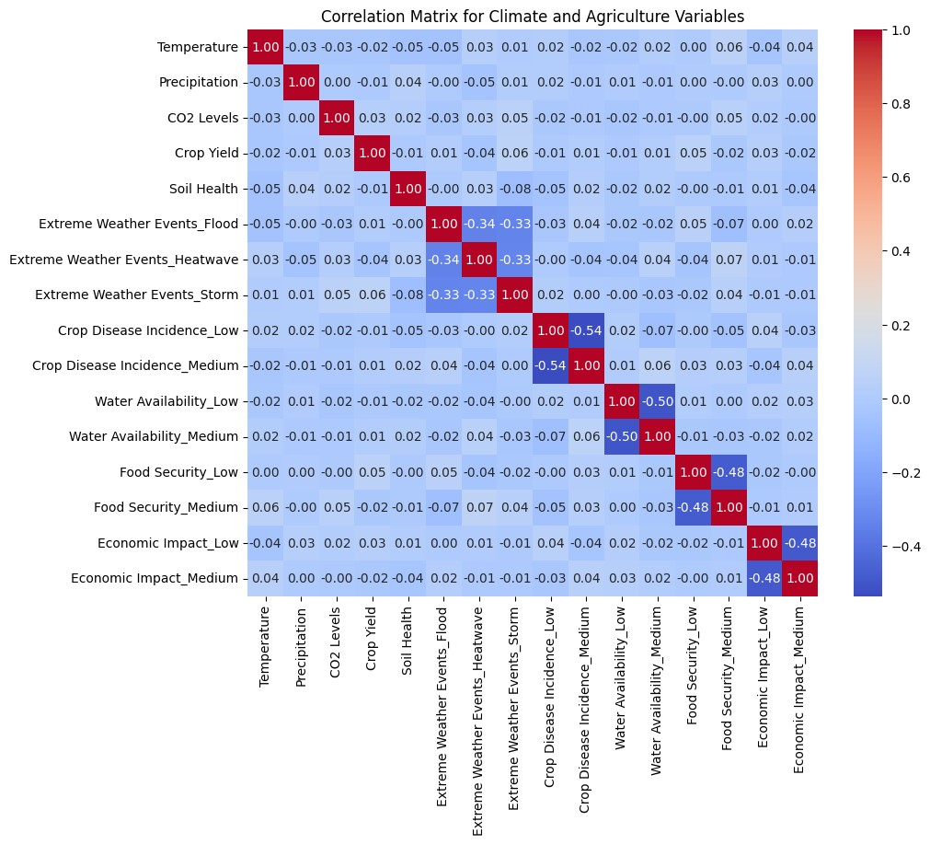

**DATA**

**ANALYTICS**

**USING PYTHON**

# Separate features (X) and target variable (y) for modeling

X = data_encoded.drop('Crop Yield', axis=1)

y = data_encoded['Crop Yield

# Split the data into training and testing sets (80% train, 20% test)

X_train, X_test, y_train, y_test = train_test_split(X, y, test_size=0.2, random_state=42)

# Make predictions on the test set

y_pred = model.predict(X_test)

# Calculate Mean Squared Error (MSE) and R

-

squared (R²) values

mse = mean_squared_error(y_test, y_pred)

r2 = r2_score(y_test, y_pred)

Mean Squared Error (MSE): 74067.68184857858

R

-

squared (R²):

-

0.03347821979968679

plt.scatter(y_test, y_pred)

plt.xlabel('Actual Crop Yield')

plt.ylabel('Predicted Crop Yield')

plt.title('Actual vs Predicted Crop Yield')

plt.show()

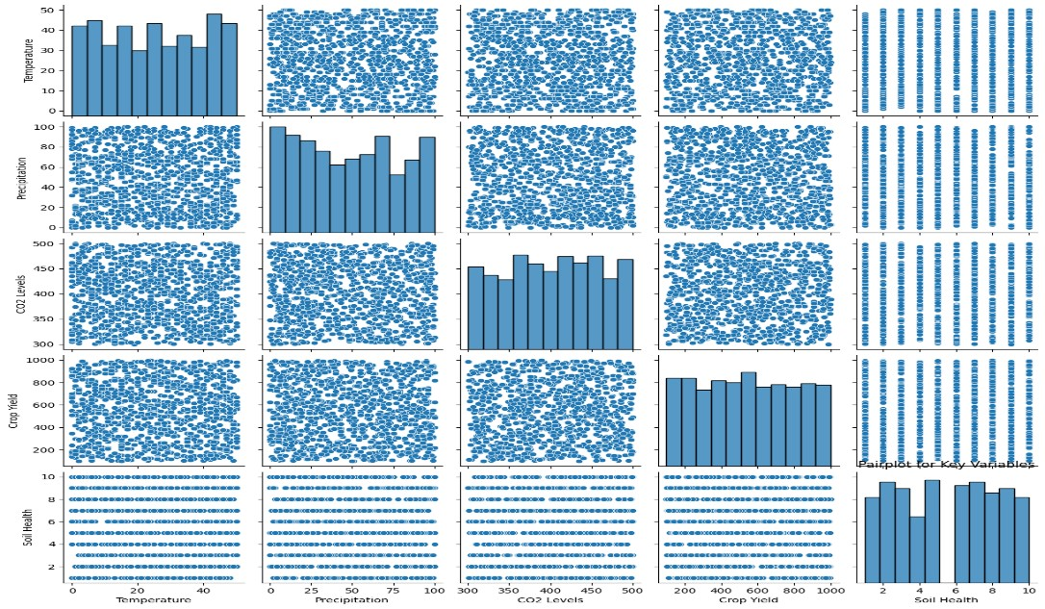

**DATA**

**ANALYTICS**

**USING PYTHON**

**OUTPUT:**

